

**UKCS Decommissioning**

**Benchmarking Report 2021**

**October 2021**

Note that all graphs in this document to be re-made by Drafting to improve legibility and appearance

Contents

1. Executive summary 3

2. Benchmark summary 3

3. Project Management 4

3.1 Projects < £150MM 4

3.2 Projects > £150MM 5

4. Platform Post-CoP Running Costs 7

4.1 Northern North Sea (NNS) & Central North Sea (CNS) 7

4.2 Southern North Sea (SNS) & East Irish Sea (EIS) – Normally Unattended Installations (NUI) 9

4.3 Southern North Sea (SNS) & East Irish Sea (EIS) – Attended Installations 10

4.4 FPSO Post-CoP Running Costs in the NNS & CNS 10

4.5 Cessation of Production (CoP) to Cold Stack: All areas 11

5. Well Decommissioning 12

5.1 Platform well decommissioning costs 13

5.2 Subsea development well decommissioning costs 19

5.4 Subsea Exploration and Appraisal (E&A) well decommissioning costs 20

5.5 Well Decommissioning (days) 23

6. FPSO removal (incl. disconnection and tow) 23

6.1 NNS & CNS 23

Appendices 25

Appendix 1: Benchmark representation of cost performance and uncertainty 25

Appendix 2: Data screening rule-set 26

# Executive summary

Managing the UKCS declining production to maximise the remaining value from the basin is vital to meet our energy demands, as well as reducing reliance on imports and their associated carbon footprint. Ensuring that decommissioning is carried out in a timely, cost effective manner not only helps value extraction from the UKCS, but also demonstrates industry’s commitment to responsibly manage the UK’s hydrocarbon legacy.

This report provides comparison data which benchmarks a wide range of UKCS decommissioning activities[1]. It follows the publication of the UKCS Decommissioning Cost Estimate 2021[2] in August. The reported benchmark information is derived from the perspective of the customer (i.e. does not necessarily reflect the costs incurred by the service provider) and, with a very small number of defined exceptions (see appendix 2), is based on ‘actual’, incurred expenditure.

The intent is that the benchmarking graphs will communicate the key insights without the need for detailed text, supporting text will therefore only be present by exception, should there be an important element of the graphs that warrants further explanation.

Decommissioning activity in 2020 was without doubt in part impacted by the Covid-19 pandemic and the low commodity price, contributing to a reduction in scope liquidation and thus the benchmark sample size has, in some instances, only seen marginal change. The benchmarks for 2020 should hence be considered in this context.

With increasing emphasis placed on energy transition, reducing greenhouse gas emissions and Carbon Capture and Storage (CCS), the overall decommissioning cost impact of the energy transition plus any potential infrastructure re-use/repurposing is evolving and is expected to remain so for a number of years. In some cases, to-date there have been cost increases, as additional work is done when infrastructure or wells are preserved or decommissioned to a different standard to allow for future re-use projects.

It is acknowledged that the range of benchmarks presented are not fully normalised to account for individual operator decommissioning circumstance and/or potential variance in the respective input data and as such the benchmark should be considered as representative of costs on a simplified like-for-like basis only.

# Benchmark summary

UKCS decommissioning cost performance benchmarks are presented for each WBS[3] component and summarised (P50) in Table 1 along with movement in metric relative to prior years data.

Benchmarks are based on actual cost outturn i.e. not including cost estimates/forecasts (where exceptions apply these are listed in appendix 2). Where insufficient “actual” cost performance data exists, no benchmark data is provided. Explanation of the benchmark calculation methodology plus metrics quartiles, P25, P50 and P75, referenced in the graphs, are provided in appendices.

Where considered to be meaningful and when sufficient actual data exists, benchmarks may be further refined and presented by UKCS geographical sector.

Consistent allocation of actual costs to each of the WBS elements by the Operator is paramount in the development of robust and consistent decommissioning benchmarks.

Does this table get a title? Maybe “Overview of 2020 Benchmarks and Movement from Prior Year”?

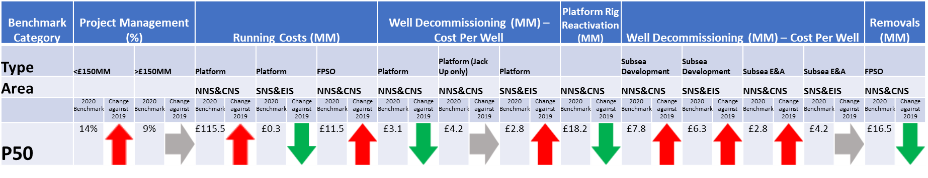

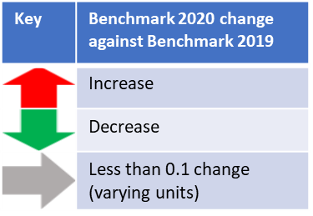

# Project Management



Benchmarks for Decommissioning Project Management (PM) are sub-divided into two categories (1) Projects < £150MM and (2) Projects > £150MM to differentiate the potential variance in PM costs as a function of project size.

Metric: Project management costs expressed as % of total decommissioning costs.

Whilst a reduction in PM % is often regarded as directionally and intuitively correct this needs to be considered within the context of the overarching objective of a reduction in overall decommissioning project execution costs. A net reduction in project costs with the same PM overheads would result in a relative increase in PM metric.

# 3.1 Projects < £150MM

Relative to the same metric for projects > £150MM a wider distribution of costs are observed for small scale decommissioning projects. The benefits of economies of scale for larger projects is not reflected in this metric.

Sample Size: 41-50

**Figure 1: Project Management (Total project: < £150MM)**

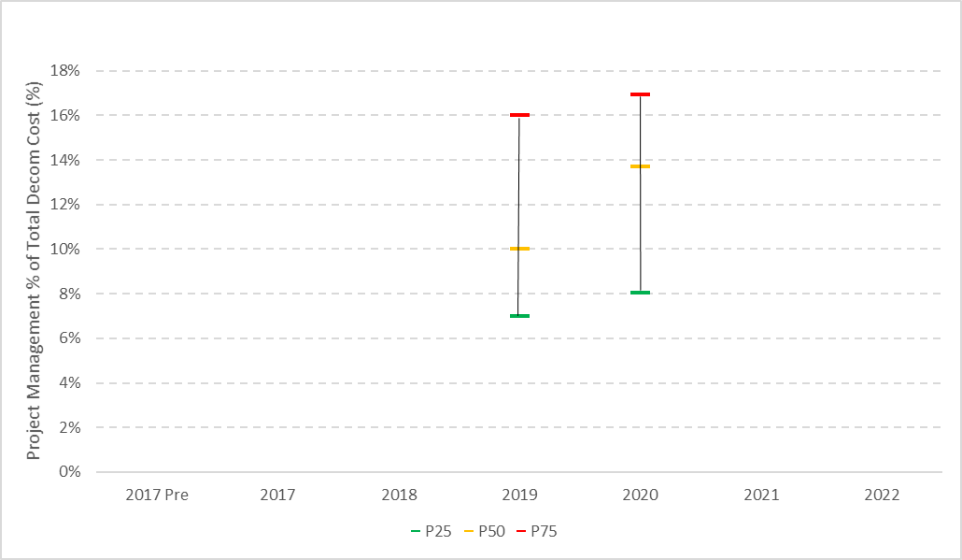

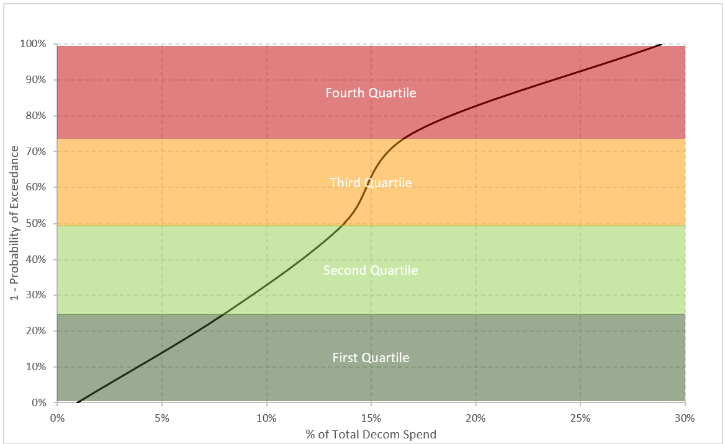

# 3.2 Projects > £150MM

Project management costs for projects > £150MM consistently reflect a narrow range.

Sample Size: 5-10

**Figure 2: Project Management (Total project: > £150MM)**

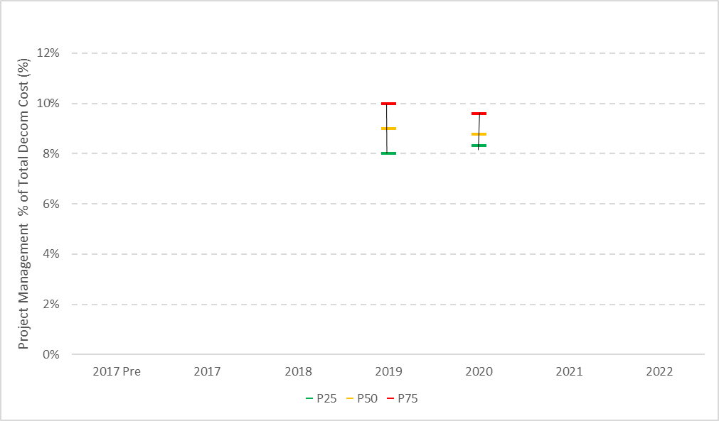 

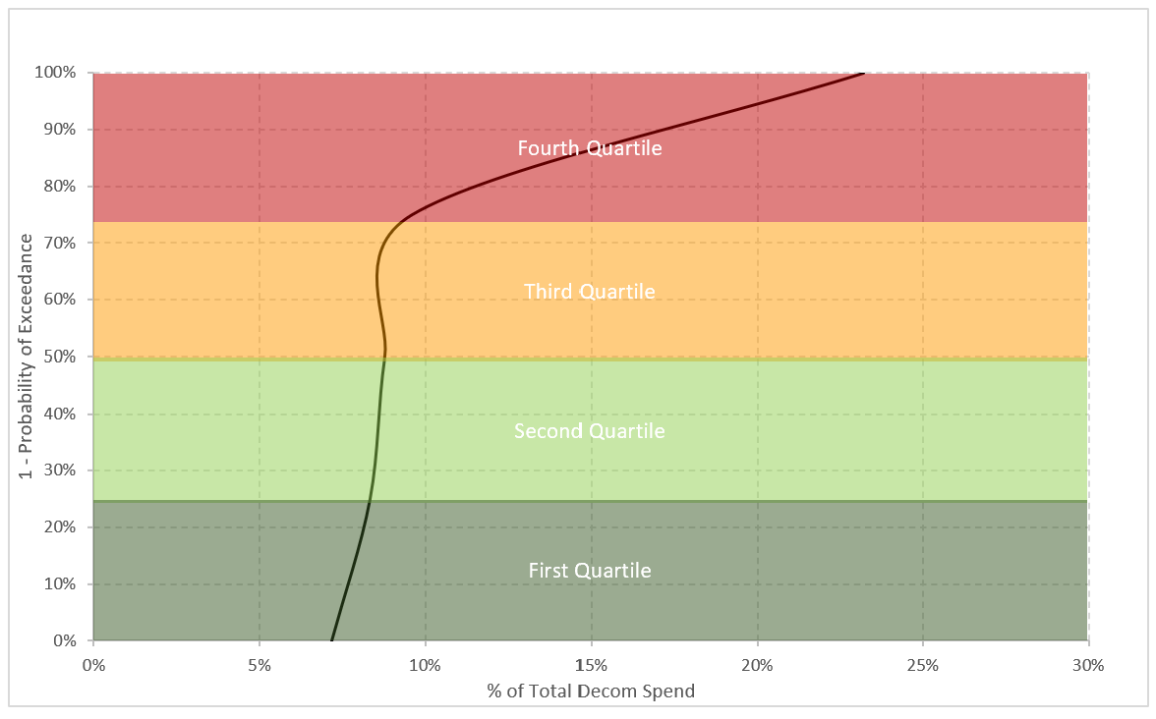

# Platform Post-CoP Running Costs



Delays in achieving cold stack due in part to the Covid-19 pandemic have had a negative bearing on this metric.

To complement the post CoP running cost metric an additional (new) benchmark of time (years) from CoP to cold stack status has been developed (section 4.5).

# 4.1 Northern North Sea (NNS) & Central North Sea (CNS)

Due to the infrequent and multi-calendar-year nature of this metric no material change is observed. Instances of early and unplanned CoP continue to occur across the basin, the effect of which on the metric has yet to be fully realised. Inadequate preparation for decommissioning, including lost opportunity to execute decommissioning scope during late life phase results in additional costs (£50MM - £100MM) being incurred.

Sample Size: 5-10

**Figure 6: Large Platform Running Cost distribution: NNS & CNS**

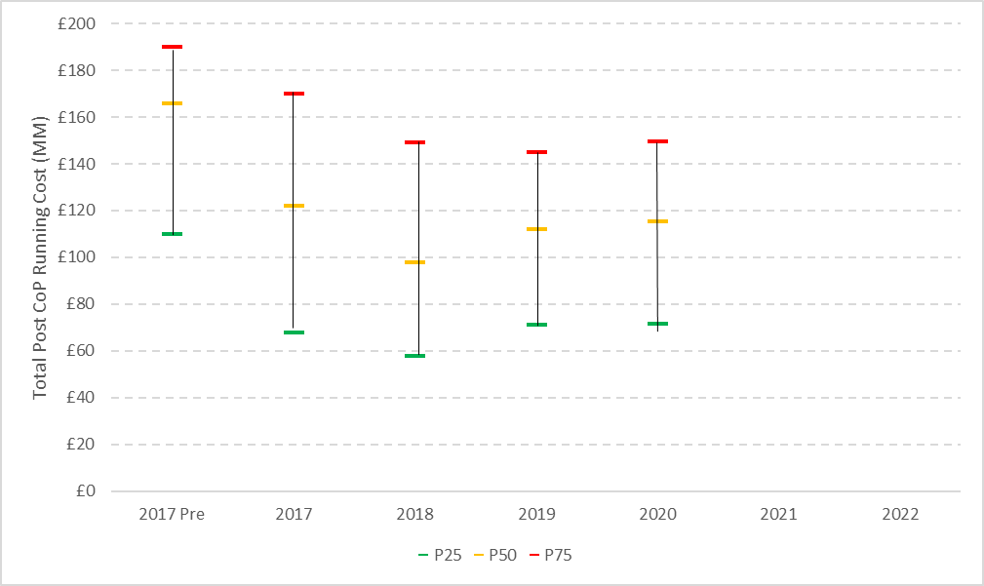 

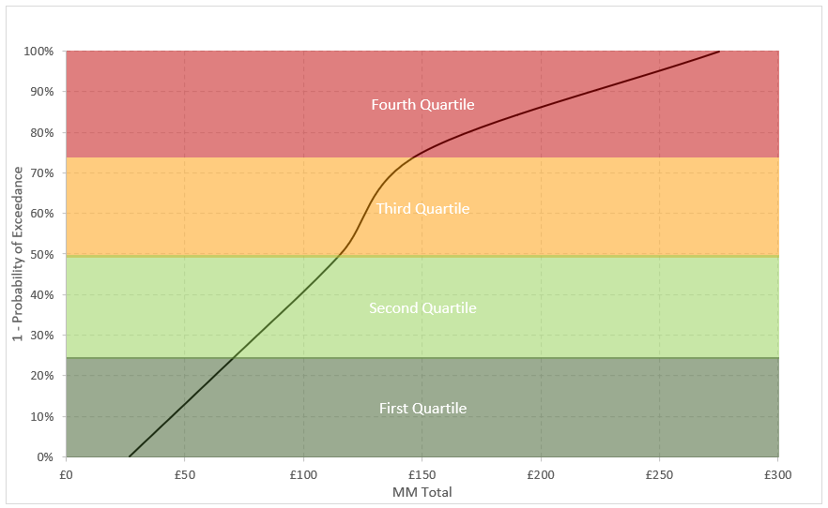

# 4.2 Southern North Sea (SNS) & East Irish Sea (EIS) – Normally Unattended Installations (NUI)

Post CoP running costs are generally very low, reflective of nominally lower Opex for NUI status in conjunction with completion of efficient well decommissioning (typically a single P&A campaign). Despite these factors, significant outliers in cost performance are still observed.

The drivers of the significant increase in 4th quartile cost performance are multi-faceted and a function of protracted period from CoP to cold stack (including delays due to Covid-19; evaluation of re-use and CCS potential) plus instances of high opex driven by commercial and contractual agreements.

Sample Size: 21-30

**Figure 7: Platform (Normally Unattended) Running Cost distribution: SNS & EIS**

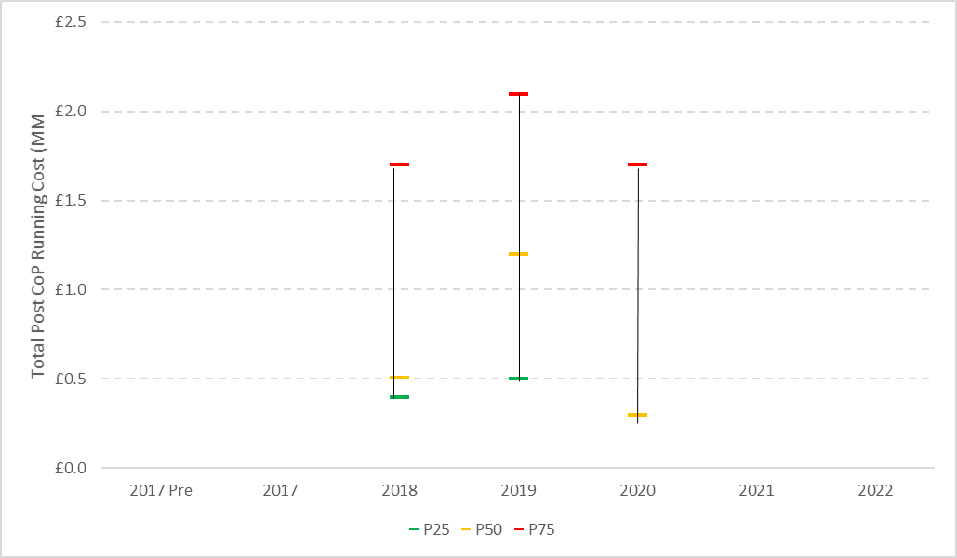 

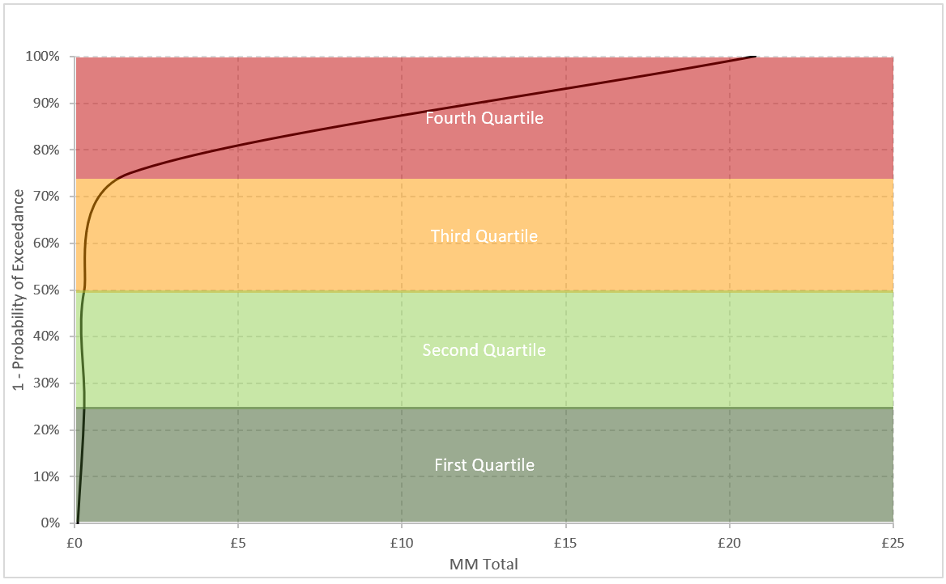

# 4.4 FPSO Post-CoP Running Costs in the NNS & CNS

Metric reflects a material change however this is a function of the relatively small sample size and infrequent nature of this decommissioning activity across UKCS. The notable increase in 4th quartile costs is largely due to extended post-CoP shutdowns plus delays in cleaning and removal from station for certain recent projects.

Sample Size: 5-10

**Figure 8: FPSO Post-CoP Running Cost distribution: NNS & CNS**

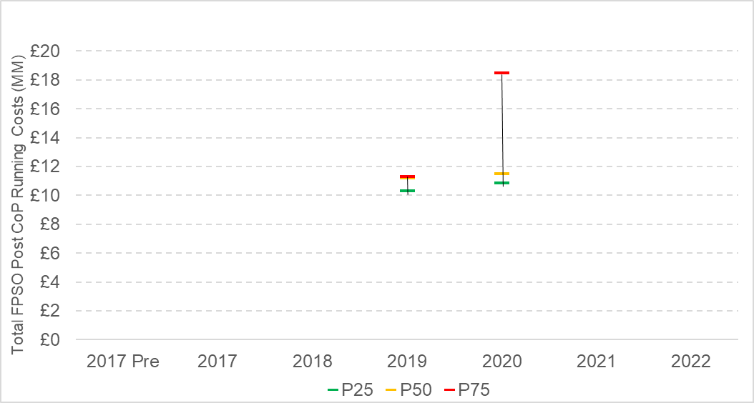 

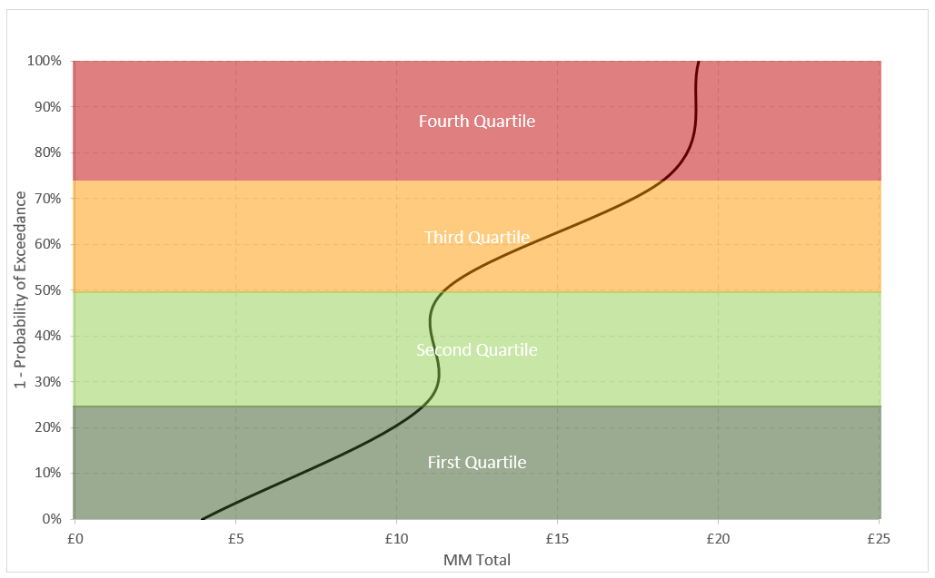

# 4.5 Cessation of Production (CoP) to Cold Stack: All areas

New metric.

CoP year is defined as the year in which the asset is expected to, or has already, permanently ceased production. Please note this is the year that the asset has stopped producing native oil and gas, and does not consider any future third party processing dates.

Cold Stack[4] is calculated as 1 year after the asset's last year of platform well decommissioning spend (e.g. if an asset’s last year of well decommissioning spend was in 2019, commencement of Cold Stack Phase is considered to be 2020).

Data based on actuals, last year of well spend is 2020 or earlier.

Establishing a “flexible” window (3 years from cold-stack to topsides removals is considered to be standard industry practice) for topsides removal provides sufficient supply chain and execution flexibility without invoking additional incremental cost.

Sample Size: 31-40

**Figure 9: No. of Years from CoP to Cold Stack: All areas**

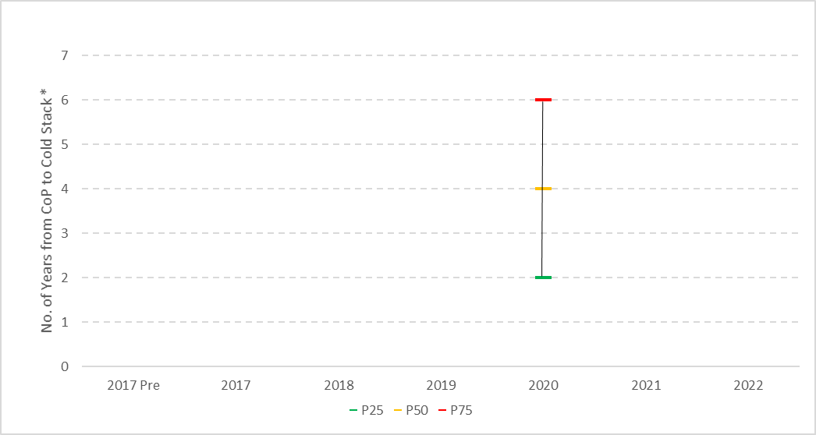 

# Well Decommissioning

Currently, the UKCS has a well portfolio in excess of ~ 4000 wells which remain to be decommissioned.

The UKCS has 893[5] inactive suspended platform and subsea wells[6] (356 subsea wells; 529 platform wells; 8 multilateral wells). In the next five years, a similar number of wells are forecast to become inactive and available for decommissioning.

Of the wells noted above, 176 are suspended open water Exploration & Appraisal (E&A) wells.

Across the UKCS basin ~ 88 wells were decommissioned during 2020, a reduction from 132 in 2019.

While adoption of campaigns to deliver cost efficient and timely decommissioning of all suspended wells has begun, significant opportunity still exists through collaboration and campaigns to drive down the unit cost of well decommissioning.

Re-use of existing wells for CCS is now becoming a consideration/reality. The incremental cost associated with decommissioning of wells designated for CCS is a consideration in well P&A benchmarking.

To complement and be read in conjunction with the existing well decommissioning cost benchmarks, a secondary (new) well decommissioning benchmark (metric: days to decommission wells) has been added where applicable data exists (section 5.5). A summary by well type is shown in Table 2.

**Table 2: Well Decommissioning (days)**

|  |  |  |  |  |  |  |  |  |  |  |  |  |  |  |  |  |
| --- | --- | --- | --- | --- | --- | --- | --- | --- | --- | --- | --- | --- | --- | --- | --- | --- |
|  |  | | | |  | | | | |  | |  | |  |  |  |
| Units: Days | Northern & Central North Sea | | | | | | Southern North Sea | | | | | |
|  | Platform well P&A | Platform well P&A via HDJU | Subsea well P&A | Subsea E&A wells | | Platform well P&A | | Subsea well P&A | Subsea E&A wells | |
| P25 | 13 | 16 | 23 | 11 | | 8 | | 20 | 20 | |
| P50 | 21 | 21 | 31 | 27 | | 14 | | 26 | 30 | |

# 5.1 Platform well decommissioning costs

**NNS & CNS**

Consistent with prior years, a wide range of cost outcomes continues to be observed.

This metric includes costs associated with rig reactivation (where appropriate), consistent with the OGUK Decommissioning Work Breakdown Structure (WBS).

Sample Size: >50

**Figure 10: Platform well decommissioning cost distribution: NNS & CNS**

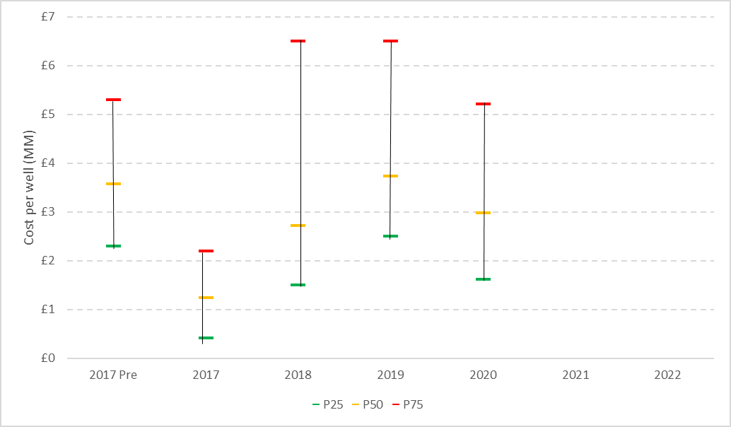

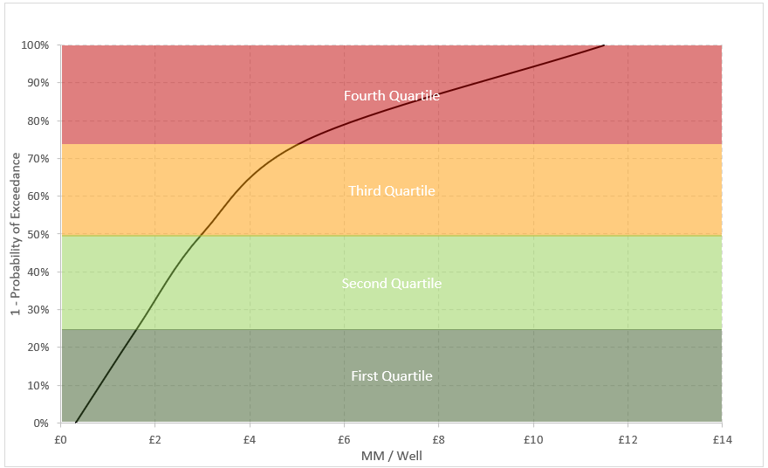

**Jack-up rigs in the NNS & CNS**

Metric remains largely unchanged from prior year and flat over full reporting period.

Sample Size: 31-40

**Figure 11: Platform well decommissioning cost distribution using jack-up rigs: NNS & CNS**

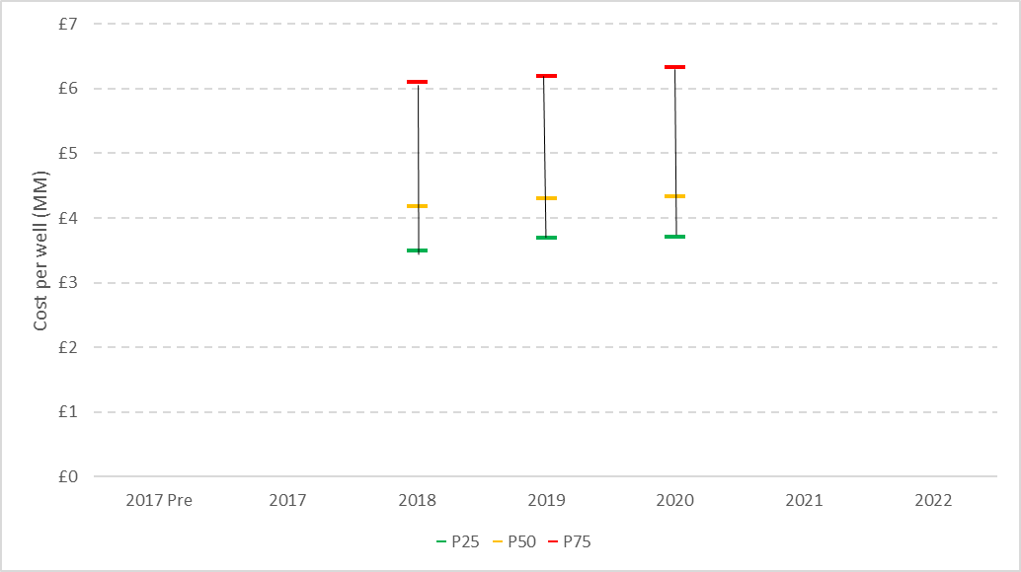

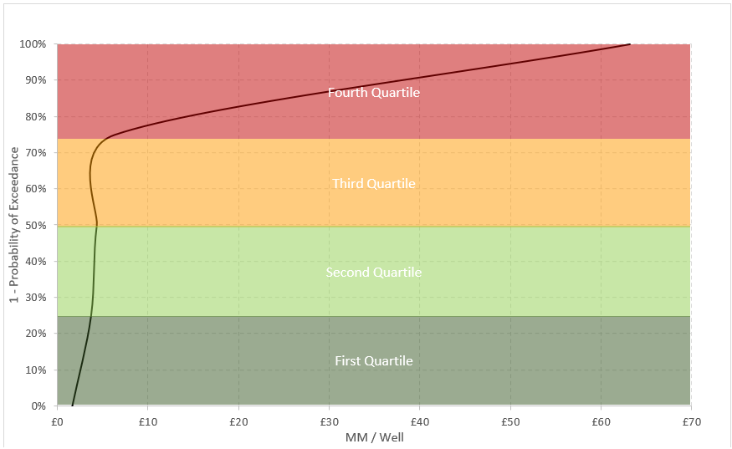

**Platform rig reactivation costs: NNS & CNS**

Range of cost performance influenced by a range of factors, including direct rig scope (e.g rig condition and time within cold stack) and indirect platform scope (e.g. ancillary/supporting services).

Sample Size: 5-10

**Figure 12: Platform rig reactivation cost distribution NNS & CNS**

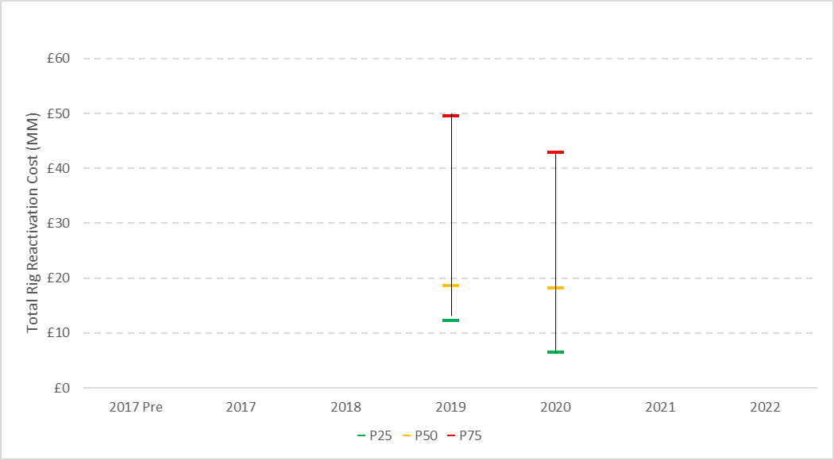

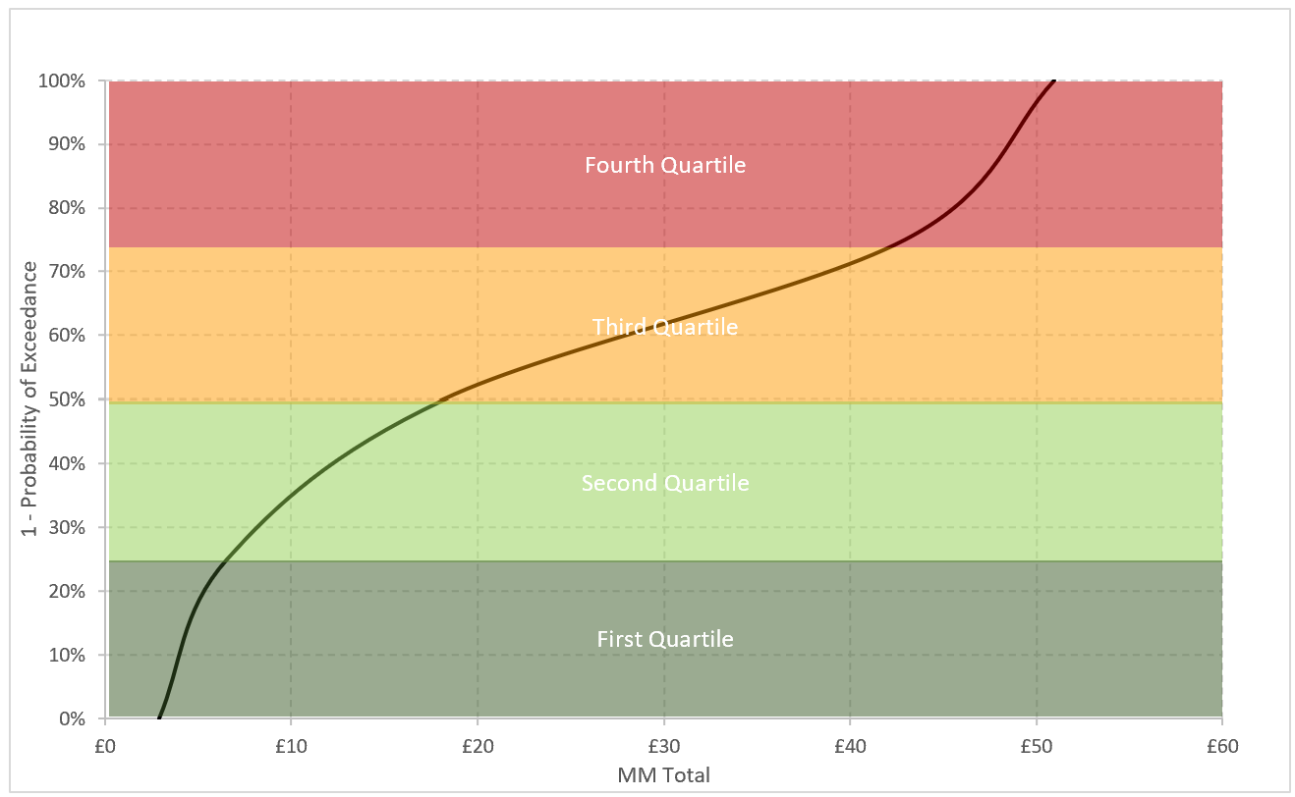

**SNS**

Metric reflects an increase in costs, in part attributable to decommissioning of technically unique wells plus delays incurred due to the Covid-19 pandemic.

Only a marginal reduction in this benchmark is observed when consideration of unique well design and hence requirement for non-traditional decommissioning is taken into account.

Given the increased prevalence of wells being re-used for CCS, the cost of well decommissioning to a CCS standard will become a contributory factor. As of 2020 the impact on the benchmark data is not yet evident.

Sample Size: >50

**Figure 13: Platform well decommissioning cost distribution: SNS**

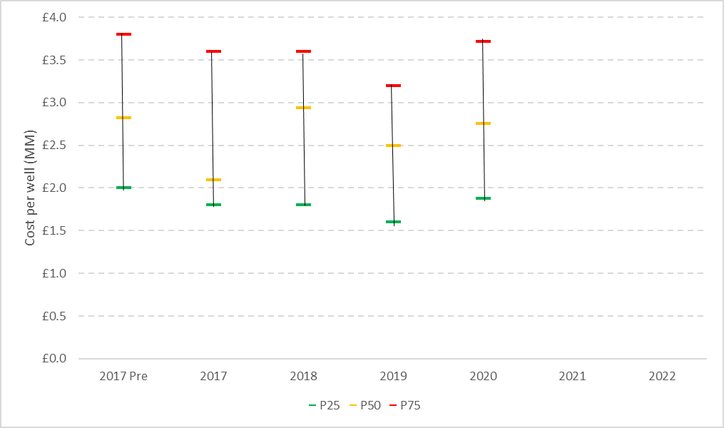 

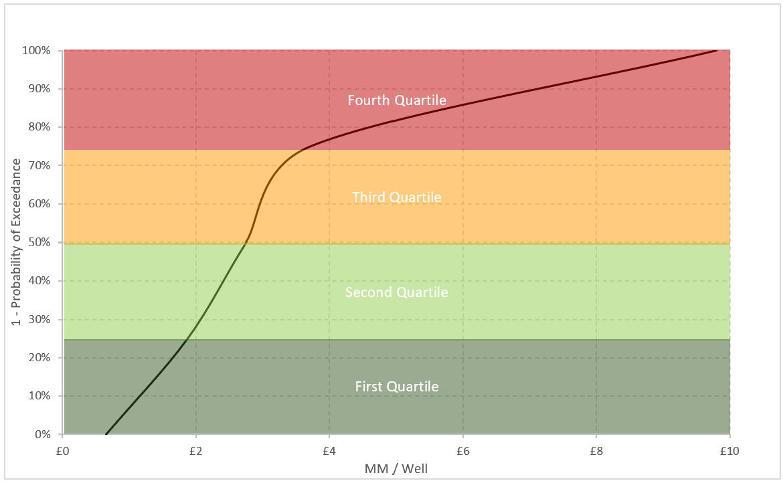

# Subsea development well decommissioning costs

**NNS & CNS**

Cost uncertainty remains relatively neutral over reporting period.

Sample Size: >50

**Figure 14: Subsea development well decommissioning cost distribution: NNS & CNS**

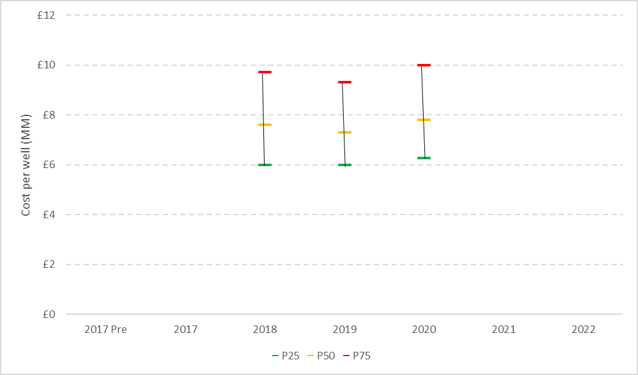 

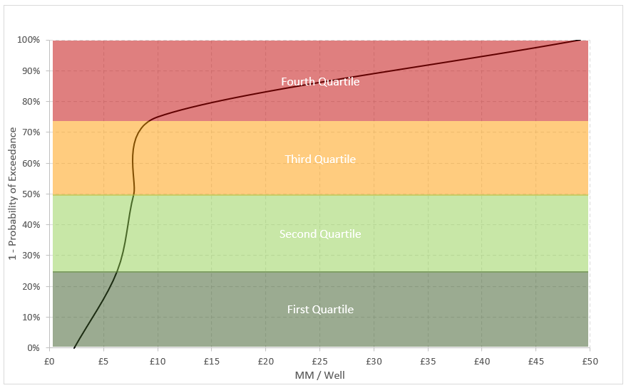

**SNS**

Sample Size: 21-30

**Figure 15: Subsea development well decommissioning cost distribution: SNS**

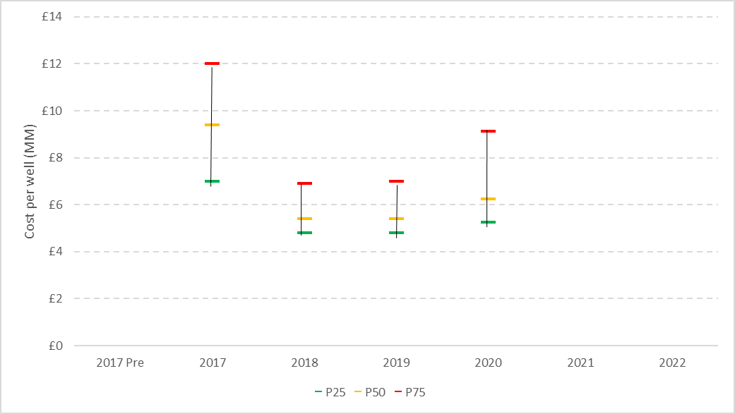 

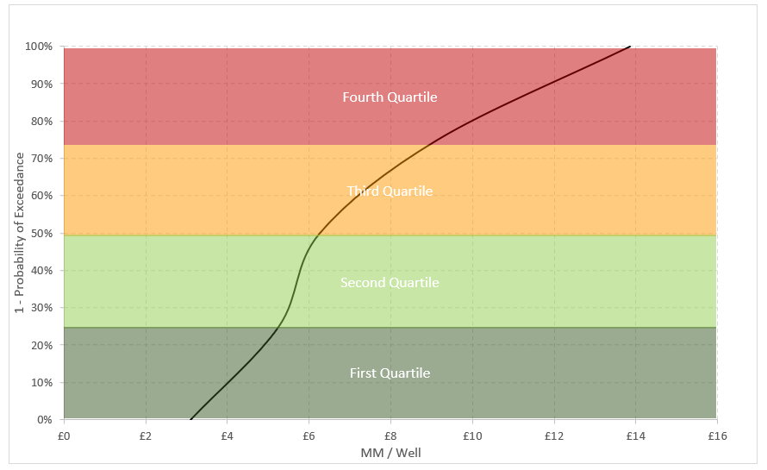

5.4 Subsea Exploration and Appraisal (E&A) well decommissioning costs

Suspended E&A wells typically have lower decommissioning costs than subsea producers and injectors, due to the absence of completion tubing and/or a simplified casing scheme. Cost data for these wells are therefore analysed separately from development wells.

The costs reflected here represent the full decommissioning of a well i.e. ‘Type 0’ wells which have negligible remaining scopes are not included.

An increased focus on decommissioning of suspended E&A wells in line with the OGA suspended inactive well guidance[7] has been initiated. In support of this, adoption of campaigns is actively encouraged and promoted as a vehicle for driving cost efficient outcomes and performance improvement.

**NNS & CNS**

Sample Size: 11-20

**Figure 16: Subsea E&A well decommissioning cost distribution: NNS & CNS**

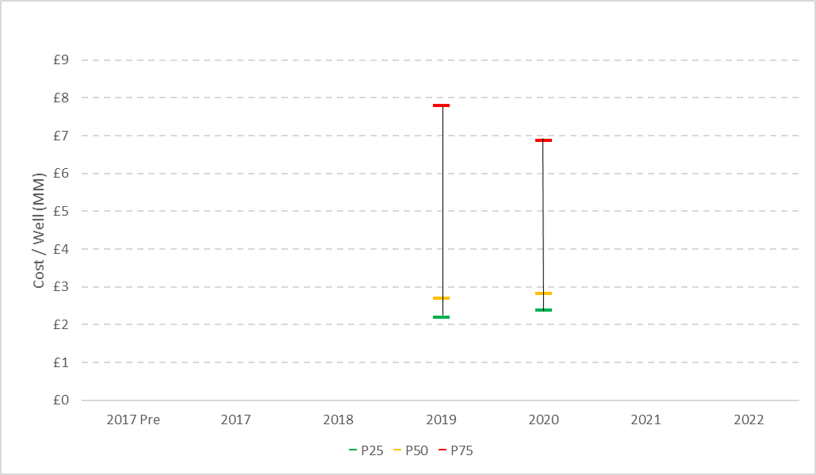 

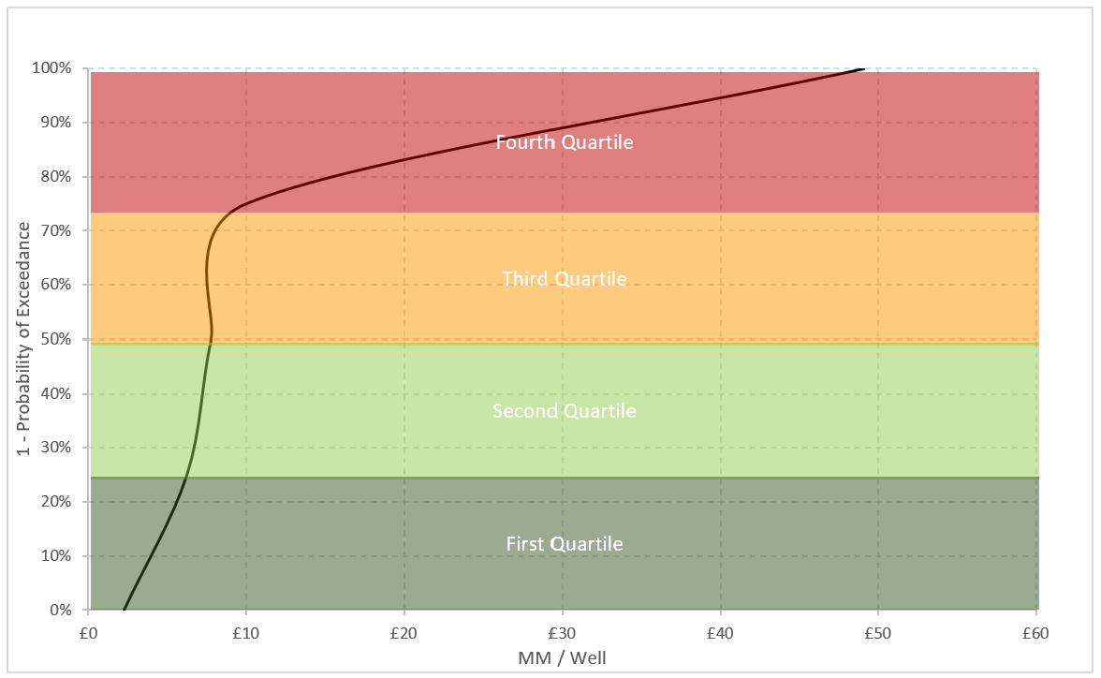

**SNS & EIS**

Sample Size: 5-10

**Figure 17: Subsea E&A well decommissioning cost distribution: SNS & EIS**

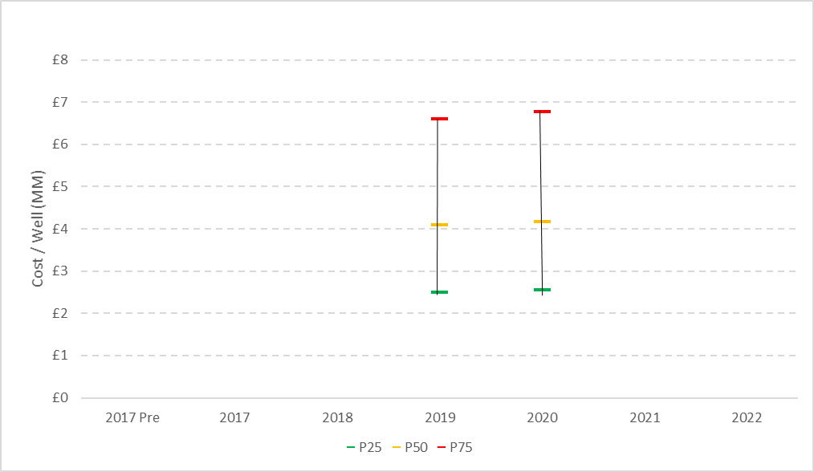 

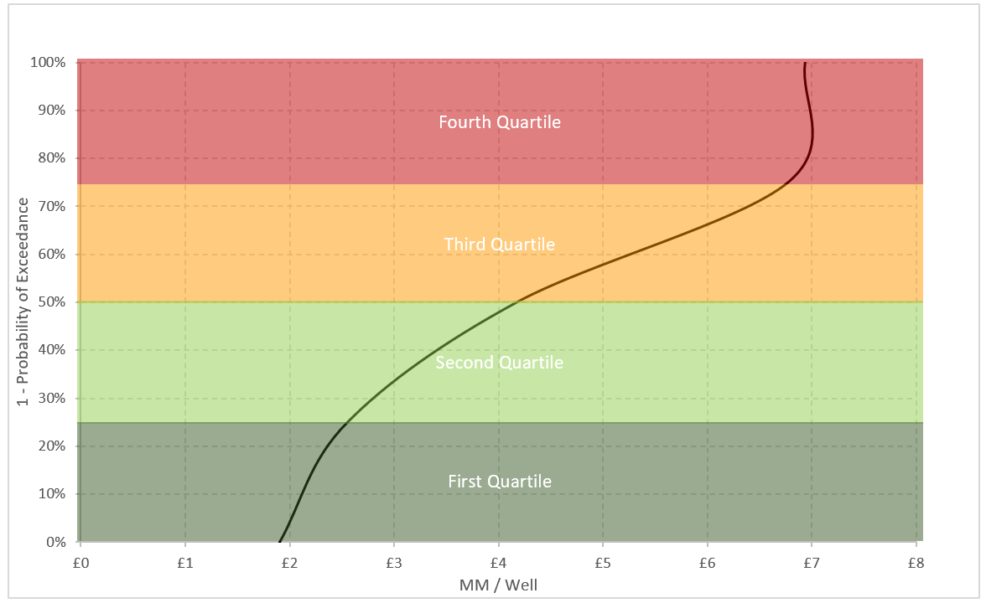

5.5 Well Decommissioning (days)

New metric.

Sample size: per table

**Figure 18: Well decommissioning (days to complete P&A – all well categories)**



*where no. of days data is available

# FPSO removal (incl. disconnection and tow)

6.1 NNS & CNS

A material change in the metric is reported (~25% reduction in P50 relative to prior years metric), however this change is influenced by the small sample size and infrequent nature of the activity across UKCS. Cost is influenced by a number of factors including scope e.g. removal of stabilisation features (mattresses); mooring recovery and transfer of FPSO ownership (where appropriate).

Sample Size: 5-10

**Figure 19: FPSO disconnection and tow**

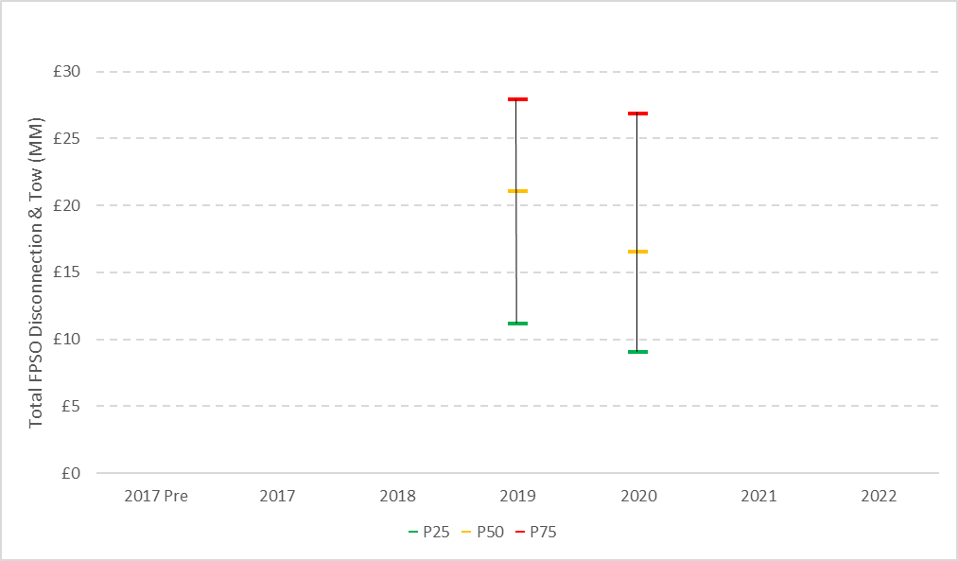 

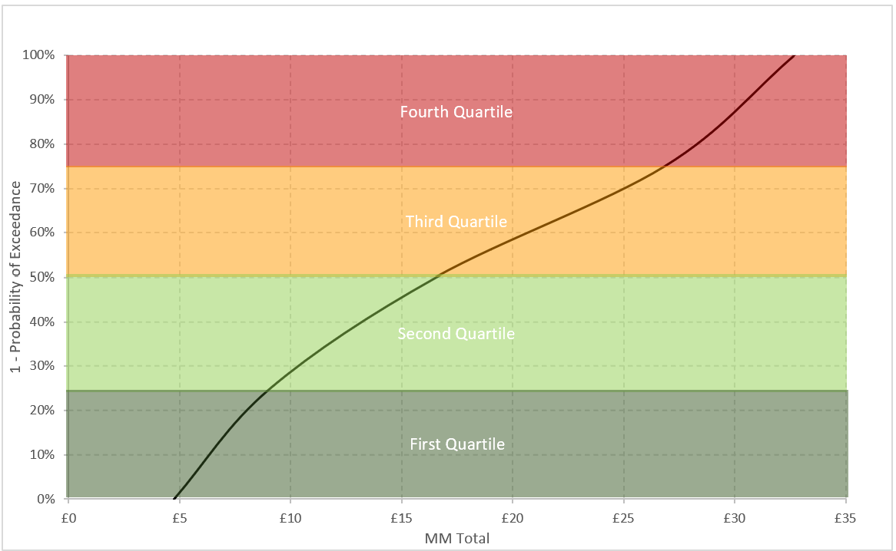

# Appendices

# Appendix 1: Benchmark representation of cost performance and uncertainty

Cost information is collected from all UK decommissioning operators. Comparable data, such as costs of decommissioning platform wells in the Southern North Sea, is screened against a data quality rule-set (see Appendix 2), sorted from large to small, and then graphed as in Figure A.1 to characterise the cost variances experienced for that parameter.

Figure A.1 illustrates the definition of several key benchmarking terms used. In the generic example:

* **the highest 25% of activity unit costs** were executed for between £20 - £45. Unit costs in this range are referred to as being in the **Fourth Quartile**
* **the second highest 25% of activity unit costs** were executed for between £15 - £20. Unit costs in this range are referred to as being in the **Third Quartile**
* **the second lowest 25% of activity unit costs** were executed for between £11 - £15. Unit costs in this range are referred to as being in the **Second Quartile**
* **the lowest 25% of activity unit costs** were executed for between £5 - £11. Unit costs in this range are referred to as being in the **First (or ‘Top’) Quartile**

The terms P25, P50 and P75 refer to the unit cost values below which 25%, 50% and 75% of these activities are executed. The simple relation between these values and the quartiles are illustrated in the figure.

**Figure A.1: Example ‘s-curve’ to illustrate definitions of quartiles and P-values**

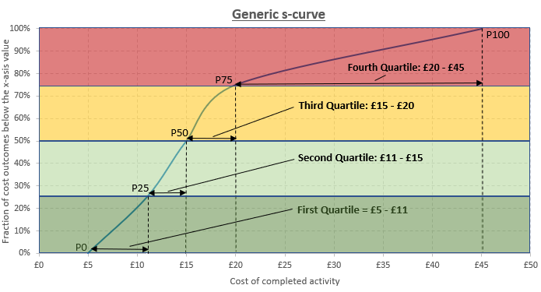

Other graphs types utilised in this report to illustrate the cost performance data are:

Cost trend graphs (see Figure A.2 exemplar): The graphic illustrates cost and cost uncertainty trends, and includes examples of the types of insights which can be derived.

**Figure A.2: Example of unit cost trend graphic**

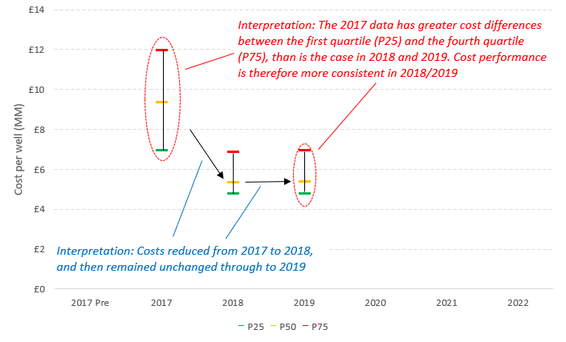

# Appendix 2: Data screening rule-set

A simple rule-set is utilised when selecting data for inclusion in the benchmark calculation and resulting metrics. The main purposes of the rule-set are to ensure that:

1. data is sufficiently current to be relevant
2. there are sufficient data points to create a meaningful s-curve
3. high certainty is achieved for the few benchmark categories1 which are not completely based on historic-costs/actuals or fixed-price contracts

The rule-set as of Quarter 2 2021 is detailed below:



1. All costs are in £2020 unless otherwise stated
2. OGA Cost report 2021 <<https://www.ogauthority.co.uk/news-publications/publications/2021/ukcs-decommissioning-cost-estimate-2021/>>
3. OGUK Work Breakdown Structure Guidelines October 2019
4. Cold Phase is defined as when “Hazards from process hydrocarbons are not present. Sources of process hydrocarbons are isolated and air/water-gapped”
5. Data as of October 2021
6. <<https://www.ogauthority.co.uk/data-centre/interactive-maps-and-tools/>>
7. Guidance for applications for suspension of inactive wells