Field Consents  System | User Guidance

Contents
System description 3
Navigation within the UK Energy Portal 4
Searching the Field consents System 6
Controlling access using Field Consents Teams and Contacts 7
Adding additional team members 8
Submitting a new Production Consent application 10
New Short term Production Consent 14
New Annual Production Consent 26
New Long Term Production Consent 37
Submitting a new Flaring Consent application 47
New Short Term Flare Consent 51
New Annual Flare Consent 66
New Long Term Flare Consent 79
Submitting a new Venting Consent application 89
New Short Term Vent Consent 93
New Annual Vent Consent 108
New Long Term Vent Consent 121
Acknowledging receipt of Consents and viewing notifications 130
Acknowledging receipt of a consent 130
Viewing Field Consent notifications 132
Revising an existing Field Consent 135
Withdrawing applications 138
Amending applications 139
Processing Payments 141
WorldPay Payments 142
BACS/CHAPS Payments 146

FIELD CONSENTS SYSTEM

System description

The Field consents system is a module delivered through the UK Energy Portal. The UK Energy Portal is accessed from this URL:
https://itportal.decc.gsi.gov.uk/eng/fox/live/PORTAL_LOGIN/login

To access the UK Energy Portal you will need to be a registered user. For further information on the UK Energy Portal and the services provided please see https://www.gov.uk/oil-and-gas-uk-oil-portal
The field consents system allows operators to apply for, and manage, consents to Flare and Vent gas from UKCS fields and consent to produce hydrocarbons.
The regulatory regime is designed to maximise the recovery of Oil and Gas from UK fields and reduce the amount of Gas released to, or burnt off in the atmosphere
The operators submit an application to the department. The application, once received, is assigned an internal reference and then sent by The Consent Team to specialists (petroleum engineers, reservoir engineers, facilities engineers etc.) who review the application to ensure it meets OGA guidelines.
The specialists will either approve the application or reject it. If the application is approved the application is sent to an OGA Authorising Manager who will prepare .pdf documents, digitally sign them and send the consent documents back to the operator and other companies who may have an interest in the field for which the application relates. If the application is rejected it is sent back to the operator together with a note as to why the application has been rejected. Once the operator has made changes they are able to re- submit the applications to the OGA and the review process can start again.
Flaring and Venting consents usually cover one calendar year, running from 1st Jan to 31st Dec. Production consents can cover longer periods.
Short term consents for Flaring, Venting and Production are also available.

If an operator needs to revise the volumes only in an already authorised consent (I.E. no changes to dates) they must revise the consent. Otherwise a new consent application must be submitted.

Navigation within the UK Energy Portal

PLEASE DO NOT USE THE BROWSER BACK OR FORWARD BUTTONS WHEN NAVIGATING THROUGH AREAS OF THE PORTAL.
Navigation with the UK Energy Portal is achieved by clicking on links within each application area. The Portal uses on screen forms to record information relating to the operators submissions. Using the browser back and forward buttons will cause the data forms to fail and cause errors when completing applications.
The Application Left hand links allow the Operator to navigate through the different pages within an application
The Form navigation links allow the Operator to move sequentially through the application by using the Next and Previous page links, opt to save the application and resume at a later time, save and go back to their workbasket or save and log out from the Portal
Action links perform actions within the screen displayed.

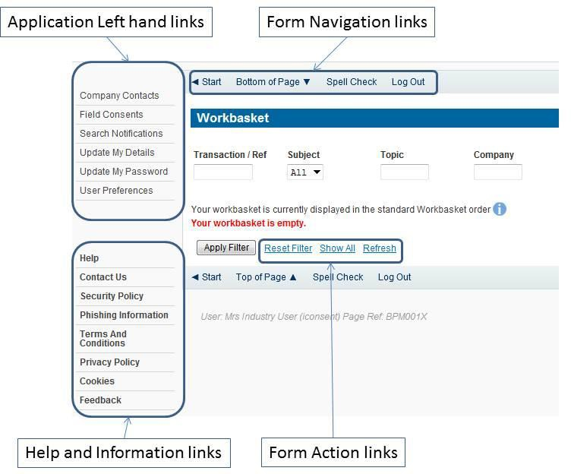

When using the Energy Portal you will frequently see this information icon displayed at various positions on the screen. If you click on this, information relating to your current activity and business context will be displayed which will help clarify what you need to do.
When you submit applications or notifications to the OGA the data you have entered is validated. If errors or problems are discovered your screen will be displayed showing a cross
against the items found in error. To find out what is wrong hover with the cursor over the cross and a message box will be displayed giving details. Enter corrections and re-submit.
Alternatively the error message will be displayed in red against the data in error.

Some submissions to the OGA are complex and long and may need to be ASSEMBLED on the Portal over a period of days. You may save your data entry session and resume this at a later stage. Another registered user in your organisation may also resume your session provided they have the appropriate access rights.
Every effort has been made to protect your data and ensure that it is not lost in the event that your pc, browser on local network fails. We aim to save all of your work each time your Portal page refreshes.

Searching the Field consents System
The Operator must log in to the UK Energy Portal at this URL: https://itportal.decc.gov.uk/eng/fox/live/PORTAL_LOGIN/login
After logging in the Operator will be taken to their Portal Workbasket. The workbasket will contain all notifications and actions for transactions made using the UK Energy Portal.
From the workbasket click on ‘Field Consents’ from the left hand menu This takes the operator into the Field Consents system search screen.
This screen allows users to search existing Field Consent applications for which they have access, such that they may be viewed or revised. Applications which are currently being processed by the OGA cannot be revised until the consent has been granted. If you have submitted an application in error and you wish to update it and resubmit then you need to contact the appropriate Aberdeen or London office using the contacts given on the application entry screen.
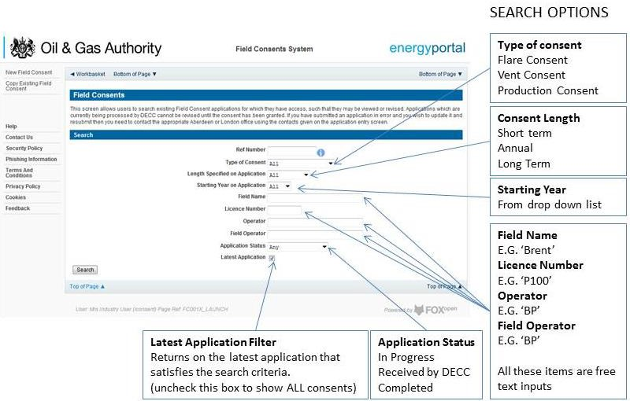

Controlling access using Field Consents Teams and Contacts

Access to the field consent application is controlled using a team of Organisation contacts. By default the person creating the consent application is enrolled in the team and has all available roles granted to them.

IT IS STRONGLY RECOMMENDED THAT MORE THAN ONE PERSON IS ENROLLED IN THE CONSENTS TEAMS TO AVOID DELAYS IN THE SUBMISSION AND APPROVAL PROCESS.
To manage team membership you must have the Team Coordinator roll granted. To add or remove team members for an application click on the ‘Current Contacts’ on the left hand menu
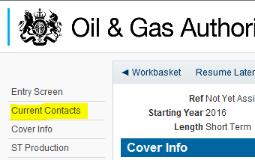

This will show the current team who are involved with the management of the consent and show their allocated roles

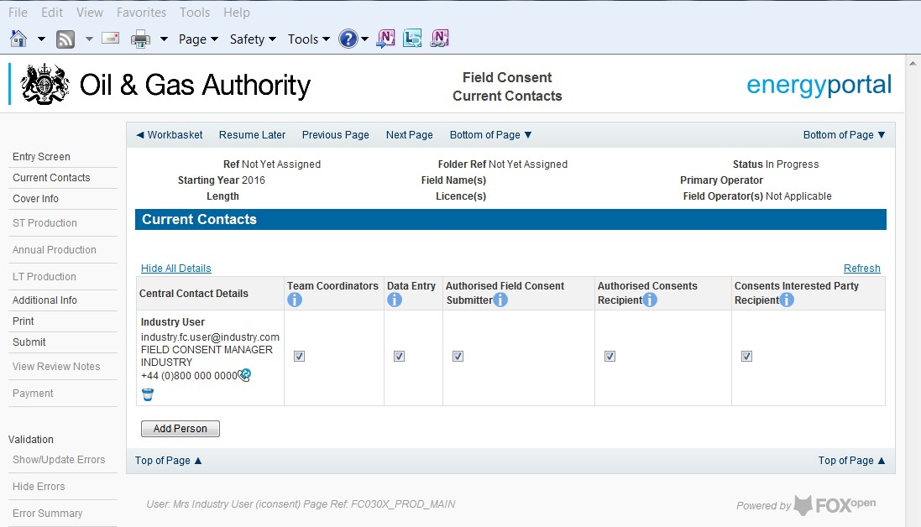

The roles available to team members are:

Team Coordinators – People with this role are able to change members who are added or removed from this team and can manage and allocate the different roles for each team member
Data Entry - Users listed here are allowed to start Revision or Update Applications for this Field Consent. They may also enter or correct data on started Field Consent Applications that have not yet been submitted to the OGA. They can view previous Consents and previous Applications relating to this Field Consent. You must nominate at least ONE Data Entry User.
Authorised Field Consent Submitter - Users listed here are required to check Applications relating to this Field Consent and are authorised to submit it to the OGA on behalf of the owner organisation. They are allowed to start Revision or Update Applications. They may also enter or correct data on started Field Consent Applications that have not yet been submitted to the OGA. They can also view previous applications relating to this Field Consent. You must nominate at least ONE Authorised Field Consent Submitter.
Authorised Consents Recipient - Users listed here will receive the Consents resulting from Applications for this Field Consent. The Consents are issued to the organisation and are subject to appropriate legislation. Thus users listed here must be authorised to receive these documents on behalf of the above organisation and know what to do with them.
Users here can view previous Consents and also view previous Field Consent Applications. You must nominate at least ONE Authorised Consents Recipient.
Consents Interested Party Recipient - Users listed here will receive a copy of the Consents resulting from Applications for this Field Consent for information only purposes. They may not work on the Field Consent directly. This list is purely for your convenience to let other users see the notifications. Information only Consent recipients do not have to be entered.

Adding additional team members
To add another member to the team click on the add person button at the bottom of the list of current contacts
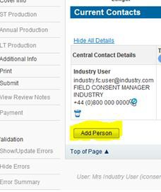

The operator must supply the contact details for the person they wish to add to the team. Mandatory information that needs to be supplied is marked with *
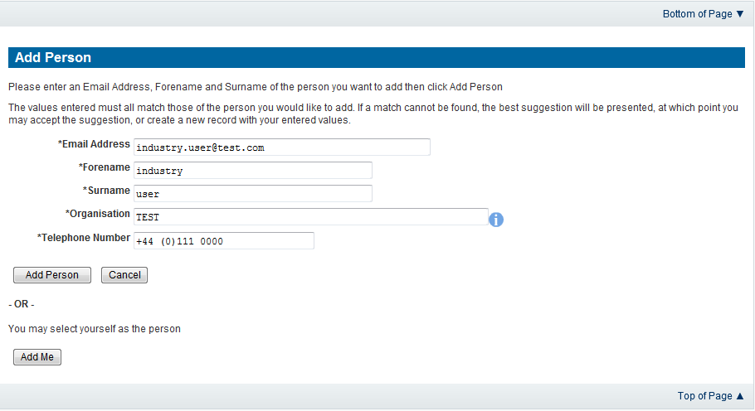

Once the information has been entered click on the ‘Add Person’ button to add them to the team.
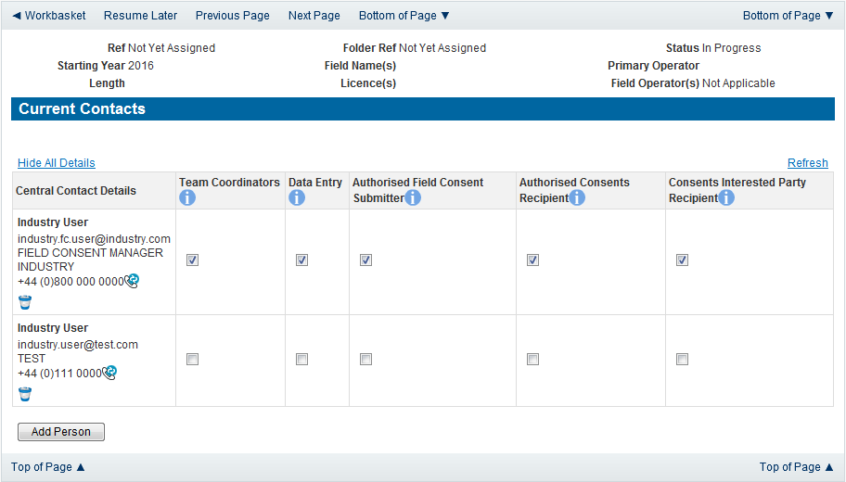

Allocate the roles for the new team member by checking the boxes beneath the relevant roles. Click on the ‘Add Person’ button to add further people to the team. To remove a
member from the team please uncheck all the roles allocated to the user and save the team by clicking on ‘save changes’

Submitting a new Production Consent application
New Production Consents consent can be submitted for UK Fields on a short term, Annual or long term basis
The Operator must log in to the UK Energy Portal at this URL: https://itportal.decc.gov.uk/eng/fox/live/PORTAL_LOGIN/login
After logging in the Operator will be taken to their Portal Workbasket. The workbasket will contain all notifications and actions for transactions made using the UK Energy Portal.
From the workbasket click on ‘Field Consents’ from the left hand menu

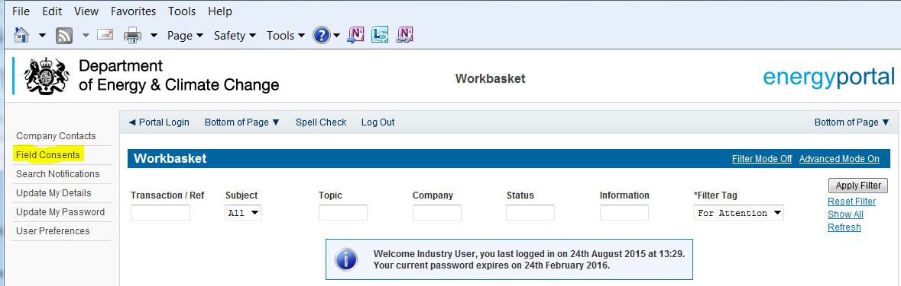

This takes the operator into the Field Consents System search screen.

From the search screen you are able to search for all field consents which have been submitted on behalf of the operators company. The Operator is able to set various search option parameters before requesting the results.
To begin a new consent application click on ‘New Field Consent from the left hand menu from the Field Consents System search screen.

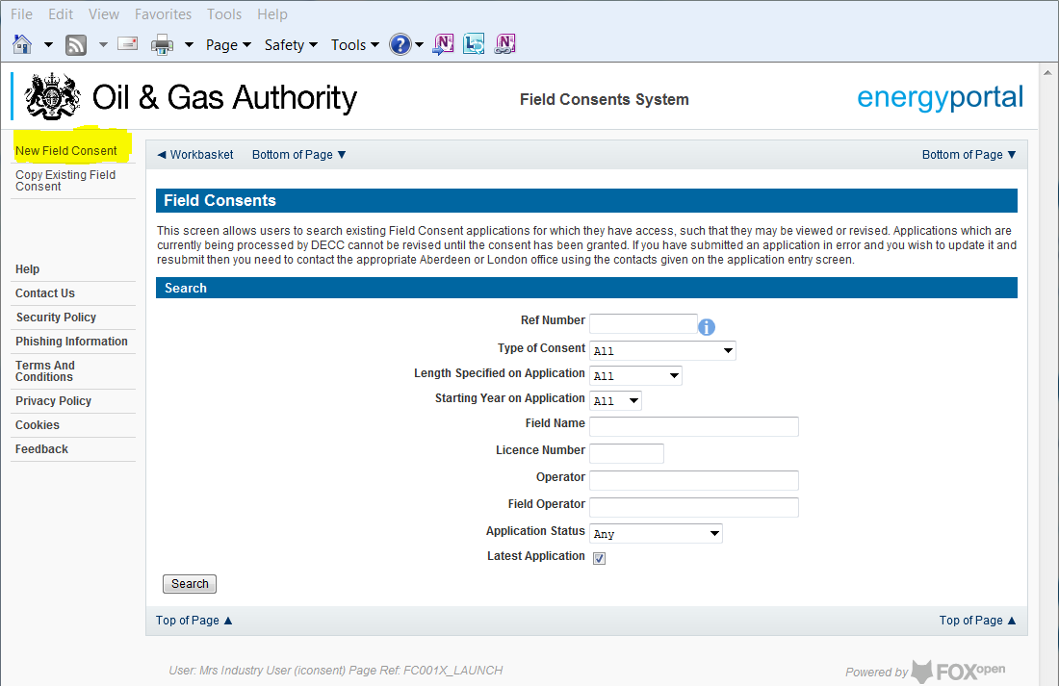

From the New Field Consent screen select the year for the start of the consent period from the drop down list. Select the type of consent, Production, from the drop down list. Click on ‘Create’ to generate a new blank Production Consent.
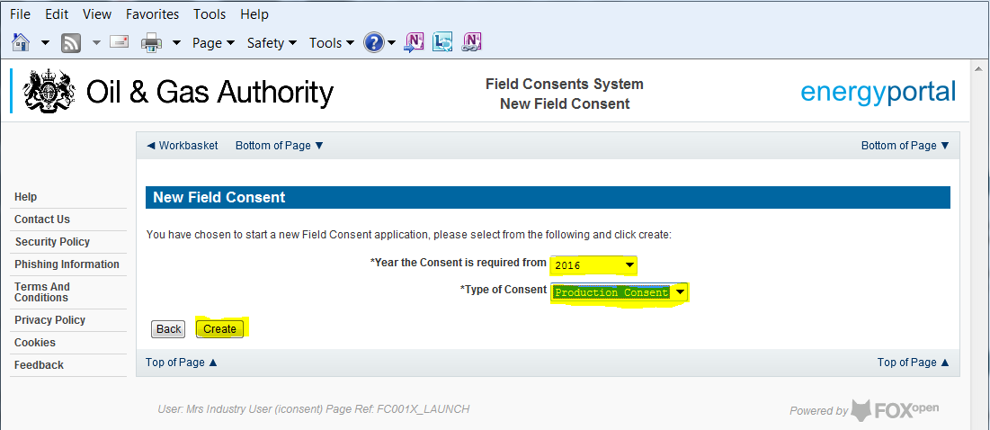
This will have created a new Production Consent application which needs to be populated with the required data. The new application will open on the Entry Screen which gives the Operator a list of OGA contacts and links to guidance on completing flaring, venting and production consent application.

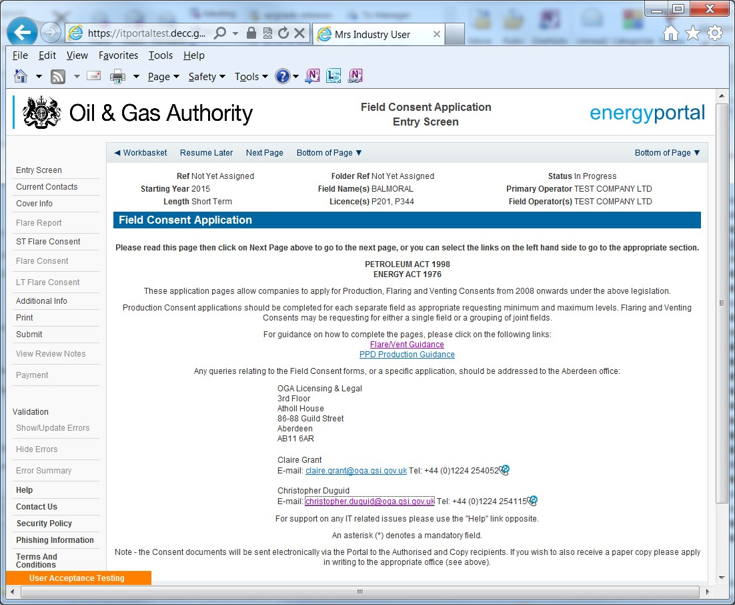

Use the navigation bar at the top of the form to navigate to the next page to display the Operators team of people who will be involved in the preparation and submission of this application. By default the person creating the application is enrolled in the team with all available roles

IT IS STRONGLY RECOMMENDED THAT MORE THAN ONE PERSON IS ENROLLED IN THE CONSENTS TEAMS TO AVOID DELAYS IN THE SUBMISSION AND APPROVAL PROCESS.
Please see the section “Controlling Access using Field Consents Teams and Contacts”

Click the ‘Next page’ link to proceed with the application.

On the next screen, Cover Info, the operator will define the length of time for which the Production Consent is being applied. There are three terms for which a Production Consent requested: Short Term, Annual, and Long term.
The process differs slightly in the data required for each type of consent length.

New Short term Production Consent
The Cover Info page is where the Operator is able to define the Field(s) and duration for the consent being applied for.
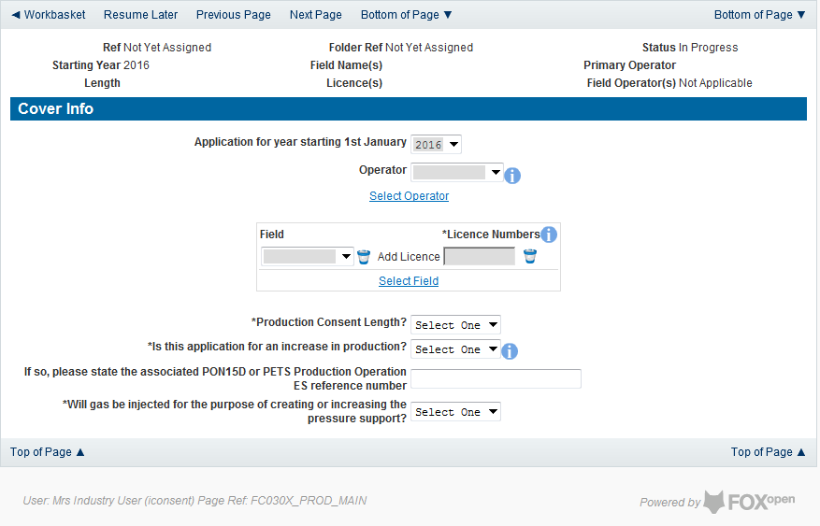
The Operator is chosen by searching for the operators name from the approved list of Operators registered with the UK Energy Portal. To use the search facility click on the select Operator link on the screen:
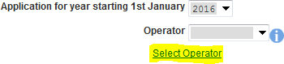

This will open the Organisation Directory Search Screen

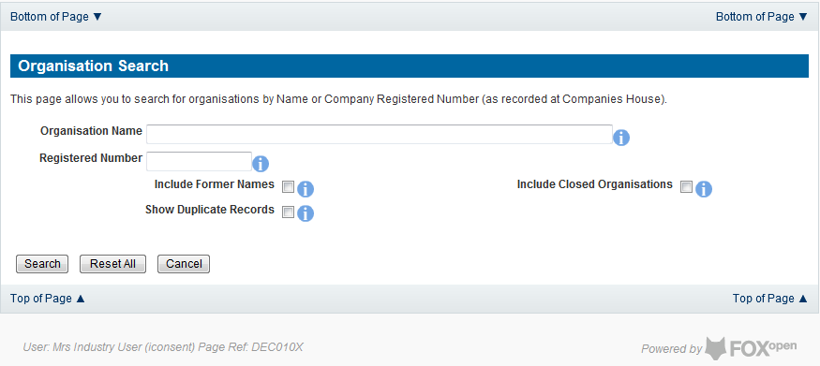

Enter the name (or the beginning letters) of the name of the Operator Responsible for the Field for which the consent is being prepared. E.G. Entering ‘tes’ as the organisation and clicking on ‘Search’ will return search results of TESSENDERLO UK LIMITED and TEST COMPANY LTD. Click on the ‘Select’ link to inset the Organisation into the application.
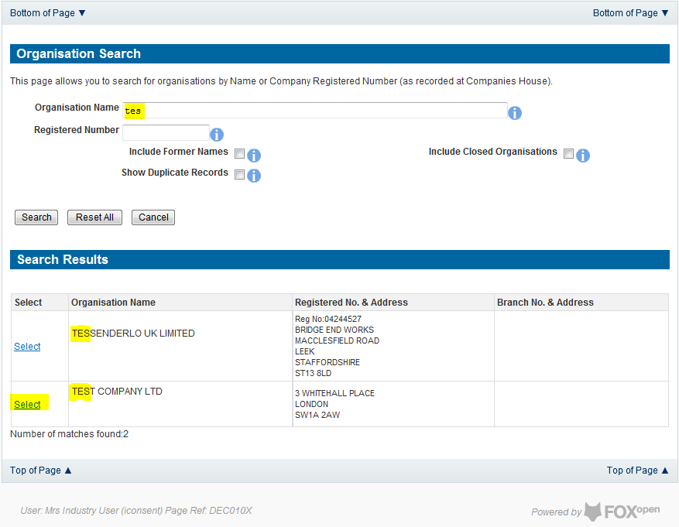
Add the field for which the production consent is being prepared. To add the field click on the ‘Select Field’ link on the screen.

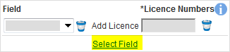

This will open the DEVUK Field Search Screen
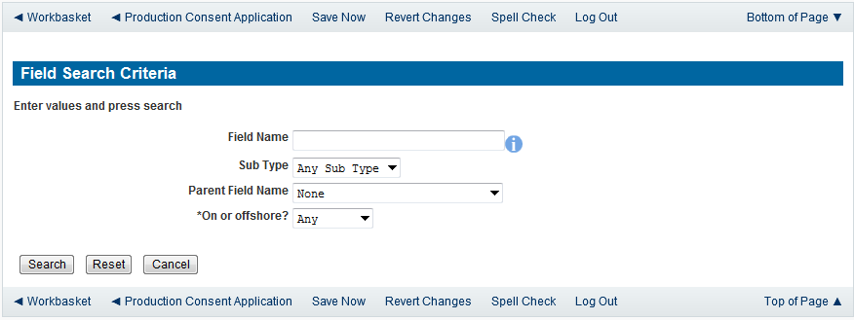
Enter the name (or the beginning letters) of the name of the Field name for which the consent is being prepared. E.G. Entering ‘bren’ as the Field Name and clicking on ‘Search’ will return search results of BRENDA and BRENT. Click on the ‘Select’ link to the right of the correct Field Name to inset the Field into the application
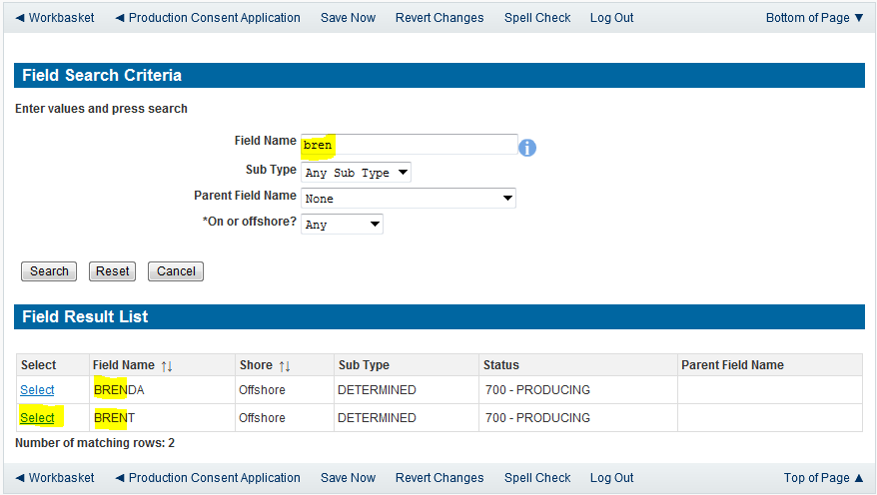
The Licence Number(s) associated with the Field are automatically entered into the application.

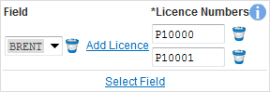

To add further Fields into the application click the ‘Select Field link and repeat the process. Any additional fields added to the application will also add any further associated Licences to the application.
Select the Production consent Length as ‘Short Term’ from the drop down menu and this will display information that will be generated when production data is entered later in the application process.
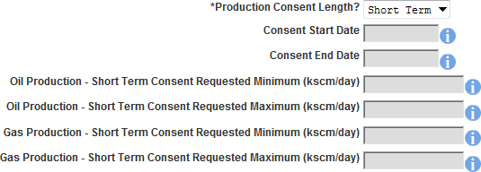

The operator must indicate if the Production Consent application is due to an increase in production. If the answer to this question is ‘Yes’ the P.E.T.S. reference for the environmental permit for this field should be entered

The last item to enter on this screen is the indication as to whether the Gas is being injected to help maintain reservoir pressure. Select ‘Yes’ or ‘No’ from the drop down menu.

The screen should now be completely populated. Click on ‘Next Page’ on the navigation bar to continue the application process.

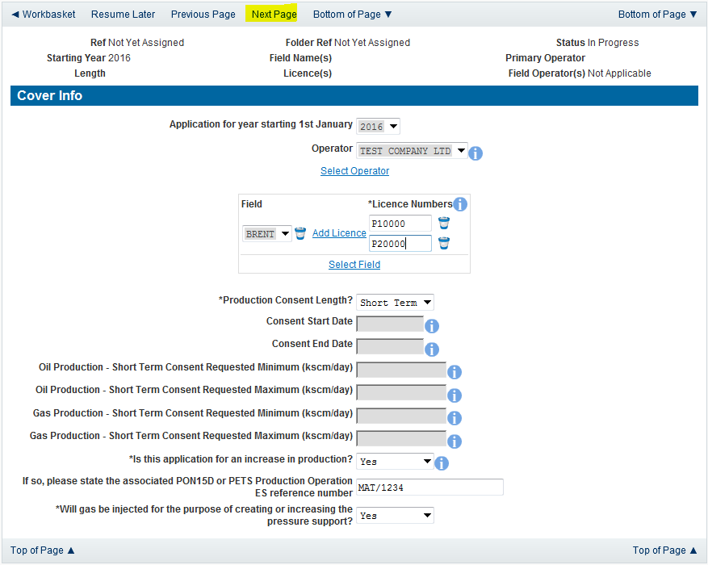

The next screen is the Short Term Production Request screen where the Short Term Consent period is created.
Enter the dates for which the consent is due to start and end by using the calendar widget or manually entering the dates, then clicking on the ‘Initialise Term’ button
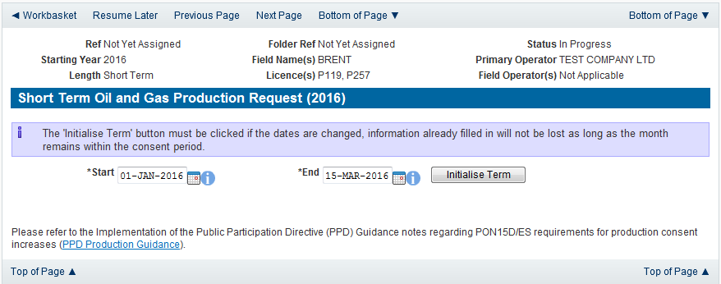

Once the Initialise term button has been pushed the screen will display the areas where the Operators requested production allowances are recorded. For each period on the screen the Operator must enter the Minimum and Maximum Gas and Oil production figures
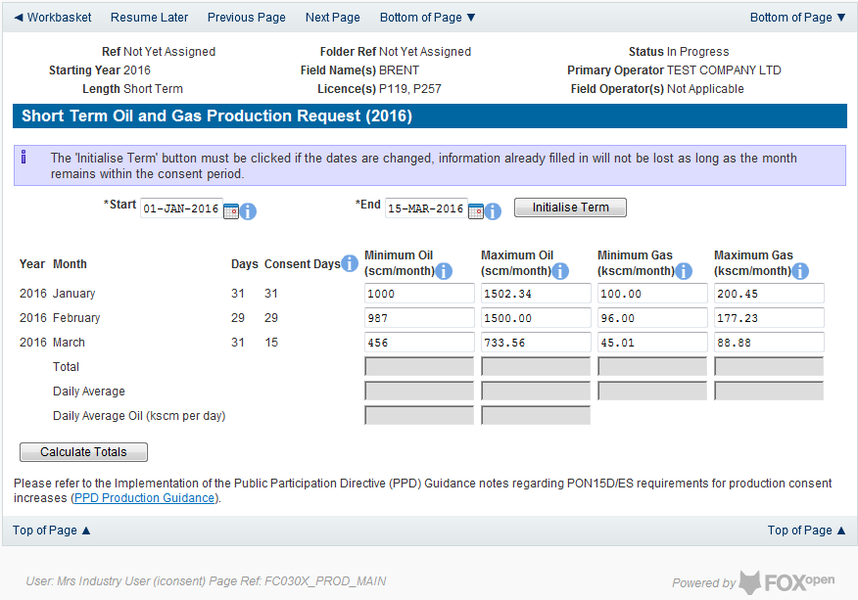
Once figures have been entered click on the ‘Calculate Totals’ button to populate the total and Average figures on the screen.

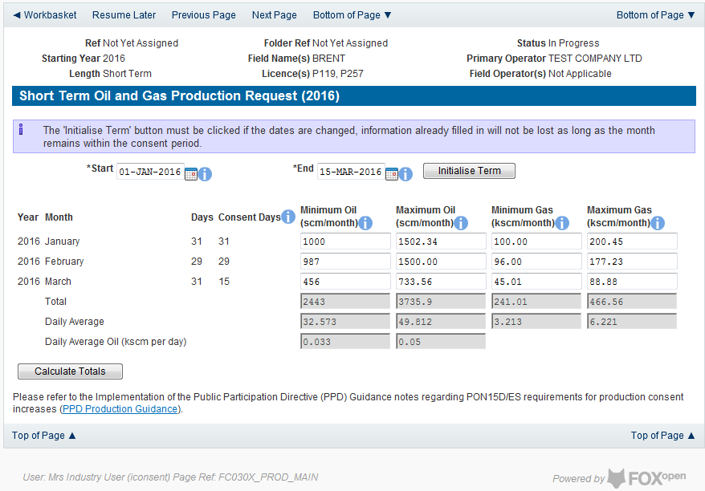

Clicking the ‘Calculate Totals button will also populate the requested Oil and Gas Production figures on the Cover Info screen
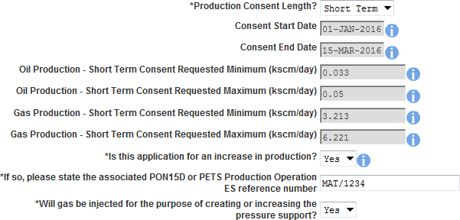

Click on ‘Next Page’ on the navigation bar to move to the next screen, ‘Additional Info’.

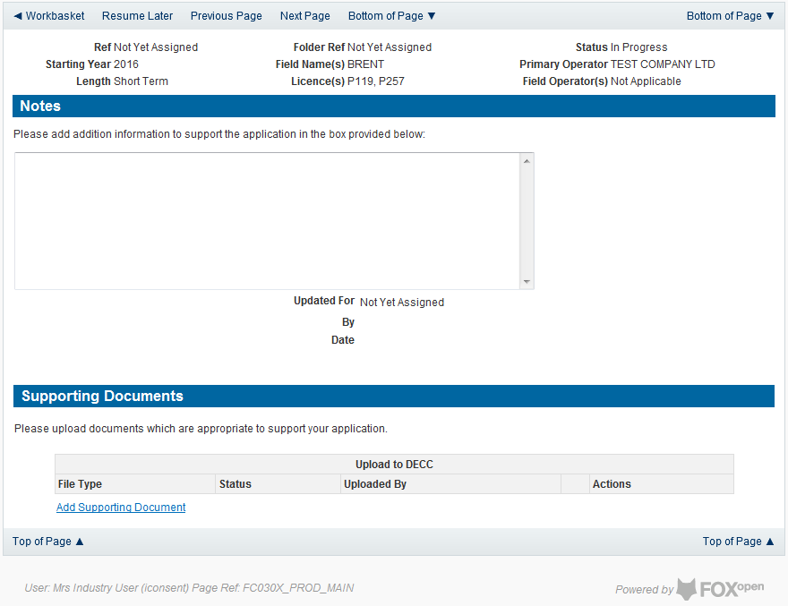

Additional notes can be added in the notes box using free text. These notes are automatically saved when the Operator navigates away from the page.
Supporting documentation can also be uploaded by clicking on the ‘Add Supporting Document’ Link on this page

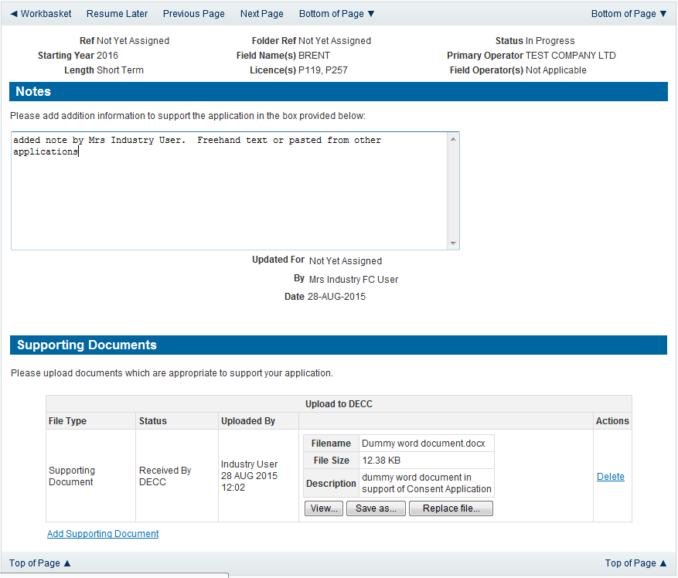

Click on ‘Next Page’ on the navigation bar to move to the next screen.

The Print Selection Screen allows the Operator to generate and print .pdf versions of the Production Consent application. Check the boxes for the areas of the application you wish to create or click the ‘Select all’ link to choose all parts of the application. Click on the
‘Generate Document’ button to produce the .pdf version of the Consent application. A copy will open in .pdf format in a new tab in the browser.

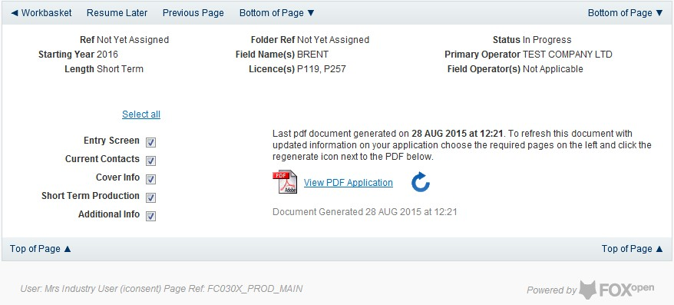

If the Consent application is ready to submit click on the submit button on the left hand menu to proceed to the next stage.
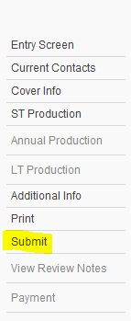

Once the ‘Submit’ button is pressed the Field Consents System will check all the entries made on the consent application. If any on the entries are invalid or missing they will be displayed in an error summary. Any error must be rectified before the application can be submitted.

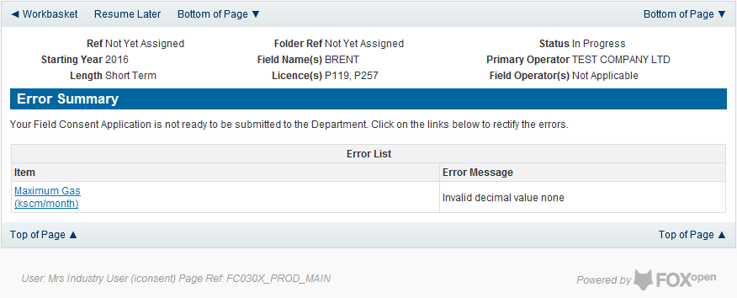

Click on the item on the errors list and you will be taken to the screen where the error is contained.

The error will be indicated by a red cross.

Hovering over the cross will give an indication of what has caused the entry to be invalid. Correct the error and click on the ‘Error Summary’ link on the left hand menu.
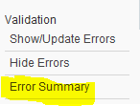

If there are still errors on the application they will still appear in the errors list. Repeat the process to view and correct all errors until all corrections have been made. The error summary will be empty.
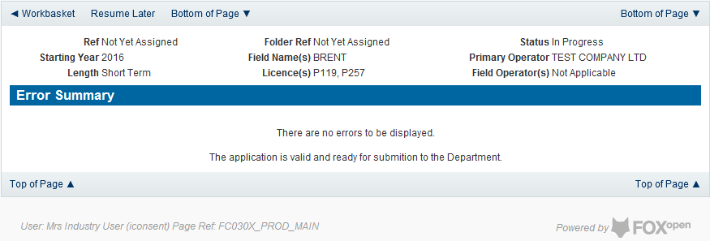
Click on the Submit link on the left hand menu to go to the submission screen

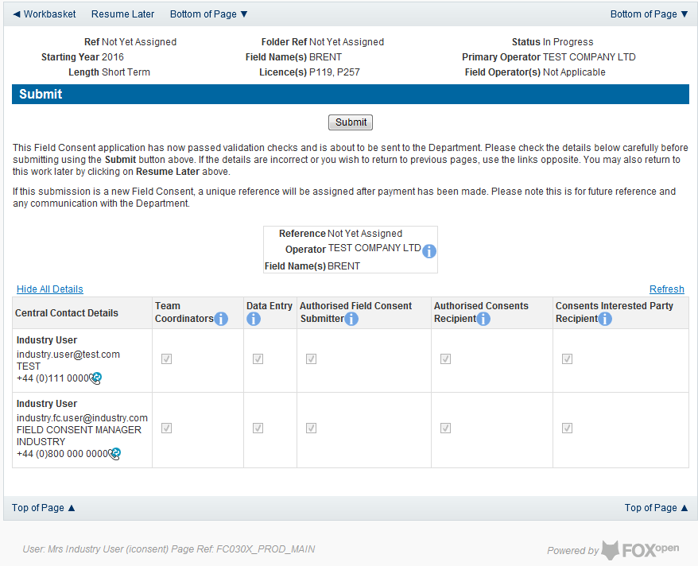

YOU MUST CLICK ON THE ‘SUBMIT’ BUTTON ON THIS PAGE TO PAY FOR THIS APPLICATION AND FINALISE THE SUBMISSION PROCESS
Clicking the ‘Submit’ button will send the application to the OGA Consents team and take the Operator to the payment screen. Details on how to make payments are contained in the in “Processing Payments” section later in this guide document.

New Annual Production Consent
The Cover Info page is where the Operator is able to define the Field(s) and duration for the consent being applied for.
The Operator is chosen by searching for the operators name from the approved list of Operators registered with the UK Energy Portal. To use the search facility click on the select Operator link on the screen:

This will open the Organisation Directory Search Screen

Enter the name (or the beginning letters) of the name of the Operator Responsible for the Field for which the consent is being prepared. E.G. Entering ‘tes’ as the organisation and clicking on ‘Search’ will return search results of TESSENDERLO UK LIMITED and TEST COMPANY LTD. Click on the ‘Select’ link to inset the Organisation into the application.
Add the field for which the production consent is being prepared. To add the field click on the ‘Select Field’ link on the screen.

This will open the DEVUK Field Search Screen
Enter the name (or the beginning letters) of the name of the Field name for which the consent is being prepared. E.G. Entering ‘bren’ as the Field Name and clicking on ‘Search’ will return search results of BRENDA and BRENT. Click on the ‘Select’ link to the right of the correct Field Name to inset the Field into the application
The Licence Number(s) associated with the Field are automatically entered into the application.

To add further Fields into the application click the ‘Select Field link and repeat the process. Any additional fields added to the application will also add any further associated Licences to the application.
Select the Production consent Length as ‘Annual’ from the drop down menu and this will display information that will be generated when production data is entered later in the application process.
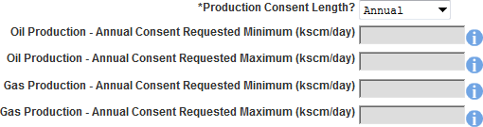

The operator must indicate if the Production Consent application is due to an increase in production. If the answer to this question is ‘Yes’ the P.E.T.S. reference for the environmental permit for this field should be entered

The last item to enter on this screen is the indication as to whether the Gas is being injected to help maintain reservoir pressure. Select ‘Yes’ or ‘No’ from the drop down menu.

The screen should now be completely populated. Click on ‘Next Page’ on the navigation bar to continue the application process.

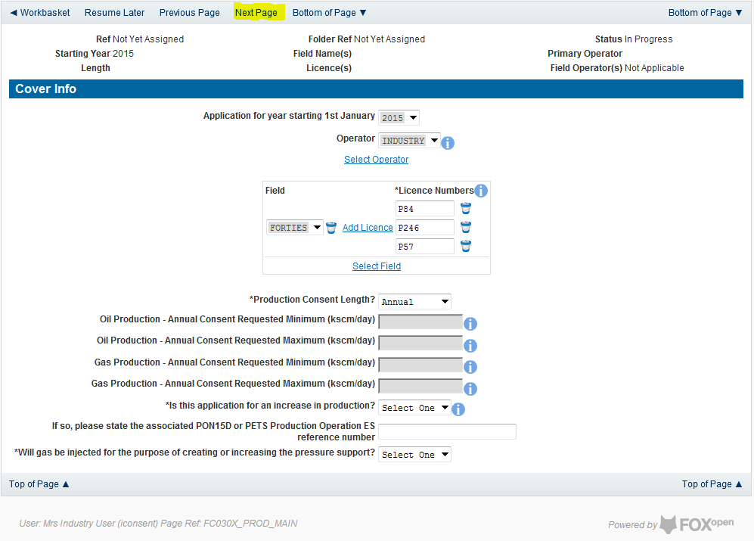

The next screen is the Annual Production Request screen where the Operator must sup the figures that they are requesting for the Annual Production Consent application

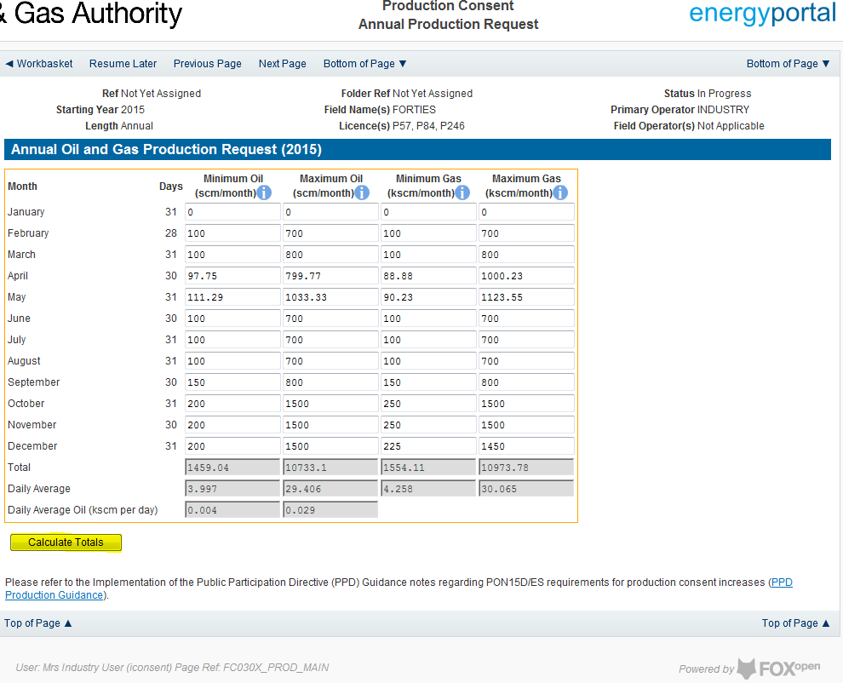

Clicking the ‘Calculate Totals button will also populate the requested Oil and Gas Production figures on the Cover Info screen
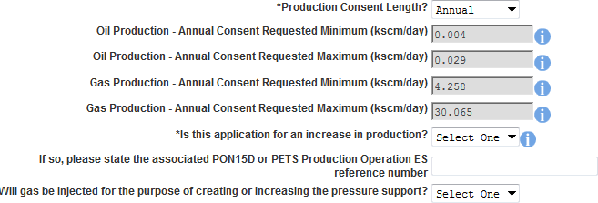

Click on ‘Next Page’ on the navigation bar to move to the next screen, ‘Additional Info’.

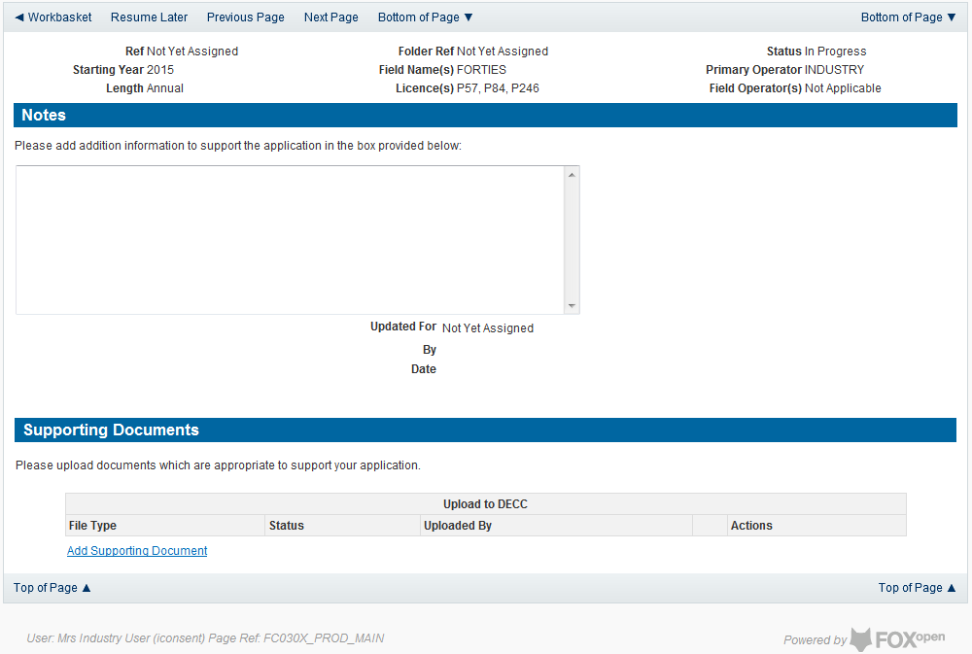

Additional notes can be added in the notes box using free text. These notes are automatically saved when the Operator navigates away from the page.
Supporting documentation can also be uploaded by clicking on the ‘Add Supporting Document’ Link on this page

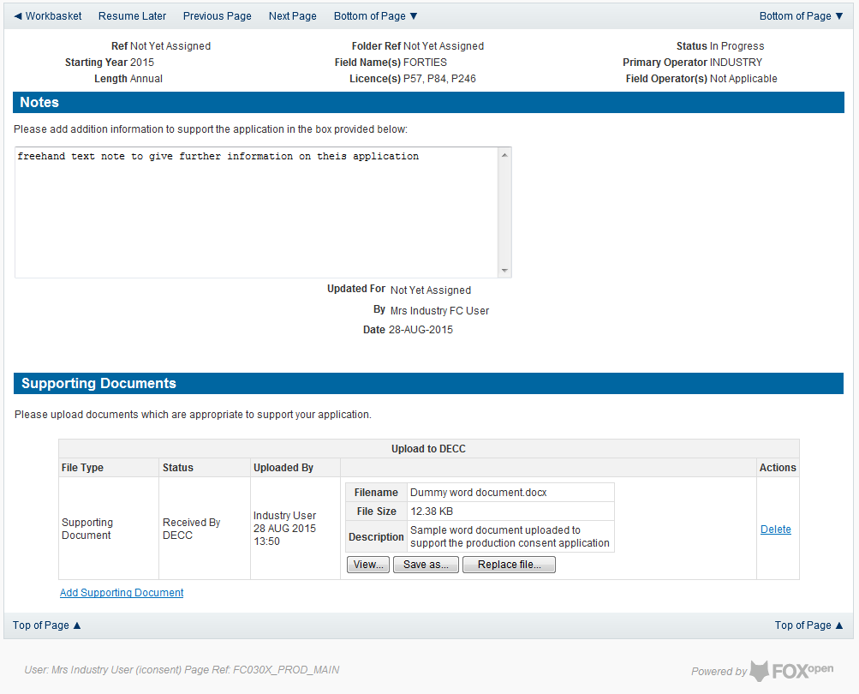

Click on ‘Next Page’ on the navigation bar to move to the next screen.

The Print Selection Screen allows the Operator to generate and print .pdf versions of the Production Consent application. Check the boxes for the areas of the application you wish to create or click the ‘Select all’ link to choose all parts of the application. Click on the
‘Generate PDF’ button to produce the .pdf version of the Consent application. A copy will open in .pdf format in a new tab in the browser.
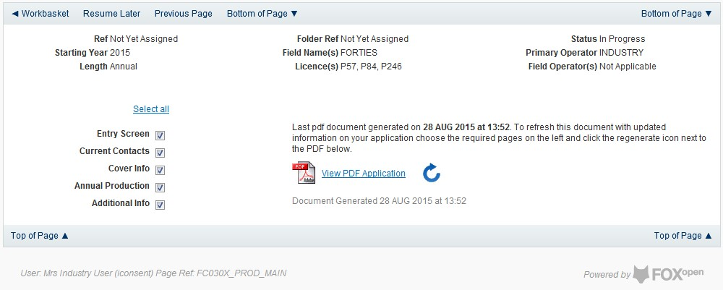

If the Consent application is ready to submit click on the submit button on the left hand menu to proceed to the next stage.

Once the ‘Submit’ button is pressed the Field Consents System will check all the entries made on the consent application. If any on the entries are invalid or missing they will be displayed in an error summary. Any error must be rectified before the application can be submitted.
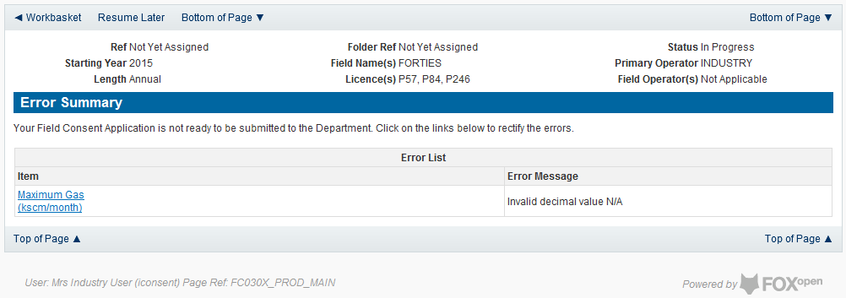

Click on the item on the errors list and you will be taken to the screen where the error is contained.

The error will be indicated by a red cross.

Hovering over the cross will give an indication of what has caused the entry to be invalid. Correct the error and click on the ‘Error Summary’ link on the left hand menu.

If there are still errors on the application they will still appear in the errors list. Repeat the process to view and correct all errors until all corrections have been made. The error summary will be empty.

Click on the Submit link on the left hand menu to go to the submission screen
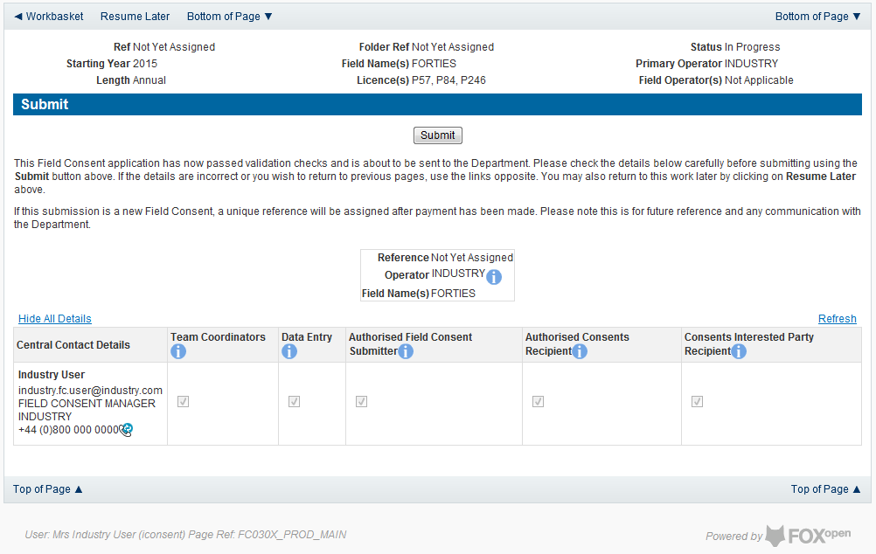

YOU MUST CLICK ON THE ‘SUBMIT’ BUTTON ON THIS PAGE TO PAY FOR THIS APPLICATION AND FINALISE THE SUBMISSION PROCESS

Clicking the ‘Submit button will send the application to the OGA Consents team and take the Operator to the payment screen. Details on how to make payments are contained in the in “Processing Payments” section later in this guide document.

New Long Term Production Consent
The Cover Info page is where the Operator is able to define the Field(s) and duration for the consent being applied for.
The Operator is chosen by searching for the operators name from the approved list of Operators registered with the UK Energy Portal. To use the search facility click on the select Operator link on the screen:

This will open the Organisation Directory Search Screen

Enter the name (or the beginning letters) of the name of the Operator Responsible for the Field for which the consent is being prepared. E.G. Entering ‘tes’ as the organisation and clicking on ‘Search’ will return search results of TESSENDERLO UK LIMITED and TEST COMPANY LTD. Click on the ‘Select’ link to inset the Organisation into the application.
Add the field for which the production consent is being prepared. To add the field click on the ‘Select Field’ link on the screen.

This will open the DEVUK Field Search Screen
Enter the name (or the beginning letters) of the name of the Field name for which the consent is being prepared. E.G. Entering ‘bren’ as the Field Name and clicking on ‘Search’ will return search results of BRENDA and BRENT. Click on the ‘Select’ link to the right of the correct Field Name to inset the Field into the application
The Licence Number(s) associated with the Field are automatically entered into the application.

To add further Fields into the application click the ‘Select Field link and repeat the process. Any additional fields added to the application will also add any further associated Licences to the application.
Select the Production consent Length as ‘Long Term’ from the drop down menu.

The operator must indicate if the Production Consent application is due to an increase in production. If the answer to this question is ‘Yes’ the P.E.T.S. reference for the environmental permit for this field should be entered

The last item to enter on this screen is the indication as to whether the Gas is being injected to help maintain reservoir pressure. Select ‘Yes’ or ‘No’ from the drop down menu.

The screen should now be completely populated. Click on ‘Next Page’ on the navigation bar to continue the application process.
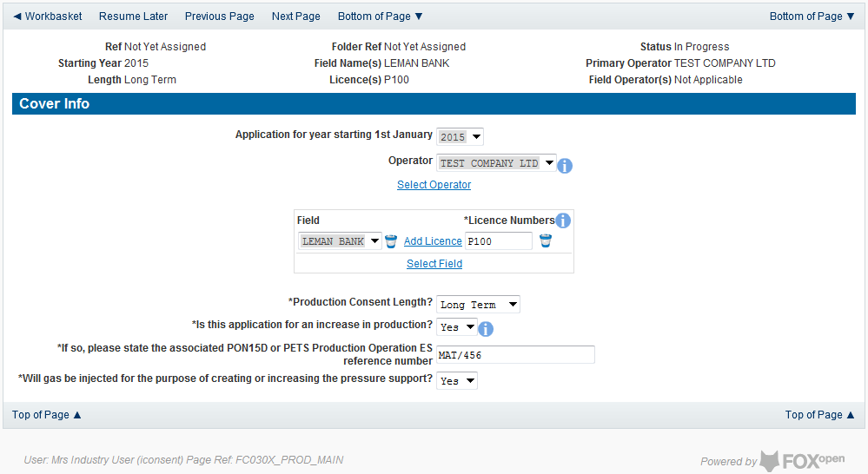

The Long Term Production page is where the operator defines the length of the consent and provides the expected minimum and maximum production figures for Oil and Gas for the selected years.
The long term Production Consent is to cover period longer than one year. By default the Long Term Production screen will begin with the year indicated on the Cover Info screen and the following year.
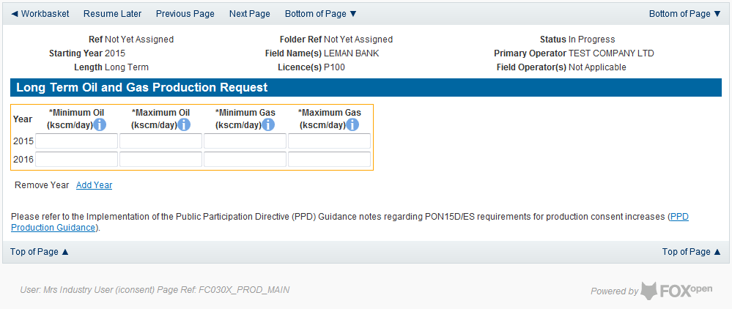

Further years may be added to the application by clicking on the ‘Add Year’ link on this page. Each time the link is clicked one year will be added to the length of the consent application.
Once extra years have been added to the consent they can be removed by using the
‘Remove Year’ link. Clicking the ‘Remove Year’ link the last year which had been added to the consent application is removed. Any number of years may be removed providing there is a minimum of two years remaining.
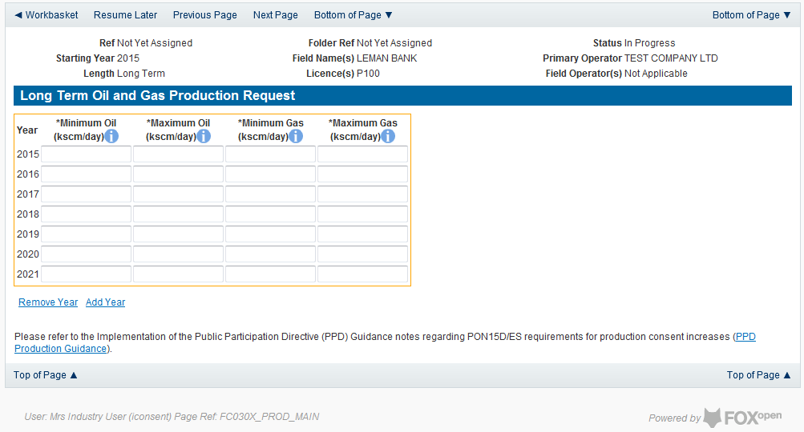

The expected minimum and maximum expected production for Oil and Gas must be entered for each year selected for this Consent application.
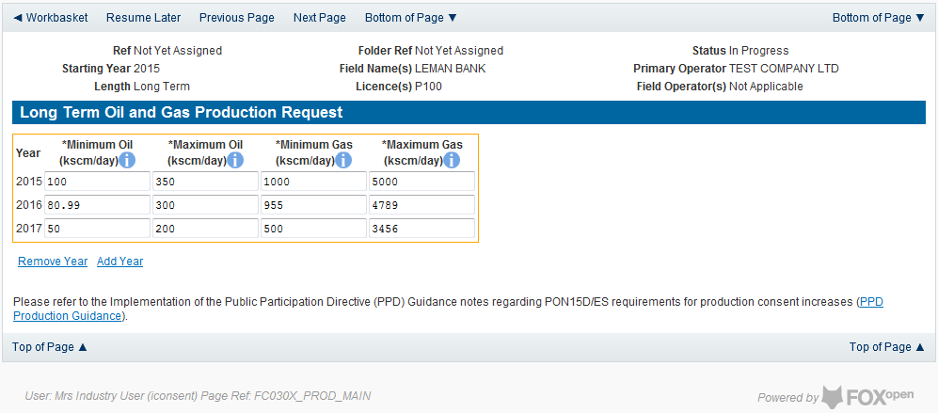

Click on the ‘Next Page’ link in the navigation bar to save the figures and move on to the next screen, ‘Additional Info’.
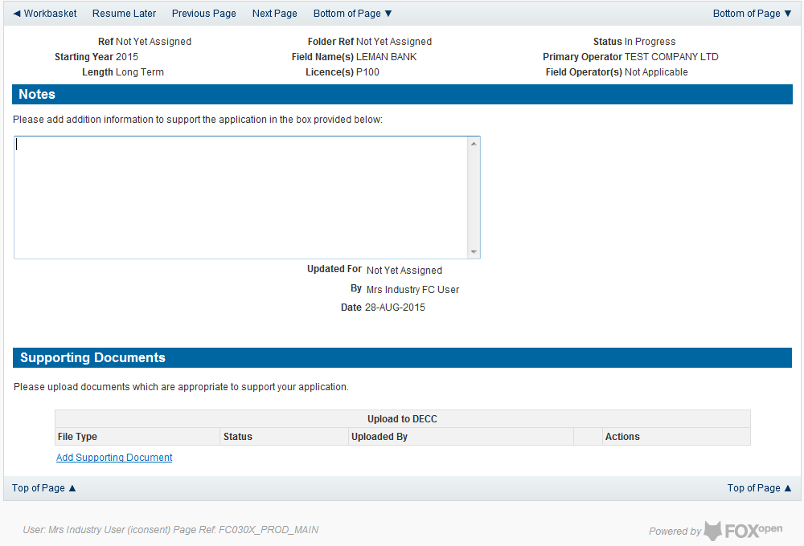

Additional notes can be added in the notes box using free text. These notes are automatically saved when the Operator navigates away from the page.
Supporting documentation can also be uploaded by clicking on the ‘Add Supporting Document’ Link on this page

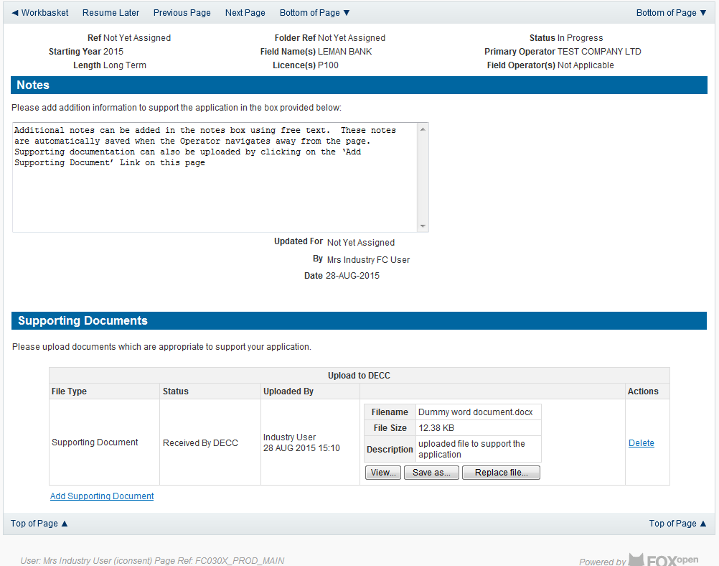

Click on ‘Next Page’ on the navigation bar to move to the next screen.

The Print Selection Screen allows the Operator to generate and print .pdf versions of the Production Consent application. Check the boxes for the areas of the application you wish to create or click the ‘Select all’ link to choose all parts of the application. Click on the
‘Generate PDF’ button to produce the .pdf version of the Consent application. A copy will open in .pdf format in a new tab in the browser.
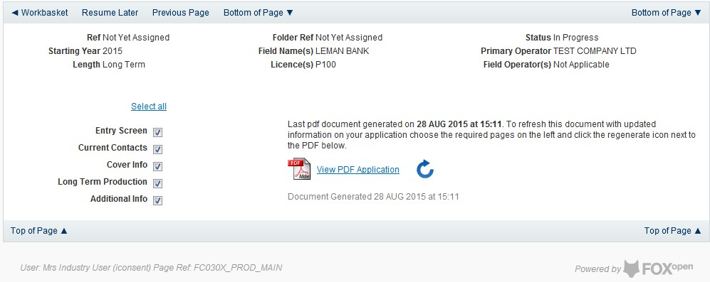

If the Consent application is ready to submit click on the submit button on the left hand menu to proceed to the next stage.

Once the ‘Submit’ button is pressed the Field Consents System will check all the entries made on the consent application. If any on the entries are invalid or missing they will be displayed in an error summary. Any error must be rectified before the application can be submitted.
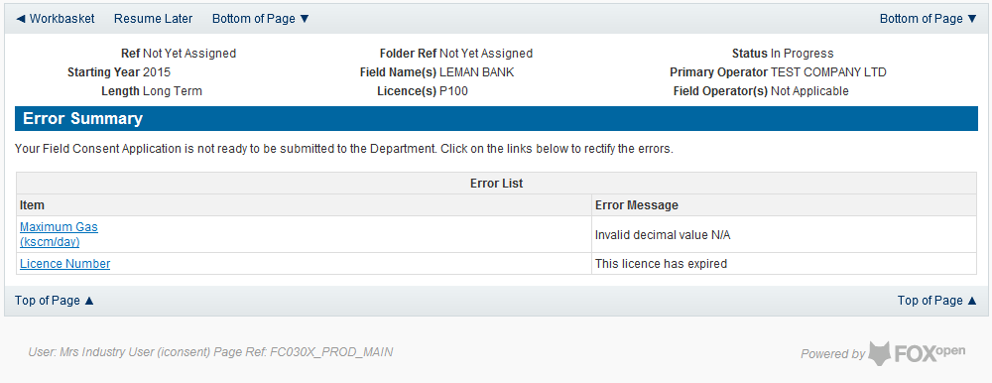

Click on the item on the errors list and you will be taken to the screen where the error is contained.

The error will be indicated by a red cross.

Hovering over the cross will give an indication of what has caused the entry to be invalid. Correct the error and click on the ‘Error Summary’ link on the left hand menu.

If there are still errors on the application they will still appear in the errors list. Repeat the process to view and correct all errors until all corrections have been made. The error summary will be empty.
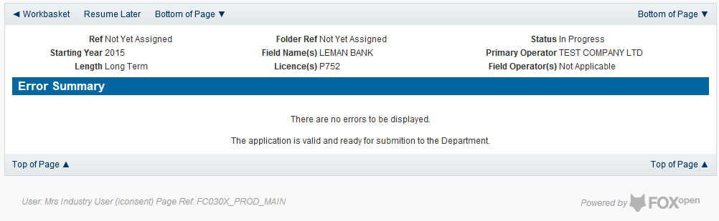

Click on the Submit link on the left hand menu to go to the submission screen
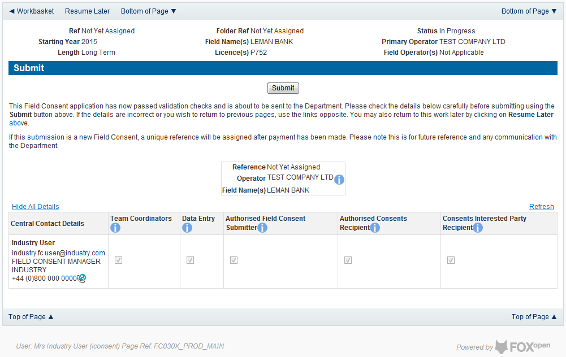

YOU MUST CLICK ON THE ‘SUBMIT’ BUTTON ON THIS PAGE TO PAY FOR THIS APPLICATION ANS FINALISE THE SUBMISSION PROCESS

Clicking the ‘Submit button will send the application to the OGA Consents team and take the Operator to the payment screen. Details on how to make payments are contained in the in “Processing Payments” section later in this guide document.

Submitting a new Flaring Consent application
New Flaring Consents applications can be submitted for UK Fields on a short term, Annual or long term basis
The Operator must log in to the UK Energy Portal at this URL: https://itportal.decc.gov.uk/eng/fox/live/PORTAL_LOGIN/login
After logging in the Operator will be taken to their Portal Workbasket. The workbasket will contain all notifications and actions for transactions made using the UK Energy Portal.
From the workbasket click on ‘Field Consents’ from the left hand menu

This takes the operator into the Field Consents System search screen.

From the search screen you are able to search for all field consents which have been submitted on behalf of the operators company. The Operator is able to set various search option parameters before requesting the results.
To begin a new consent application click on ‘New Field Consent from the left hand menu from the Field Consents System search screen

From the New Field Consent screen select the year for the start of the consent period from the drop down list. Select the type of consent, Flaring, from the drop down list. Click on ‘Create’ to generate a new blank Flaring Consent
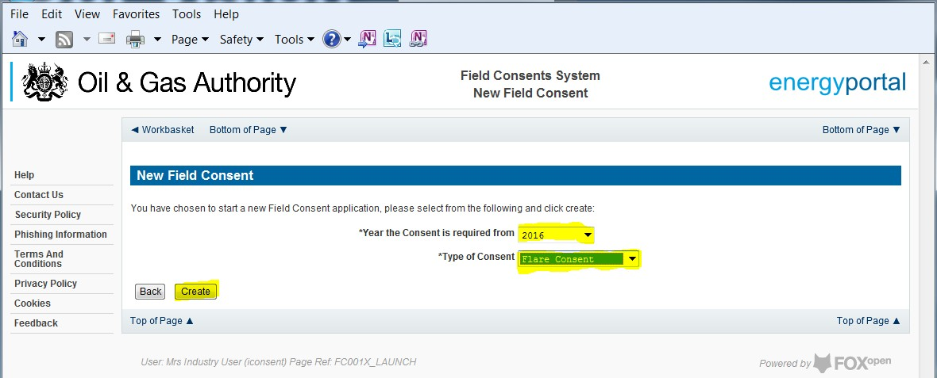

This will have created a new Flare Consent application which needs to be populated with the required data. The new application will open on the Entry Screen which gives the Operator a list of OGA contacts and links to guidance on completing flaring, venting and production consent applications.

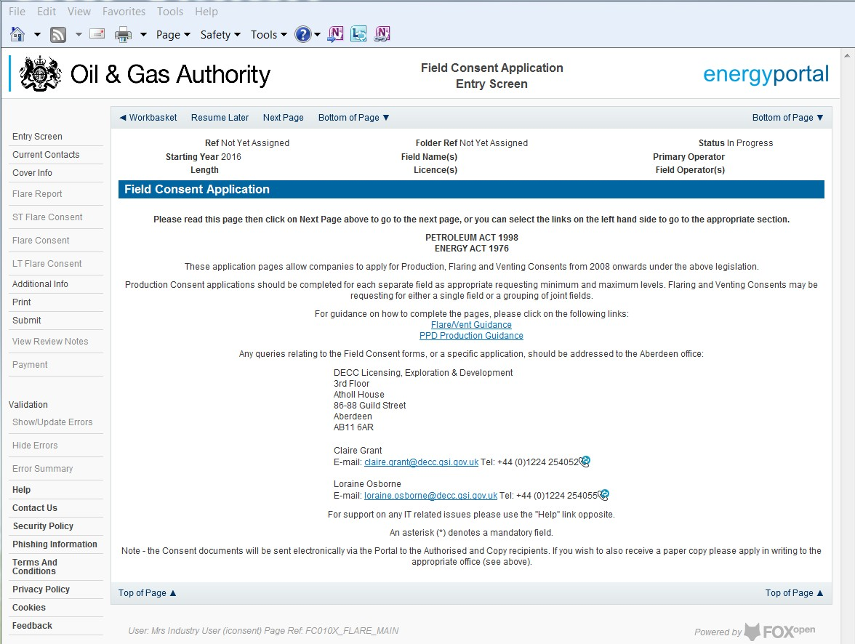

Use the navigation bar at the top of the form to navigate to the next page to display the Operators team of people who will be involved in the preparation and submission of this application. By default the person creating the application is enrolled in the team with all available roles

IT IS STRONGLY RECOMMENDED THAT MORE THAN ONE PERSON IS ENROLLED IN THE CONSENTS TEAMS TO AVOID DELAYS IN THE SUBMISSION AND APPROVAL PROCESS.
Please see the section “Controlling Access using Field Consents Teams and Contacts”

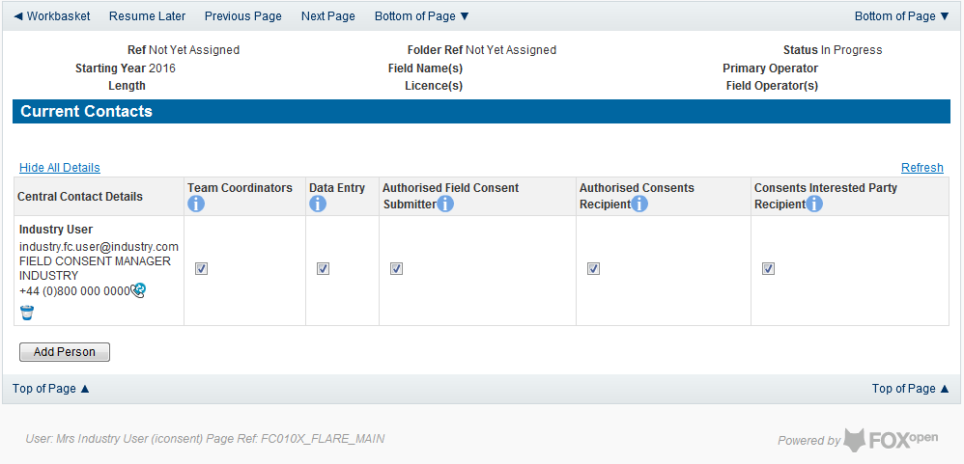

Click the ‘Next page’ link to proceed with the application.

On the next screen, Cover Info, the operator will define the length of time for which the Flare Consent is being applied. There are three terms for which a Flare Consent may be requested: Short Term, Annual, and Long term.
The process differs slightly in the data required for each type of consent length.

New Short Term Flare Consent
The Cover Info page is where the Operator is able to define the Field(s) and duration for the consent being applied for.
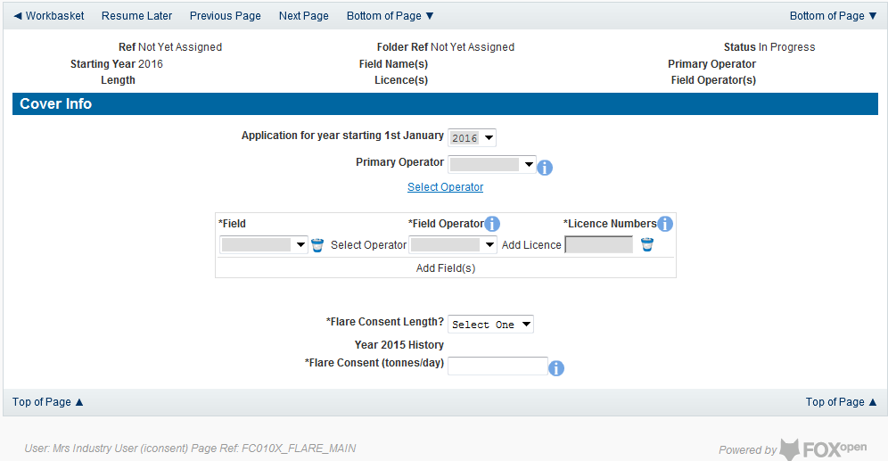

The Operator is chosen by searching for the operators name from the approved list of Operators registered with the UK Energy Portal. To use the search facility click on the select Operator link on the screen:

This will open the Organisation Directory Search Screen

Enter the name (or the beginning letters) of the name of the Operator Responsible for the Field for which the consent is being prepared. E.G. Entering ‘tes’ as the organisation and clicking on ‘Search’ will return search results of TESSENDERLO UK LIMITED and TEST COMPANY LTD. Click on the ‘Select’ link to inset the Organisation into the application.
Add the field for which the production consent is being prepared. To add the field click on the ‘Add Field’ link on the screen.
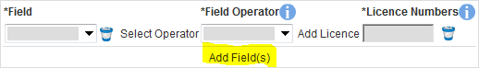
This will open the DEVUK Field Search Screen

Enter the name (or the beginning letters) of the name of the Field name for which the consent is being prepared. E.G. Entering ‘bren’ as the Field Name and clicking on ‘Search’ will return search results of BRENDA and BRENT. Click on the ‘Select’ link to the right of the correct Field Name to inset the Field into the application
The Licence Number(s) associated with the Field are automatically entered into the application.
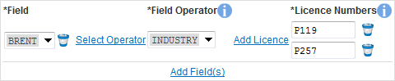

To add further Fields into the application click the ‘Select Field link and repeat the process. Any additional fields added to the application will also add any further associated Licences to the application.

Select the field at which the flaring is going to take place by clicking the drop down menu next to the question “Which field are the flaring facilities located?” and selecting the correct Field name.
Set the Flare Consent Length to ‘Short Term’ by selecting this option from the drop down menu.
Finally, enter the figure which was granted for the previous Consent Period
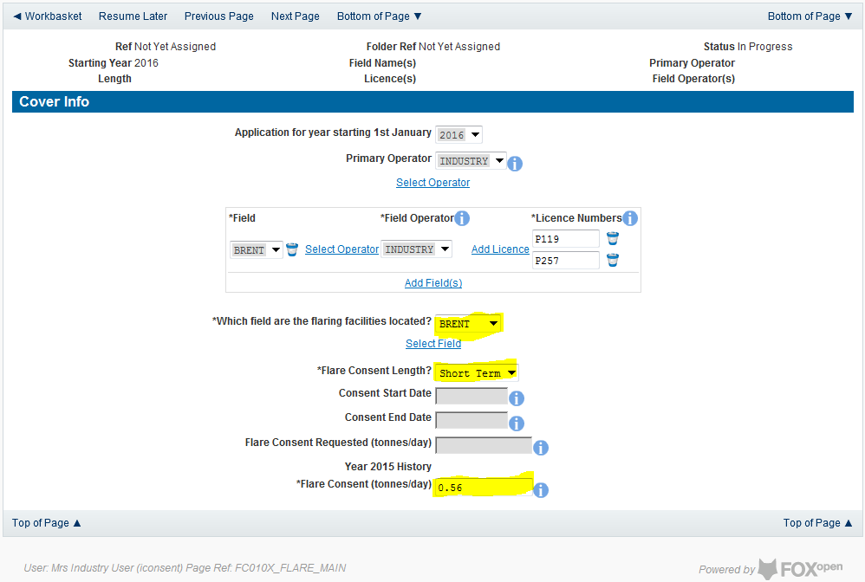

The screen should now be completely populated. Select “ST Flare Consent” from the left hand menu to continue the application process.
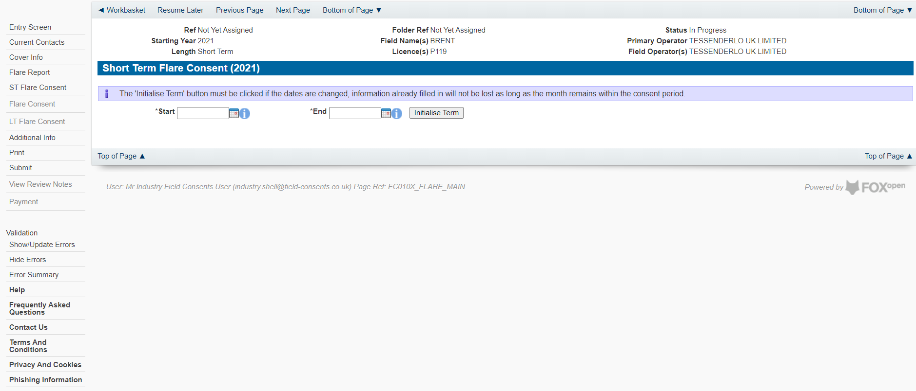

Enter the dates for which the consent is due to start and end by using the calendar widget or manually entering the dates, then clicking on the ‘Initialise Term’ button
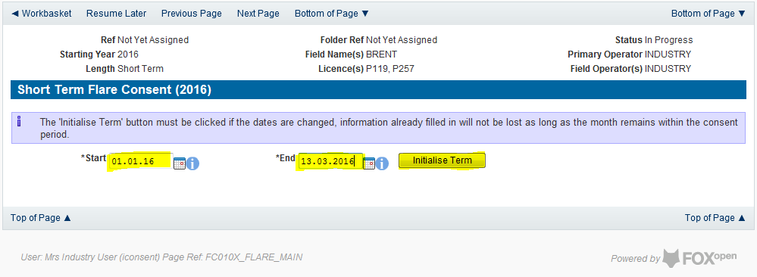

Once the initialise button has been pushed the screen will display the areas where the Operators requested flare allowances are recorded. For each period on the screen the Operator must enter the requested figure for Categories A, B and C. If the Operator wishes to add a comment to the figures for a requested month it can be entered in the comments box on the right hand side of the monthly figures

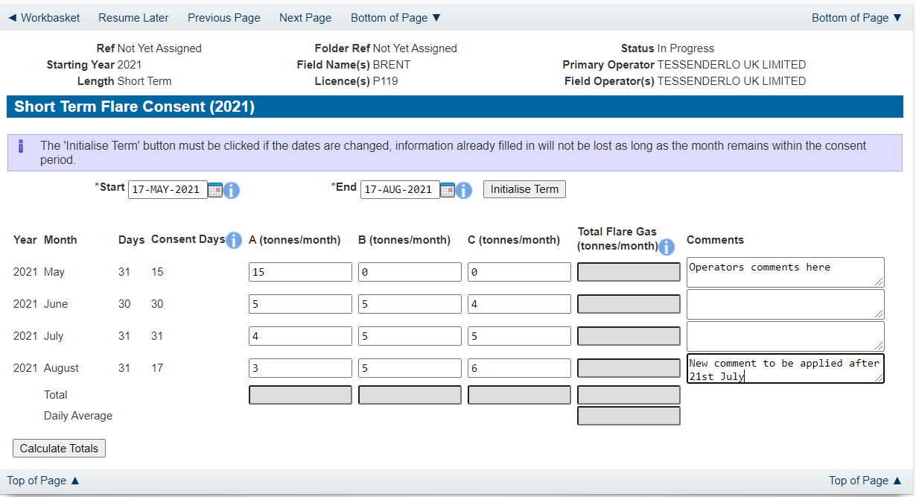

Once figures have been entered click on the ‘Calculate Totals’ button to populate the total and Average figures on the screen.

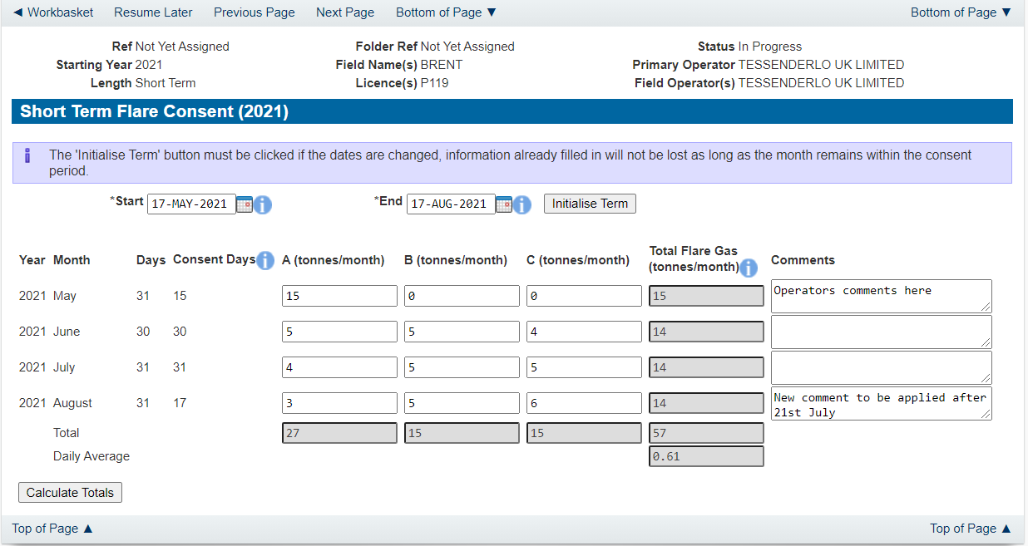

Clicking the ‘Calculate Totals’ button will also populate the Consent start and end dates and the requested flare consent information on the Cover Info page.

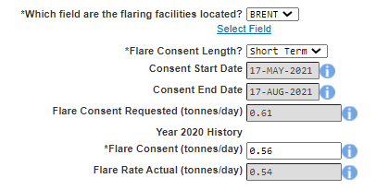

Select ‘Flare Report’ from the left hand menu to provide actuals data about the past 12 months of flaring

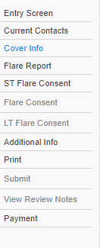

The next stage is to fill out the “Flare Report”. This is where Operators must supply details of the amount of flaring reported for the past 12 months from the date of application for Categories A, B and C (i.e. for an application with a start date from May 2021, the report will need complete data from the period May 2020 – April 2021) along with details of the measuring method used for recording the reported figures. If, for any reason (such as operational/new field), figures are not available for the whole period months can be removed from this list by clicking the ‘Remove Month From End’ button. Operators should provide reasons for incomplete figures due to unavailable months in the comment box of the last month reported for the flare report.

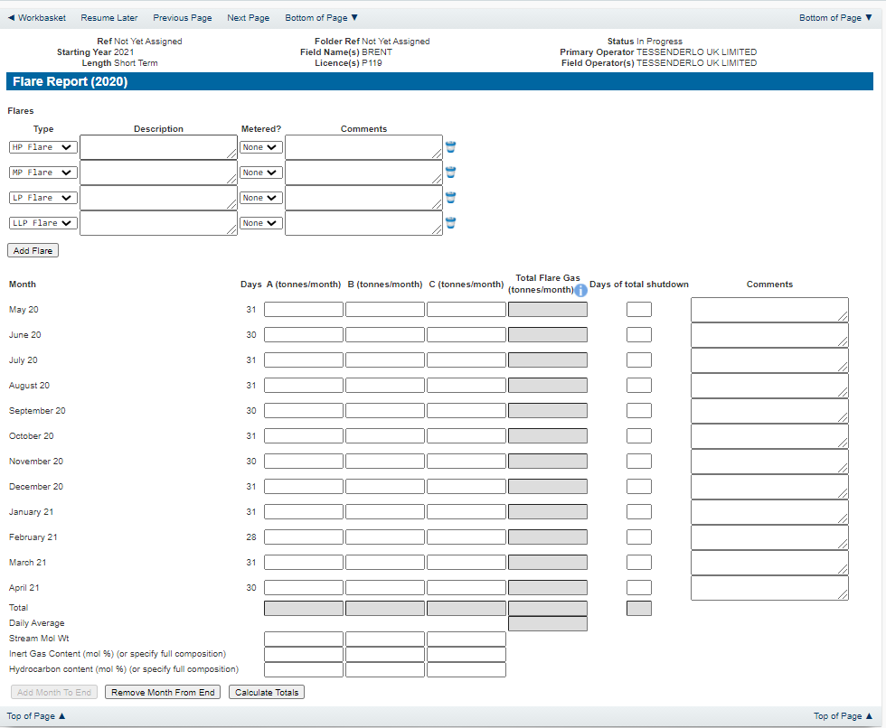

Enter the details of the recorded flare figures
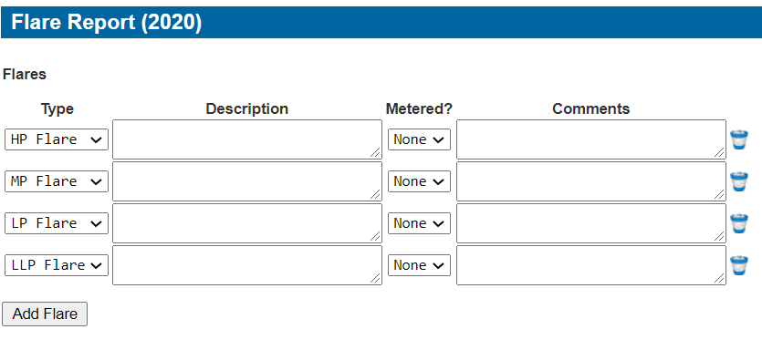

Items on this list may be removed by click the remove icon to the right hand side of the entry
Extra entries may be added if needed by clicking on the ‘Add Flare button

Each item in the list should contain an optional description and a mandatory indication of if this flare was metered or not. An optional comments box is available to allow freehand text comments.
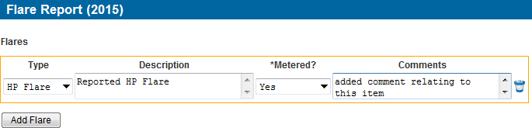

Details of the monthly flaring activity is recorded in the next section along with details of days a Field may have been shut in and a comments box to add notes relating to the entry.

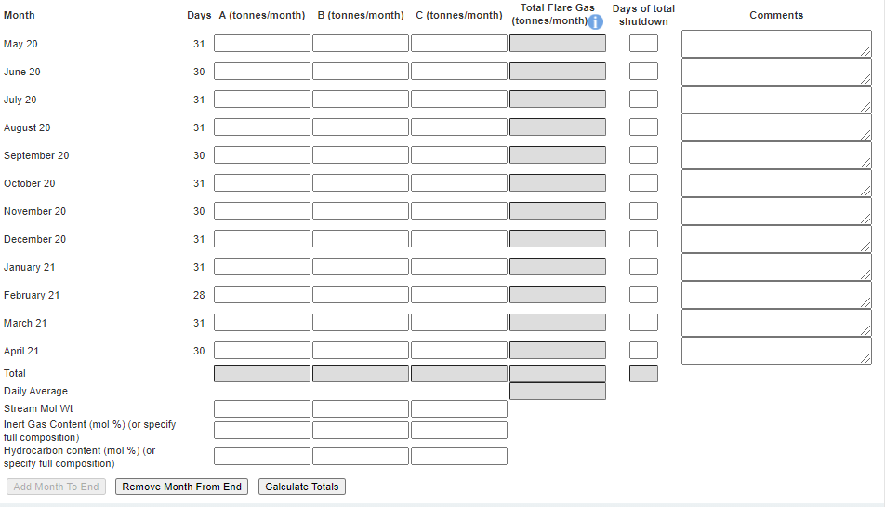
By default the screen request details for the year before the consent date (i.e. May 2020 – April 2021 request for a consent starting May 2021 as above). Figures for the entire period must be filled in. If, for any reason (such as operational/new field), figures are not available for the whole period months can be removed from this list by clicking the ‘Remove Month From End’ button. Operators should provide reasons for incomplete figures due to unavailable months in the comment box of the last month reported for the flare report

The reported figures should be populated in the appropriate sections on the screen

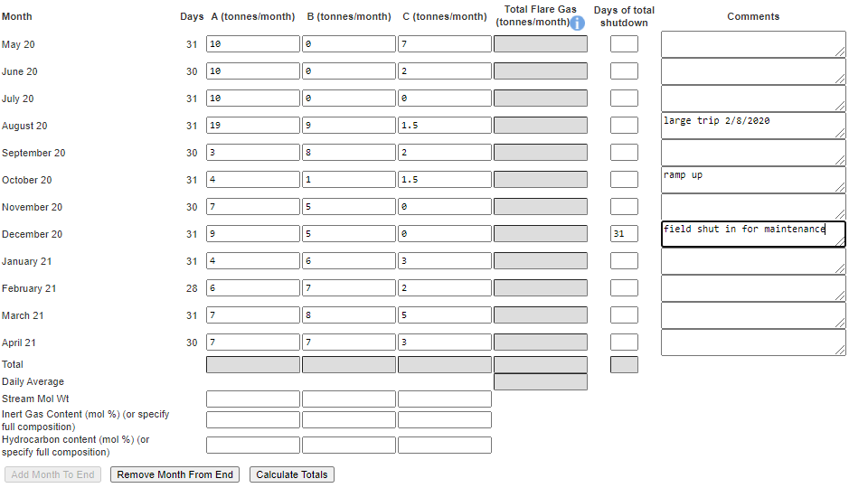

Once the data has been populated click on the ‘Calculate Totals’ and the Field Consents system will calculate the monthly totals and the totals for the whole of the period being reported.

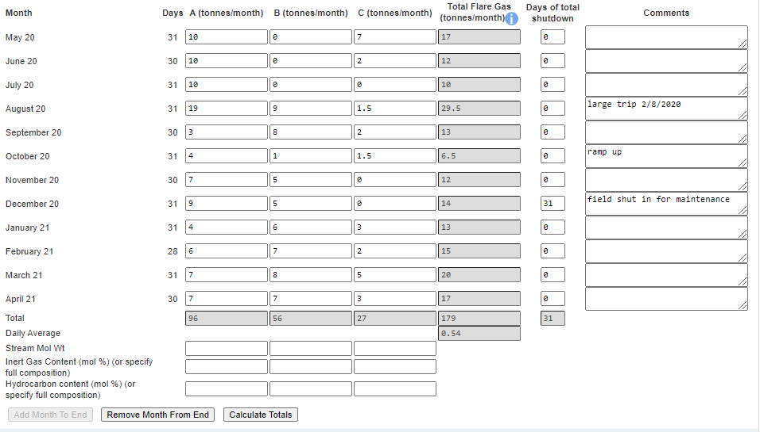

The system will also populate the actual Flare rate item contained on the Cover Info page which was previously greyed out and could not be entered manually
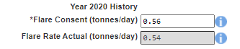

Click on ‘Next Page’ on the navigation bar to continue the application process and move to the Additional info screen

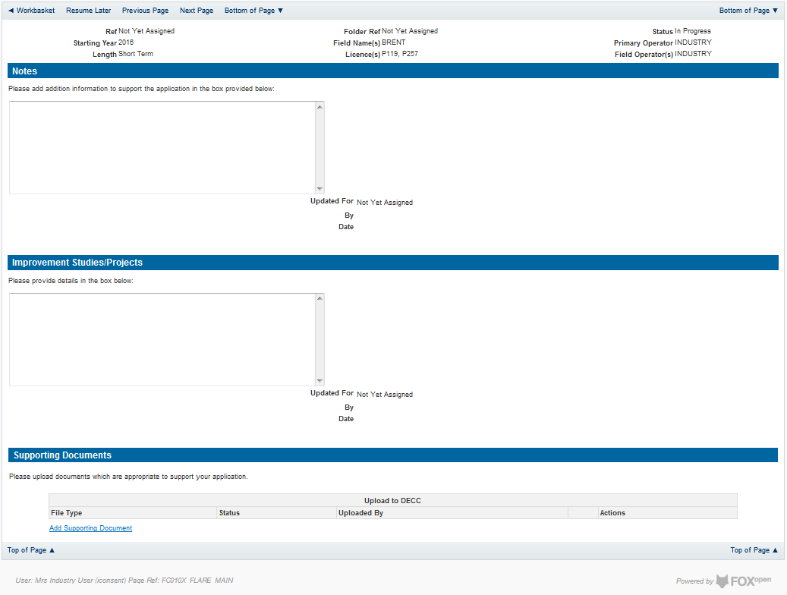

Additional notes can be added in the notes box using free text or copied and pasted from other applications. These notes are automatically saved when the Operator navigates away from the page.
Details can also be recorded relating to improvement studies and projects on this page. These details can be types as free text or pasted from other applications. Any added details are automatically save when the Operator navigates away from the page.
Supporting documentation can also be uploaded by clicking on the ‘Add Supporting Document’ Link on this page.

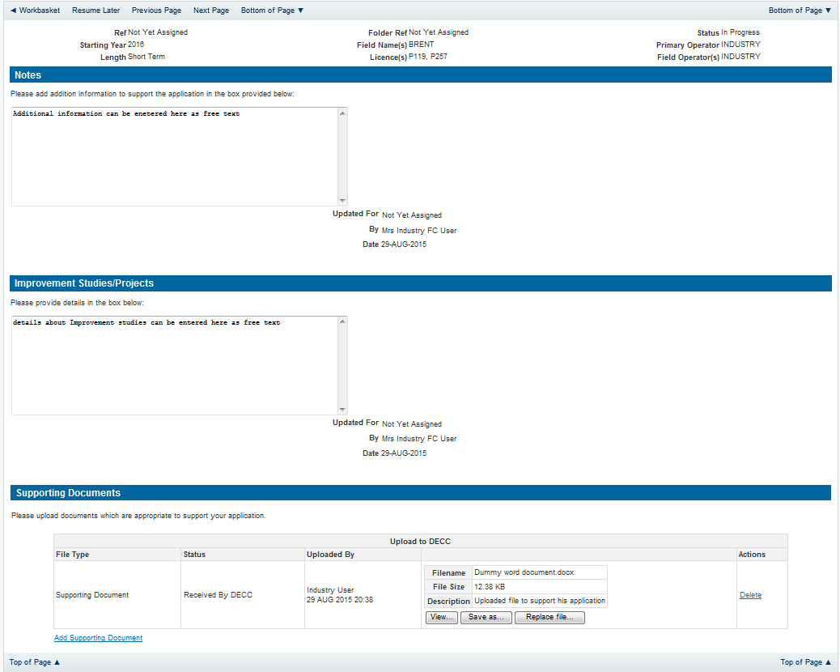

Click on ‘Next Page’ on the navigation bar to move to the next screen.

The Print Selection Screen allows the Operator to generate and print .pdf versions of the Flare Consent application. Check the boxes for the areas of the application you wish to create or click the ‘Select all’ link to choose all parts of the application. Click on the
‘Generate Document’ button to produce the .pdf version of the Consent application. A copy will open in .pdf format in a new tab in the browser.
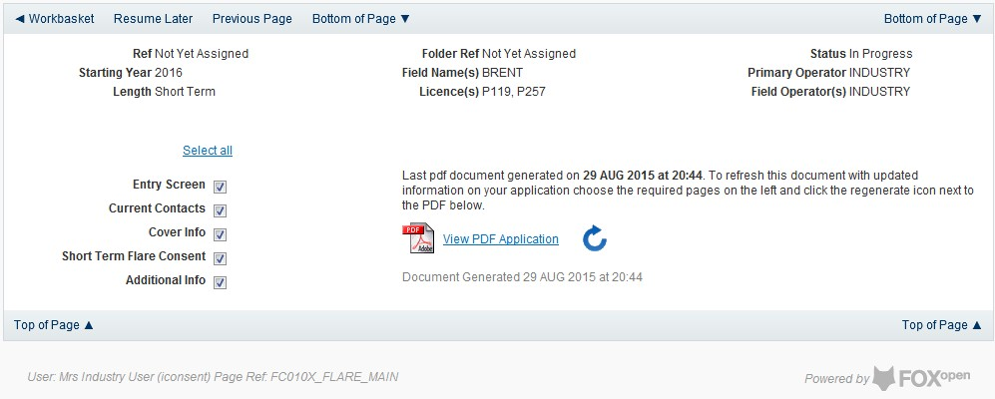

If the Consent application is ready to submit click on the submit button on the left hand menu to proceed to the next stage.
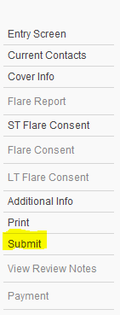

Once the ‘Submit’ button is pressed the Field Consents System will check all the entries made on the consent application. If any on the entries are invalid or missing they will be displayed in an error summary. Any error must be rectified before the application can be submitted.
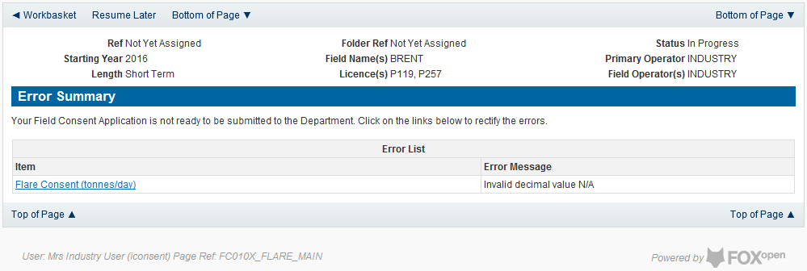

Click on the item on the errors list and you will be taken to the screen where the error is contained.

The error will be indicated by a red cross.

Hovering over the cross will give an indication of what has caused the entry to be invalid. Correct the error and click on the ‘Error Summary’ link on the left hand menu.

If there are still errors on the application they will still appear in the errors list. Repeat the process to view and correct all errors until all corrections have been made. The error summary will be empty.
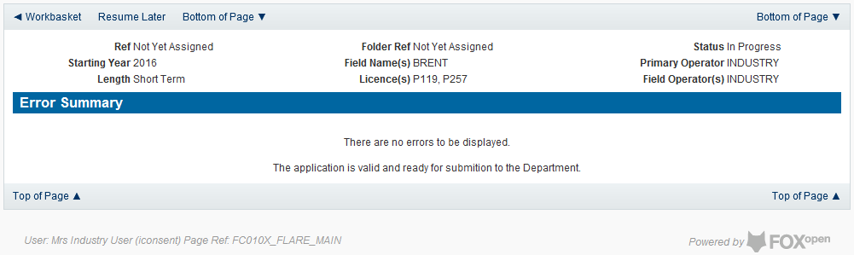

Click on the Submit link on the left hand menu to go to the submission screen
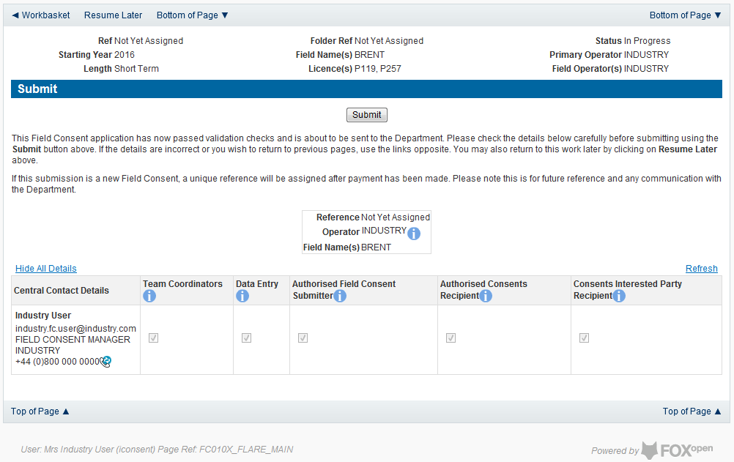

YOU MUST CLICK ON THE ‘SUBMIT’ BUTTON ON THIS PAGE TO FINALISE THE SUBMISSION PROCESS

Clicking the ‘Submit button will send the application to the OGA Consents team and take the Operator to the payment screen. Details on how to make payments are contained in the in “Processing Payments” section later in this guide document.

New Annual Flare Consent
The Cover Info page is where the Operator is able to define the Field(s) and duration for the consent being applied for.

The Operator is chosen by searching for the operators name from the approved list of Operators registered with the UK Energy Portal. To use the search facility click on the select Operator link on the screen:

This will open the Organisation Directory Search Screen

Enter the name (or the beginning letters) of the name of the Operator Responsible for the Field for which the consent is being prepared. E.G. Entering ‘tes’ as the organisation and clicking on ‘Search’ will return search results of TESSENDERLO UK LIMITED and TEST COMPANY LTD. Click on the ‘Select’ link to inset the Organisation into the application.
Add the field for which the production consent is being prepared. To add the field click on the ‘Add Field’ link on the screen.
This will open the DEVUK Field Search Screen

Enter the name (or the beginning letters) of the name of the Field name for which the consent is being prepared. E.G. Entering ‘bren’ as the Field Name and clicking on ‘Search’ will return search results of BRENDA and BRENT. Click on the ‘Select’ link to the right of the correct Field Name to inset the Field into the application
The Licence Number(s) associated with the Field are automatically entered into the application.

To add further Fields into the application click the ‘Select Field link and repeat the process. Any additional fields added to the application will also add any further associated Licences to the application.

Select the field at which the flaring is going to take place by clicking the drop down menu next to the question “Which field are the flaring facilities located?”and selecting the correct Field name.
Set the Flare Consent Length to ‘Short Term’ by selecting this option from the drop down menu.
Finally, enter the figure which was granted for the previous Consent Period.

The Figure for the requested Flare quantity for this new application and Flare rate for the previous (or current) period are not enterable. These figures are automatically generated from the Flare Report and the Flare Request date supplied later in the process.
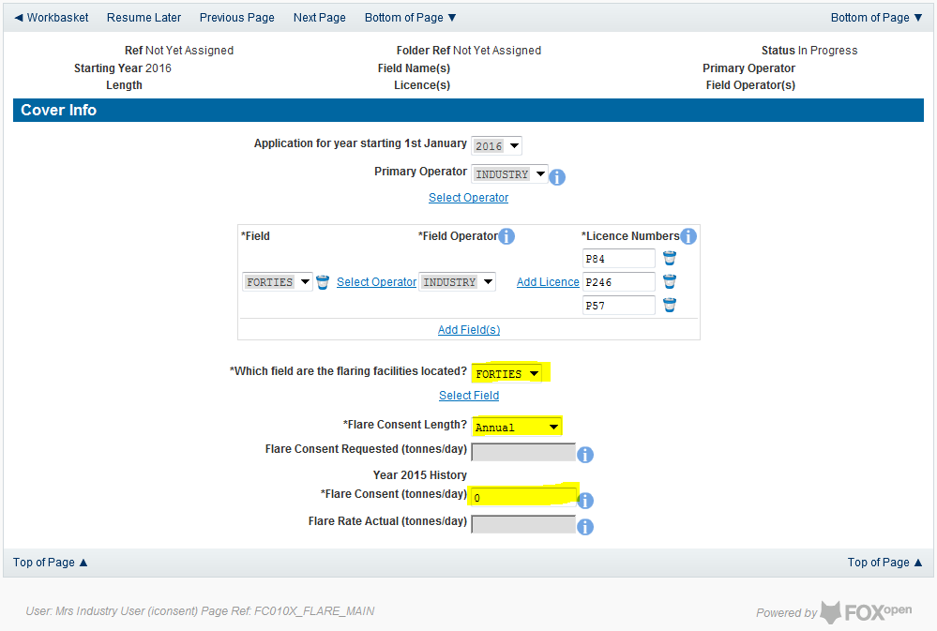

The screen should now be completely populated. Click on ‘Next Page’ on the navigation bar to continue the application process.
The next stage in the process to supply details of the amount of flaring reported for the past 12 months from the date of application (October to September for the annual consents exercise) for categories A, B and C along with details of the measuring method used for recording the reported figures

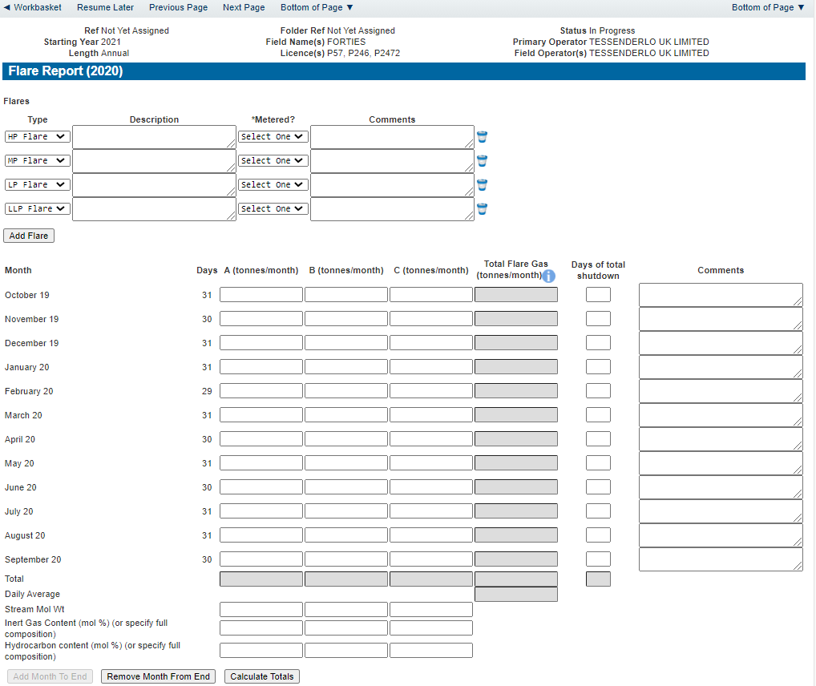

Enter the details of the recorded flare figures.

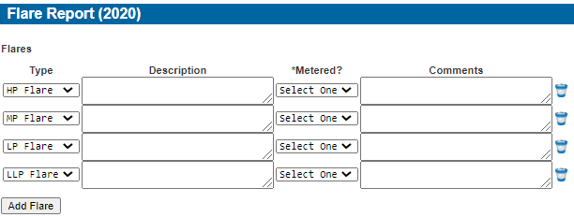

Items on this list may be removed by click the remove icon to the right hand side of the entry
Extra entries may be added if needed by clicking on the ‘Add Flare button

Each item in the list should contain an optional description and a mandatory indication of if this flare was metered or not. An optional comments box is available to allow freehand text comments.

Details of the monthly flaring activity is recorded in the next section along with details of days a Field may have been shut in and a comments box to add notes relating to the entry.

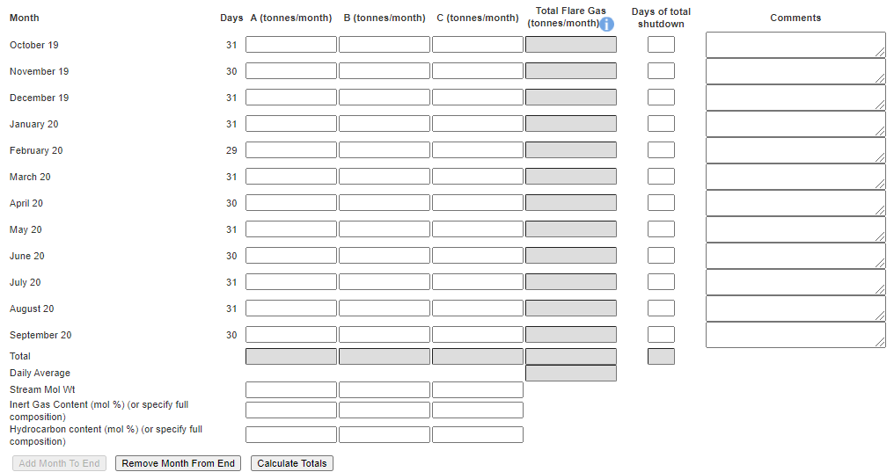

By default the screen request details for October to September. Figures for the entire October to September period must be filled in. If, for any reason (such as operational/new field), figures are not available for the whole period months can be removed from this list by clicking the ‘Remove Month From End’ button. Operators should provide reasons for incomplete figures due to unavailable months in the comment box of the last month reported for the flare report.
The reported figures should be populated in the appropriate sections on the screen

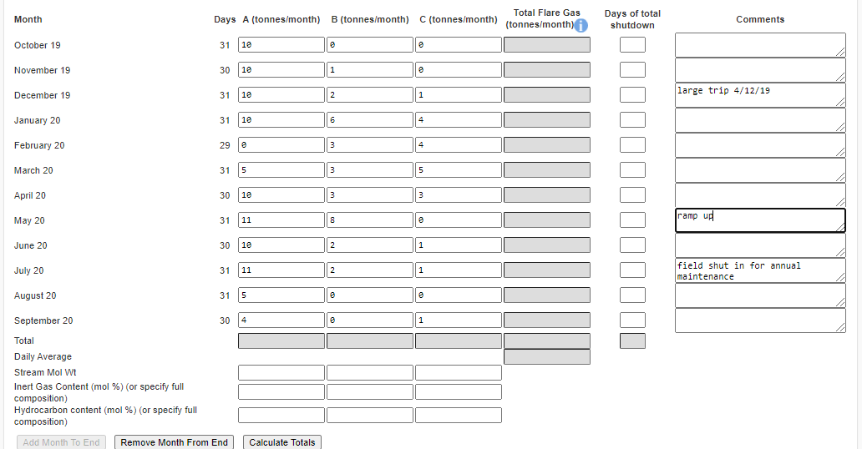

Once the data has been populated click on the ‘Calculate Totals’ and the Field Consents system will calculate the monthly totals and the totals for the whole of the period being reported.
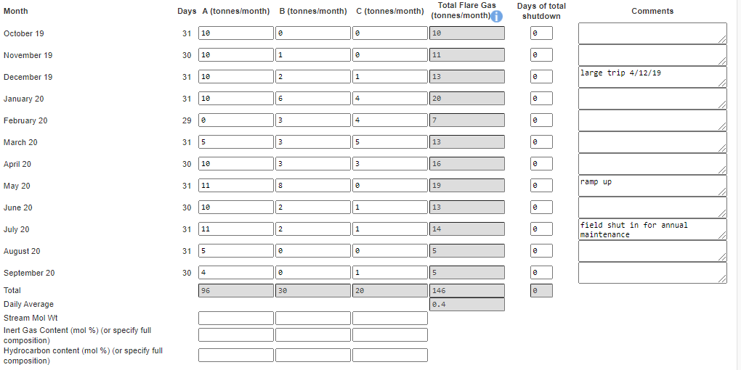
The system will also populate the actual Flare rate item contained on the Cover Info page which was previously greyed out and could not be entered manually

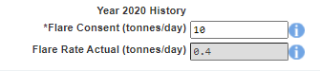

Click on ‘Next Page’ on the navigation bar to continue the application process. This will take the Operator Flare Consent request page. The Operator must supply a realistic estimate of the quantity which will be needed to be flared during the period of new consent
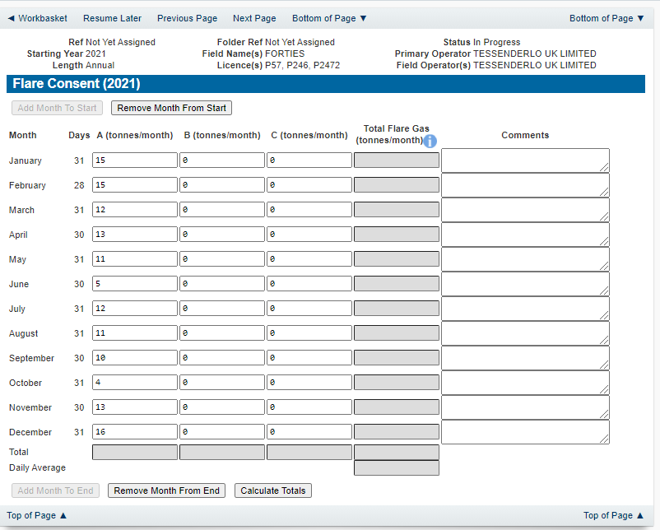

Click on the ‘Calculate Totals’ button to populate the totals on this screen.

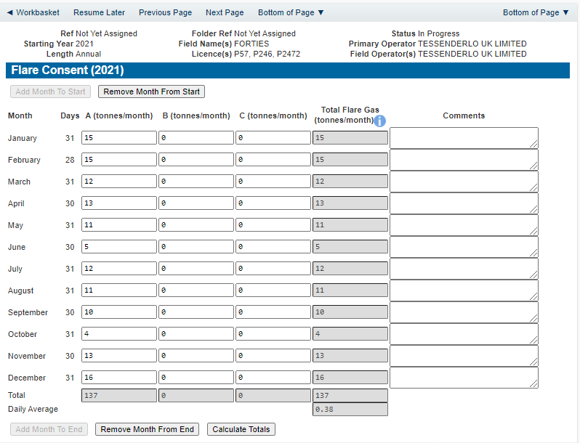

Clicking the ‘Calculate Totals’ button will also populate the Requested Flare Consent figure on the Cover Info page which were greyed out and could not be entered manually
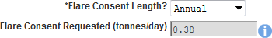

Click on ‘Next Page’ on the navigation bar to continue the application process and move to the Additional info screen.

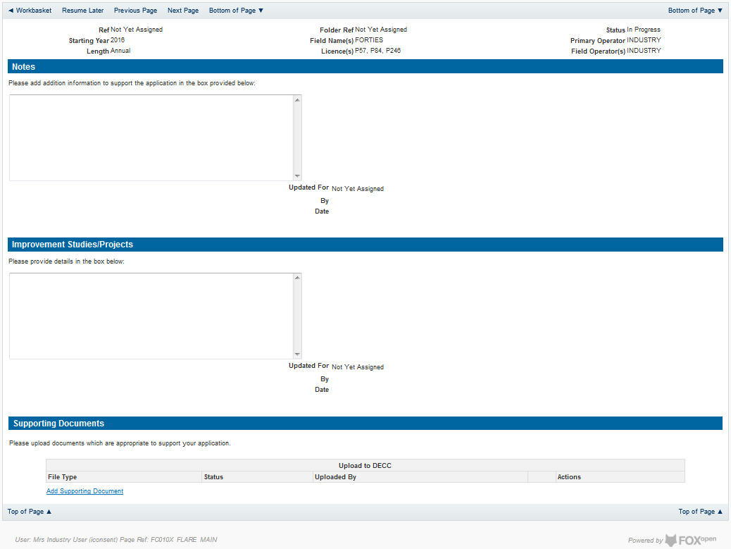

Additional notes can be added in the notes box using free text or copied and pasted from other applications. These notes are automatically saved when the Operator navigates away from the page.
Details can also be recorded relating to improvement studies and projects on this page. These details can be types as free text or pasted from other applications. Any added details are automatically save when the Operator navigates away from the page.
Supporting documentation can also be uploaded by clicking on the ‘Add Supporting Document’ Link on this page.

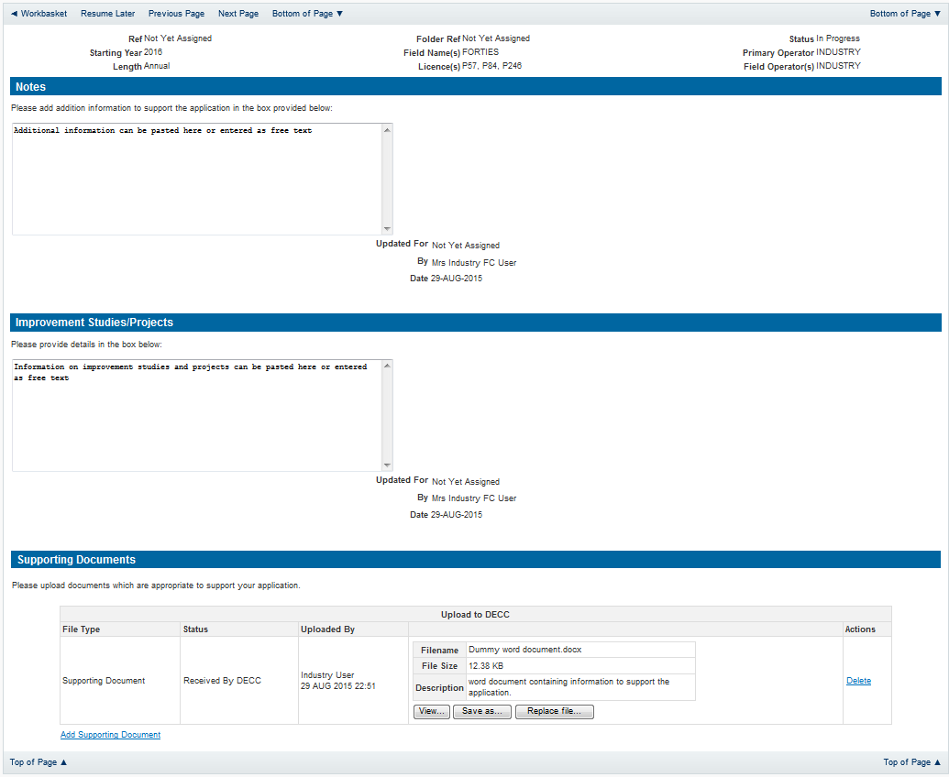

Click on ‘Next Page’ on the navigation bar to move to the next screen.

The Print Selection Screen allows the Operator to generate and print .pdf versions of the Flare Consent application. Check the boxes for the areas of the application you wish to create or click the ‘Select all’ link to choose all parts of the application. Click on the
‘Generate PDF’ button to produce the .pdf version of the Consent application. A copy will open in .pdf format in a new tab in the browser.
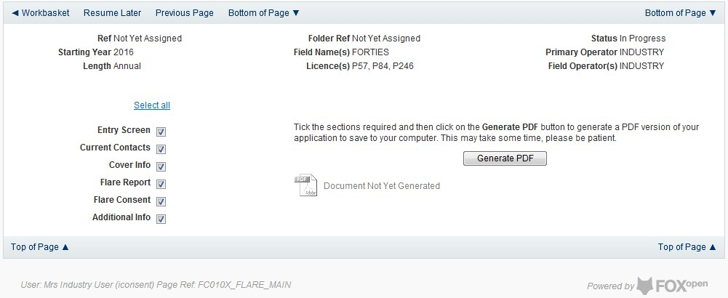

Once the ‘Submit’ button is pressed the Field Consents System will check all the entries made on the consent application. If any on the entries are invalid or missing they will be displayed in an error summary. Any error must be rectified before the application can be submitted.
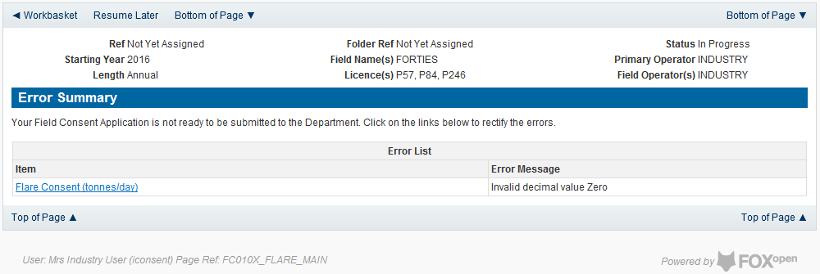

Click on the item on the errors list and you will be taken to the screen where the error is contained.

The error will be indicated by a red cross.

Hovering over the cross will give an indication of what has caused the entry to be invalid. Correct the error and click on the ‘Error Summary’ link on the left hand menu.

If there are still errors on the application they will still appear in the errors list. Repeat the process to view and correct all errors until all corrections have been made. The error summary will be empty.
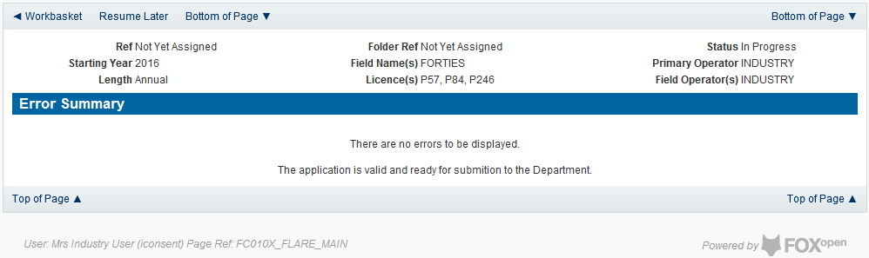

Click on the Submit link on the left hand menu to go to the submission screen
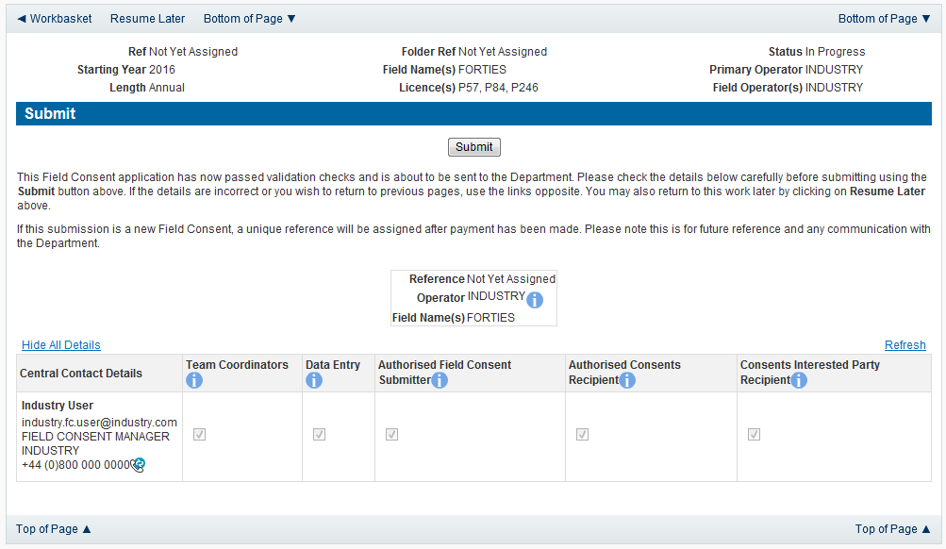

YOU MUST CLICK ON THE ‘SUBMIT’ BUTTON ON THIS PAGE TO MAKE THE PAYMENT AND FINALISE THE SUBMISSION PROCESS
Clicking the ‘Submit’ button will send the application to the OGA Consents team and take the Operator to the payment screen. Details on how to make payments are contained in the in “Processing Payments” section later in this guide document.

New Long Term Flare Consent

Long term flare consents are currently only granted for onshore Fields. .

The Cover Info page is where the Operator is able to define the Field(s) and duration for the consent being applied for.

The Operator is chosen by searching for the operators name from the approved list of Operators registered with the UK Energy Portal. To use the search facility click on the select Operator link on the screen:

This will open the Organisation Directory Search Screen

Enter the name (or the beginning letters) of the name of the Operator Responsible for the Field for which the consent is being prepared. E.G. Entering ‘tes’ as the organisation and clicking on ‘Search’ will return search results of TESSENDERLO UK LIMITED and TEST COMPANY LTD. Click on the ‘Select’ link to inset the Organisation into the application.
Add the field for which the production consent is being prepared. To add the field click on the ‘Add Field’ link on the screen.

This will open the DEVUK Field Search Screen
Enter the name (or the beginning letters) of the name of the Field name for which the consent is being prepared. E.G. Entering ‘bren’ as the Field Name and clicking on ‘Search’ will return search results of BRENDA and BRENT. Click on the ‘Select’ link to the right of the correct Field Name to inset the Field into the application
The Licence Number(s) associated with the Field are automatically entered into the application.

To add further Fields into the application click the ‘Select Field link and repeat the process. Any additional fields added to the application will also add any further associated Licences to the application.
Select the field at which the flaring is going to take place by clicking the drop down menu
next to the question “Which field are the flaring facilities located?” and selecting the correct Field name.
Set the Flare Consent Length to ‘Long Term’ by selecting this option from the drop down menu.
Enter the figure for which the Operator was granted in the previous (or current) flaring consent.
This last item on the Cover Info screen is the actual quantity reported by the operator for the previous (or current) consent period in tonnes per day
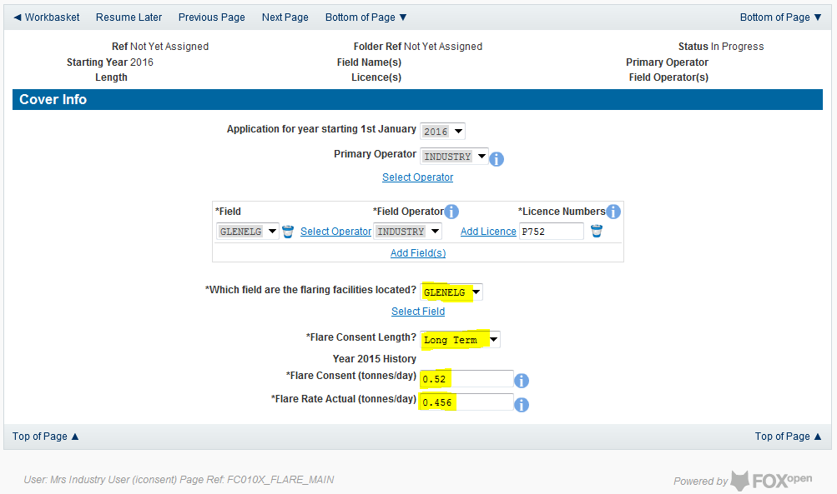

The screen should now be completely populated. Click on ‘Next Page’ on the navigation bar to continue the application process.

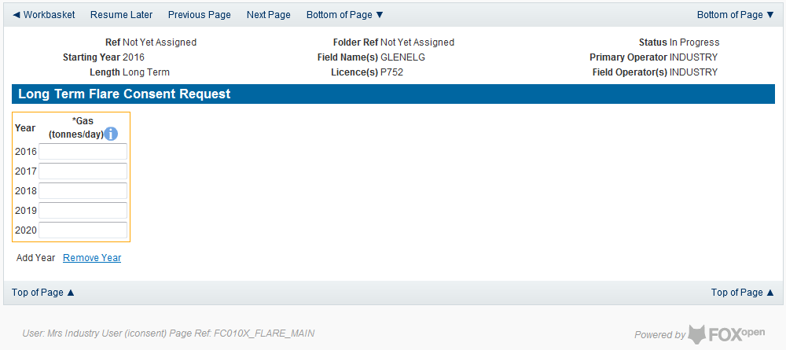

By default the Long Term Flare request screen allocates a maximum of a five year period for which the Operator may submit a long term Flare Consent. This period may be reduced to a minimum of two tears by clicking on the ‘Remove Year’ link on this page.
The operator must provide an average figure that they reasonably expect to need to Flare per day for each year for the consent period.
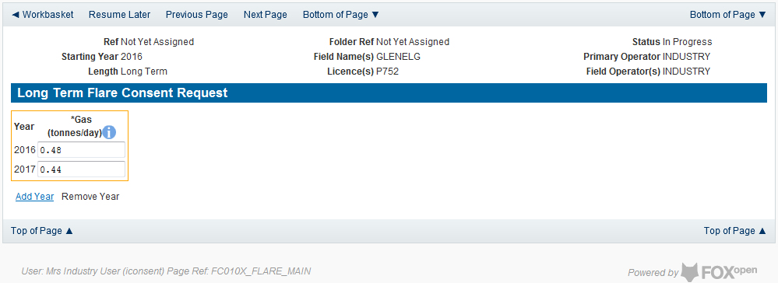

Click on ‘Next Page’ on the navigation bar to continue with the application.

This will take the operator to the Additional Information screen where the operator can provide further information to support their Flare Consent application.

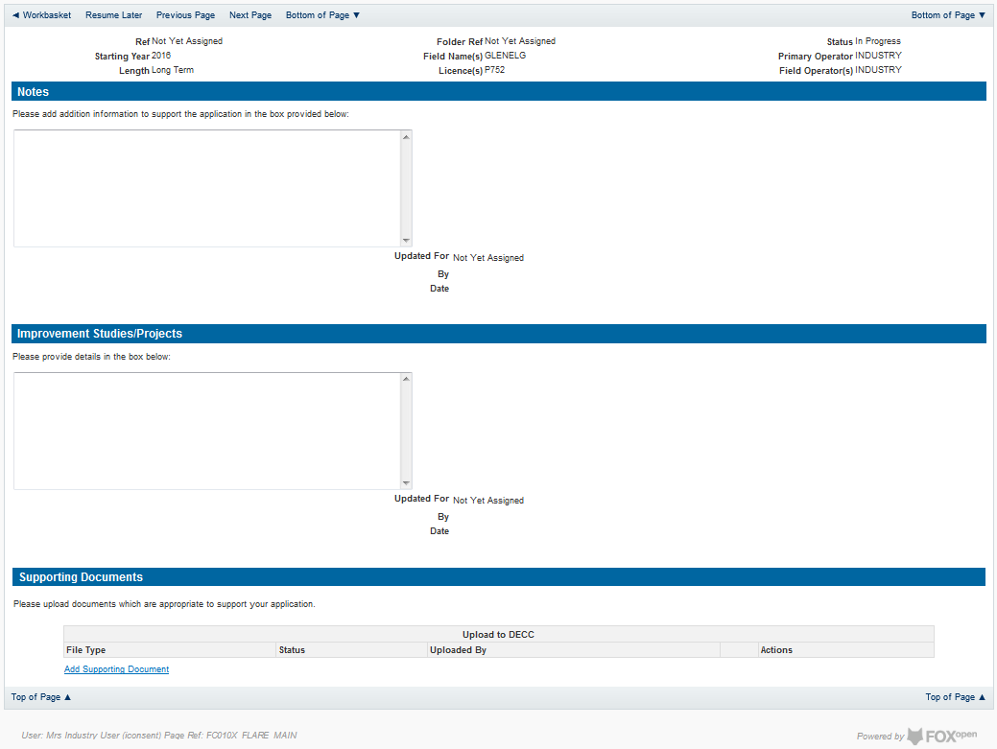

Additional notes can be added in the notes box using free text or copied and pasted from other applications. These notes are automatically saved when the Operator navigates away from the page.
Details can also be recorded relating to improvement studies and projects on this page. These details can be types as free text or pasted from other applications. Any added details are automatically save when the Operator navigates away from the page.
Supporting documentation can also be uploaded by clicking on the ‘Add Supporting Document’ Link on this page.

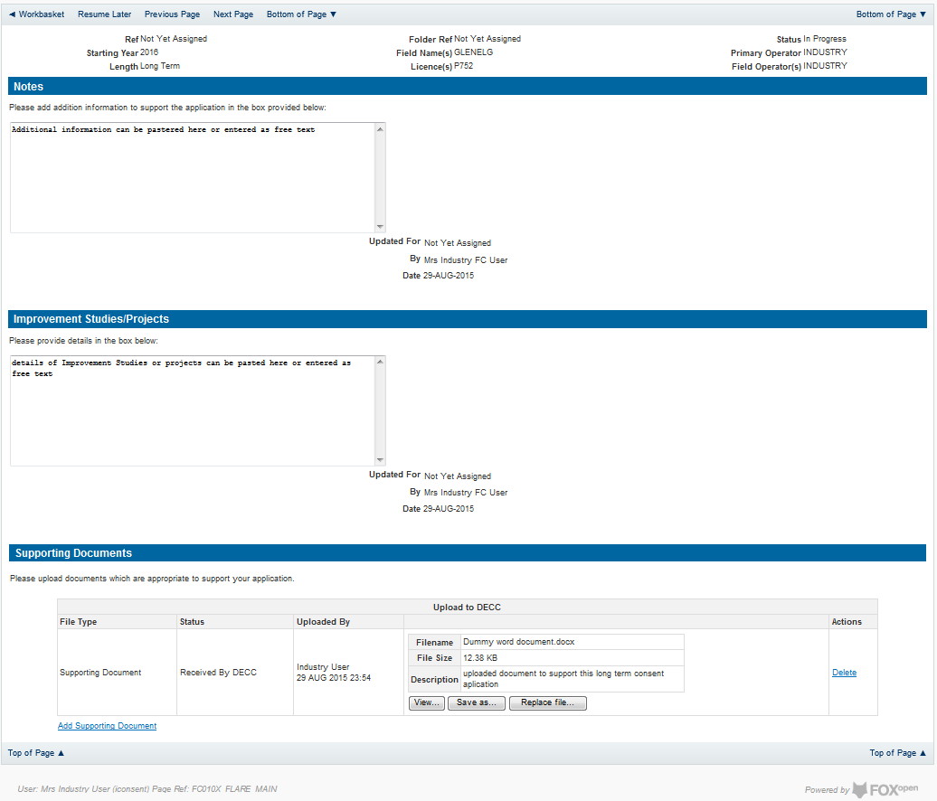

Click on ‘Next Page’ on the navigation bar to move to the next screen.

The Print Selection Screen allows the Operator to generate and print .pdf versions of the Flare Consent application. Check the boxes for the areas of the application you wish to create or click the ‘Select all’ link to choose all parts of the application. Click on the
‘Generate PDF’ button to produce the .pdf version of the Consent application. A copy will open in .pdf format in a new tab in the browser.

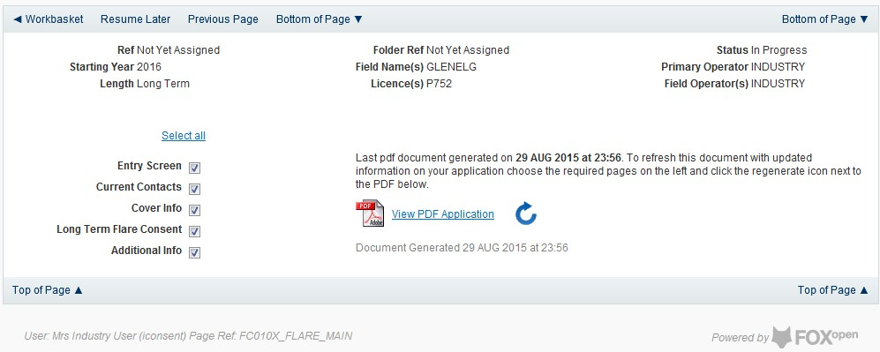

If the Consent application is ready to submit click on the submit button on the left hand menu to proceed to the next stage.

Once the ‘Submit’ button is pressed the Field Consents System will check all the entries made on the consent application. If any on the entries are invalid or missing they will be displayed in an error summary. Any errors must be rectified before the application can be submitted.

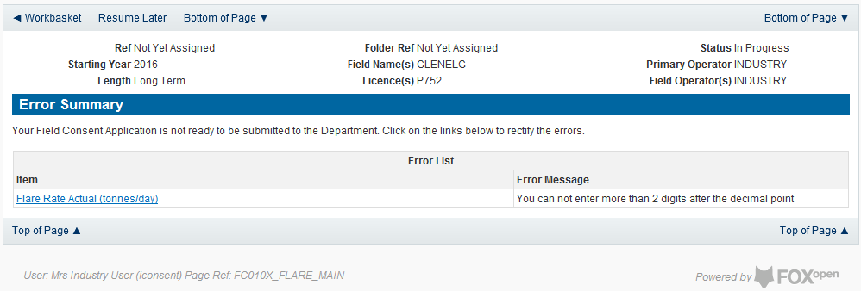

Click on the item on the errors list and you will be taken to the screen where the error is contained.

The error will be indicated by a red cross.

Hovering over the cross will give an indication of what has caused the entry to be invalid. Correct the error and click on the ‘Error Summary’ link on the left hand menu.

If there are still errors on the application they will still appear in the errors list. Repeat the process to view and correct all errors until all corrections have been made. The error summary will be empty.
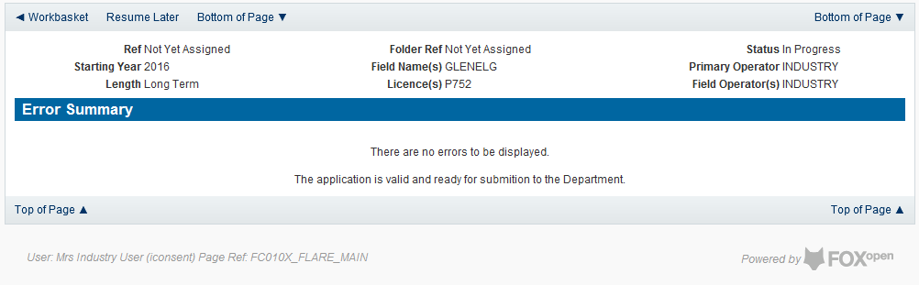

Click on the ‘Submit’ link on the left hand menu to go to the submission screen.

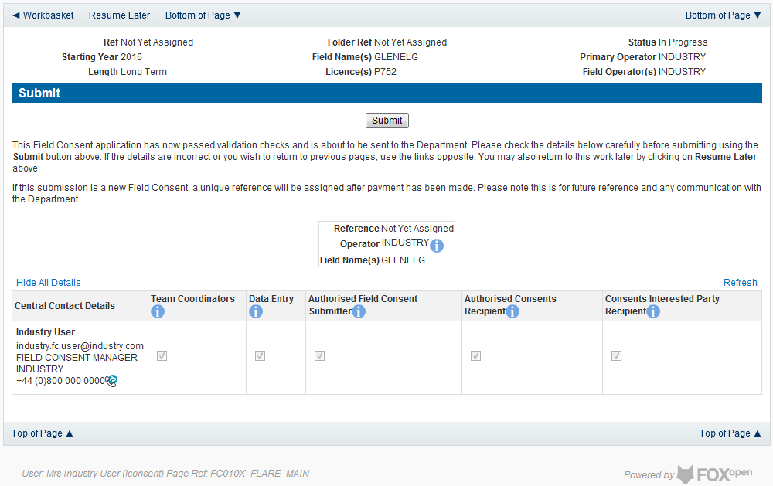

YOU MUST CLICK ON THE ‘SUBMIT’ BUTTON ON THIS PAGE TO MAKE THE PAYMENT AND FINALISE THE SUBMISSION PROCESS
Clicking the ‘Submit’ button will send the application to the OGA Consents team and take the Operator to the payment screen. Details on how to make payments are contained in the in “Processing Payments” section later in this guide document.

Submitting a new Venting Consent application
New Venting Consent applications can be submitted for UK Fields on a short term, Annual or long term basis
The Operator must log in to the UK Energy Portal at this URL: https://itportal.decc.gov.uk/eng/fox/live/PORTAL_LOGIN/login
After logging in the Operator will be taken to their Portal Workbasket. The workbasket will contain all notifications and actions for transactions made using the UK Energy Portal.
From the workbasket click on ‘Field Consents’ from the left hand menu

This takes the operator into the Field Consents System search screen.

From the search screen you are able to search for all field consents which have been submitted on behalf of the operators company. The Operator is able to set various search option parameters before requesting the results.
To begin a new consent application click on ‘New Field Consent from the left hand menu from the Field Consents System search screen

From the New Field Consent screen select the year for the start of the consent period from the drop down list. Select the type of consent, ‘Vent Consent’, from the drop down list.
Click on ‘Create’ to generate a new blank Venting Consent.
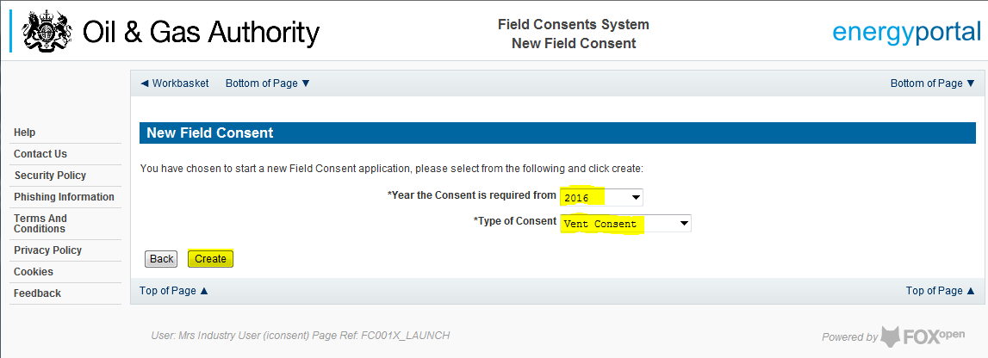

This will have created a new Vent Consent application which needs to be populated with the required data. The new application will open on the Entry Screen which gives the Operator a list of OGA contacts and links to guidance on completing flaring, venting and production consent application

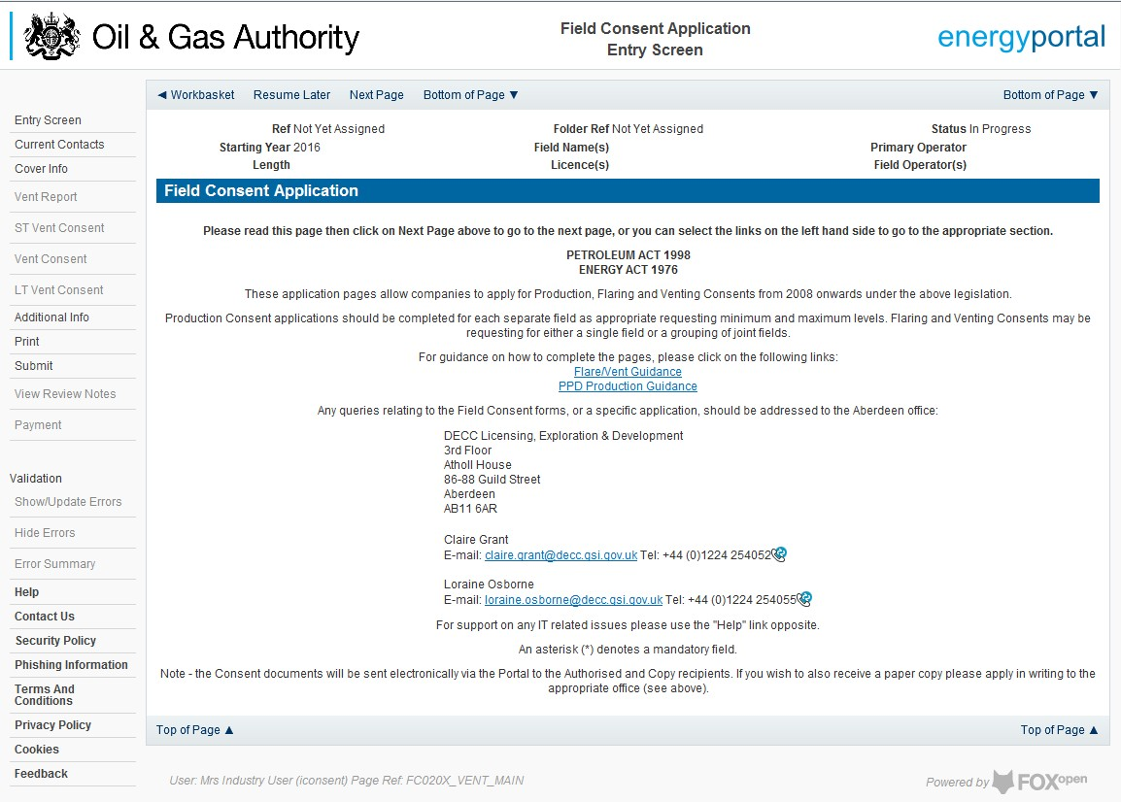

Use the navigation bar at the top of the form to navigate to the next page to display the Operators team of people who will be involved in the preparation and submission of this application. By default the person creating the application is enrolled in the team with all available roles

IT IS STRONGLY RECOMMENDED THAT MORE THAN ONE PERSON IS ENROLLED IN THE CONSENTS TEAMS TO AVOID DELAYS IN THE SUBMISSION AND APPROVAL PROCESS.
Please see the section “Controlling Access using Field Consents Teams and Contacts”

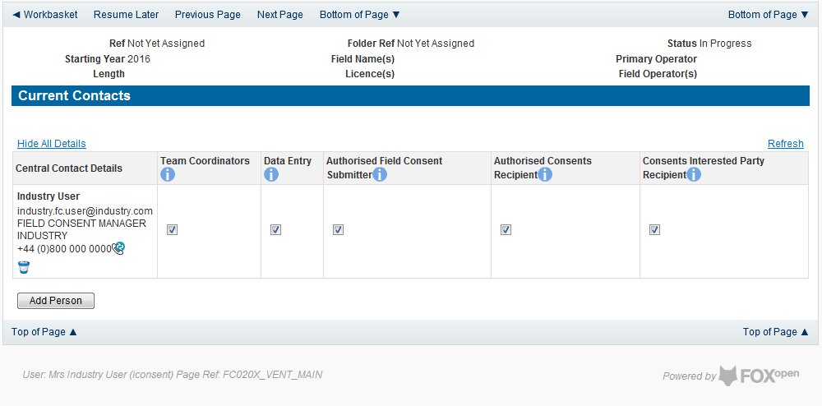

Click the ‘Next page’ link to proceed with the application.

On the next screen, Cover Info, the operator will define the length of time for which the Vent Consent is being applied. There are three terms for which a Flare Consent may be requested: Short Term, Annual, and Long term.
The process differs slightly in the data required for each type of consent length.

New Short Term Vent Consent
Short term venting can be issued for occasions when, for operational or safety reasons the Operator needs to vent hydrocarbons in excess of their normal consent allowance or for periods where a new field is beginning to prepare for first production.
The Cover Info page is where the Operator is able to define the Field(s) and duration for the consent being applied for.
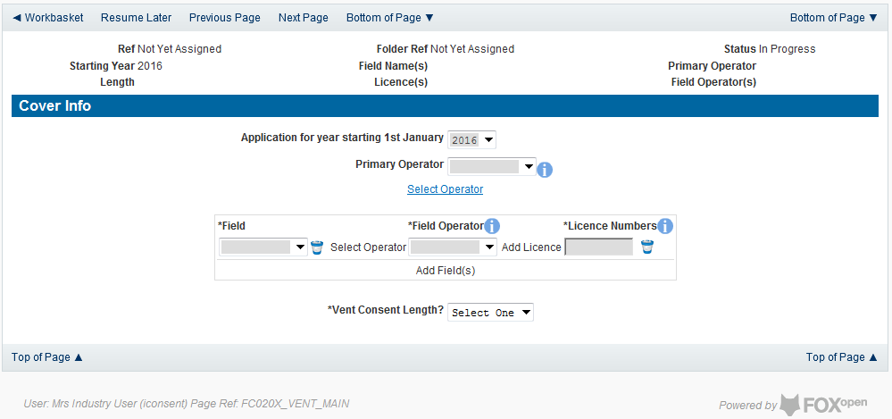

The Operator is chosen by searching for the operators name from the approved list of Operators registered with the UK Energy Portal. To use the search facility click on the select Operator link on the screen:
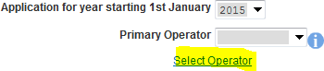

This will open the Organisation Directory Search Screen

Enter the name (or the beginning letters) of the name of the Operator Responsible for the Field for which the consent is being prepared. E.G. Entering ‘tes’ as the organisation and clicking on ‘Search’ will return search results of TESSENDERLO UK LIMITED and TEST COMPANY LTD. Click on the ‘Select’ link to inset the Organisation into the application.
Add the field for which the production consent is being prepared. To add the field click on the ‘Add Field’ link on the screen.

This will open the DEVUK Field Search Screen
Enter the name (or the beginning letters) of the name of the Field name for which the consent is being prepared. E.G. Entering ‘bren’ as the Field Name and clicking on ‘Search’ will return search results of BRENDA and BRENT. Click on the ‘Select’ link to the right of the correct Field Name to inset the Field into the application.
The Licence Number(s) associated with the Field are automatically entered into the application.

To add further Fields into the application click the ‘Select Field link and repeat the process. Any additional fields added to the application will also add any further associated Licences to the application.
Select the field at which the venting is going to take place by clicking the drop down menu next to the question “Which field are the venting facilities located?” and selecting the correct Field name.
Set the Vent Consent Length to ‘Short Term’ by selecting this option from the drop down menu.
The Consent Start Date and End date are not entered at this point. These items will be populated from information provided later in the application process.
Select the UKCS location of the Field for which the consent is being applied for. This is selected from the drop down menu.
Select the Field at which the venting will be recorded from the drop down menu.

The Vent Consent Requested item is not entered at this point. This item will be populated from information provided later in the application process.
Enter the figure allocated to the Operator for venting at this facility from the consent issues for the previous period.
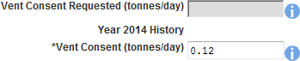

The screen should now be completely populated. Click on ‘Next Page’ on the navigation bar to move to the Short Term Vent Consent request page and continue the application process.
Enter the dates for which the consent is due to start and end by using the calendar widget or manually entering the dates, then clicking on the ‘Initialise Term’ button.

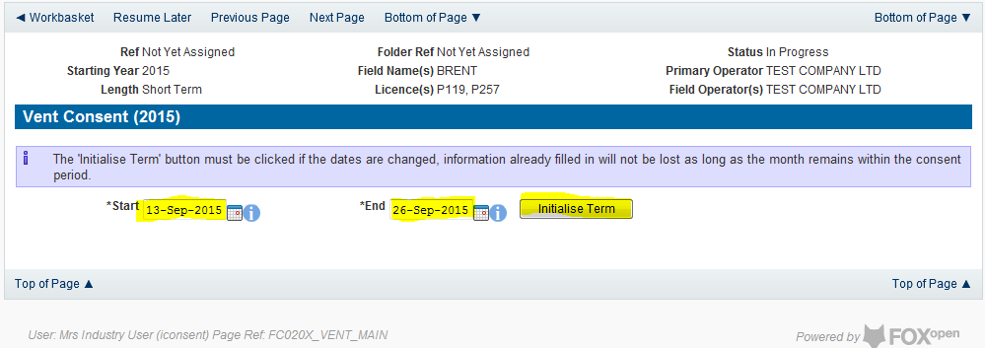

Once the Initialise term button has been pushed the screen will display the areas where the Operators’ requested vent allowances are recorded. For each period on the screen the Operator must enter the requested figure for categories A, B and C. If the Operator wishes to add a comment to the figures for a requested month it can be entered in the comments box on the right hand side of the monthly figures.

Select ‘ST Vent Consent’ from the left hand menu to continue the application process, to add details for the Vent Consent.

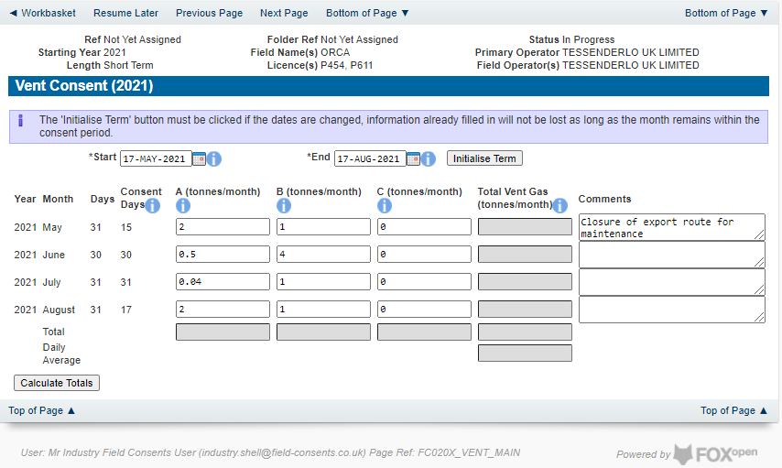

Once figures have been entered click on the ‘Calculate Totals’ button to populate the total and Daily Average figures on the screen.

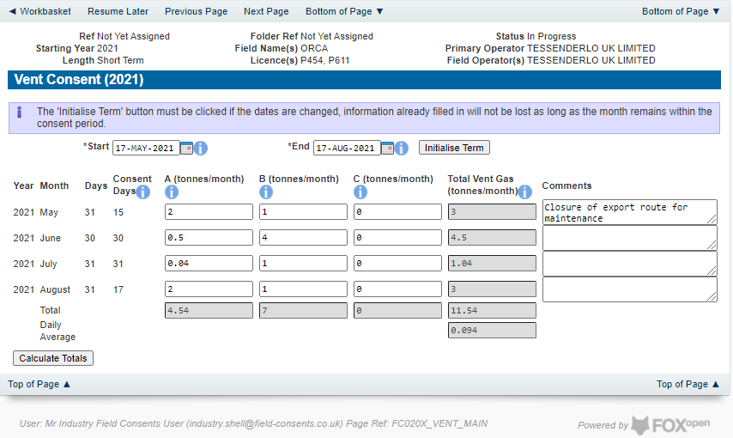

Clicking the ‘Calculate Totals’ button will also populate the Consent start and end dates and the requested vent consent information on the Cover Info page.

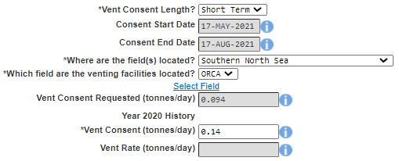

Select ‘Vent Report’ from the left hand menu to provide actuals data about the past 12 months of flaring
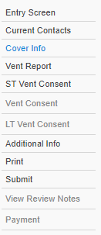

The next stage is to fill out the “Vent Report”. This is where Operators must supply details of the amount of venting reported for the past 12 months from the date of application for Categories A, B and C (i.e. for an application with a start date from May 2021, the report will need complete data from the period May 2020 – April 2021) along with details of the measuring method used for recording the reported figures. If, for any reason (such as operational/new field), figures are not available for the whole period months can be removed from this list by clicking the ‘Remove Month From End’ button. Operators should provide reasons for incomplete figures due to unavailable months in the comment box of the last month reported for the vent report.

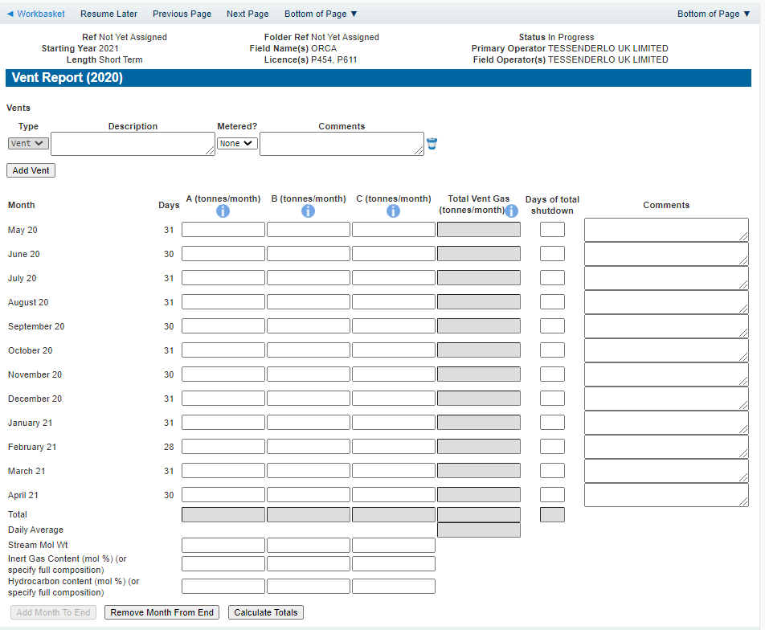

Enter the details of the recorded vent figures

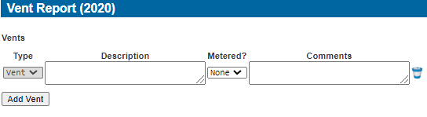
Items on this list may be removed by click the remove icon to the right hand side of the entry
Extra entries may be added if needed by clicking on the ‘Add Vent button

It is an optional indication to give information on whether the vent was metered or not. An optional comments box is also available to allow freehand text comments.
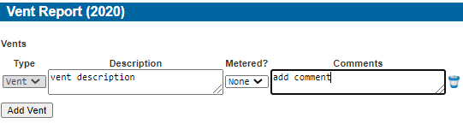

Details of the monthly venting activity is recorded in the next section along with details of days a Field may have been shut in and a comments box to add notes relating to the entry.

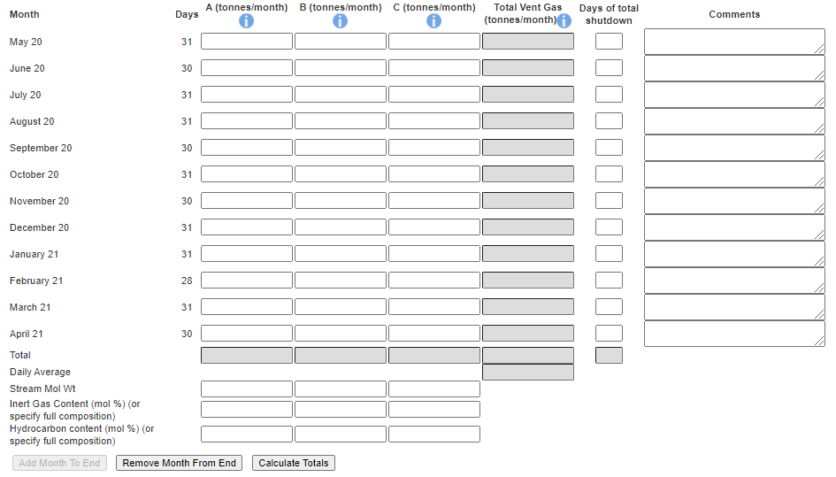
By default the screen request details for the year before the consent date (i.e. May 2020 – April 2021 request for a consent starting May 2021 as above). Figures for the entire period must be filled in. If, for any reason (such as operational/new field), figures are not available for the whole period months can be removed from this list by clicking the ‘Remove Month From End’ button. Operators should provide reasons for incomplete figures due to unavailable months in the comment box of the last month reported for the vent report

The reported figures should be populated in the appropriate sections on the screen

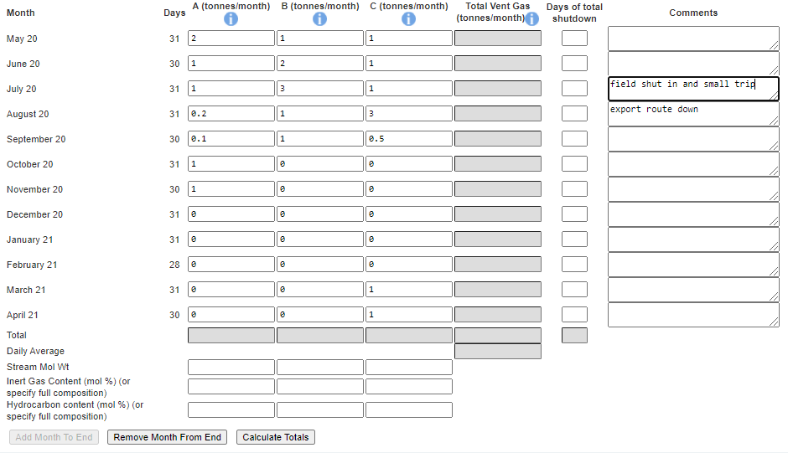

Once the data has been populated click on the ‘Calculate Totals’ and the Field Consents system will calculate the monthly totals and the totals for the whole of the period being reported.

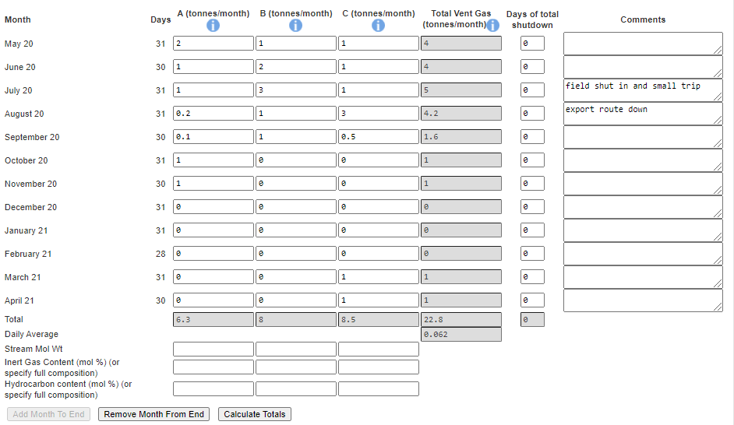
The system will also populate the actual Vent rate item contained on the Cover Info page which was previously greyed out and could not be entered manually

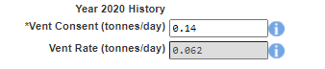

Click on ‘Next Page’ on the navigation bar to continue the application process and move to the Additional info screen

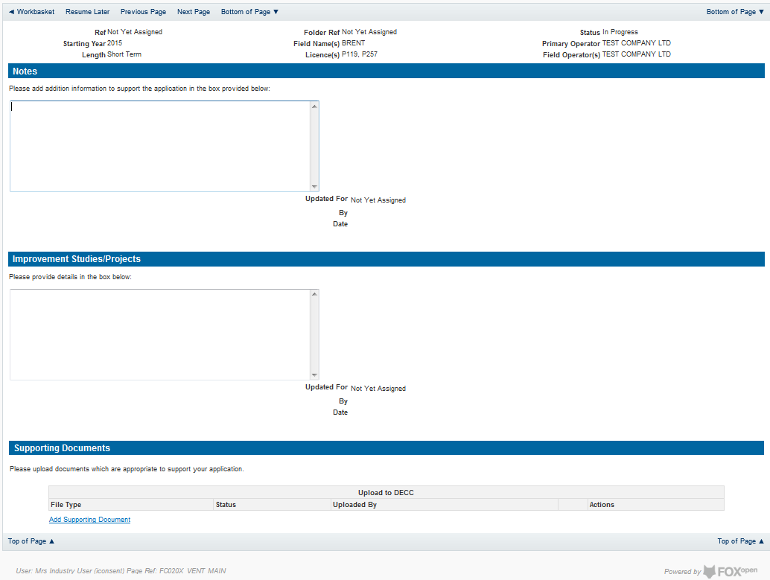

Additional notes can be added in the notes box using free text or copied and pasted from other applications. These notes are automatically saved when the Operator navigates away from the page.
Details can also be recorded relating to improvement studies and projects on this page. These details can be types as free text or pasted from other applications. Any added details are automatically save when the Operator navigates away from the page.
Supporting documentation can also be uploaded by clicking on the ‘Add Supporting Document’ Link on this page.

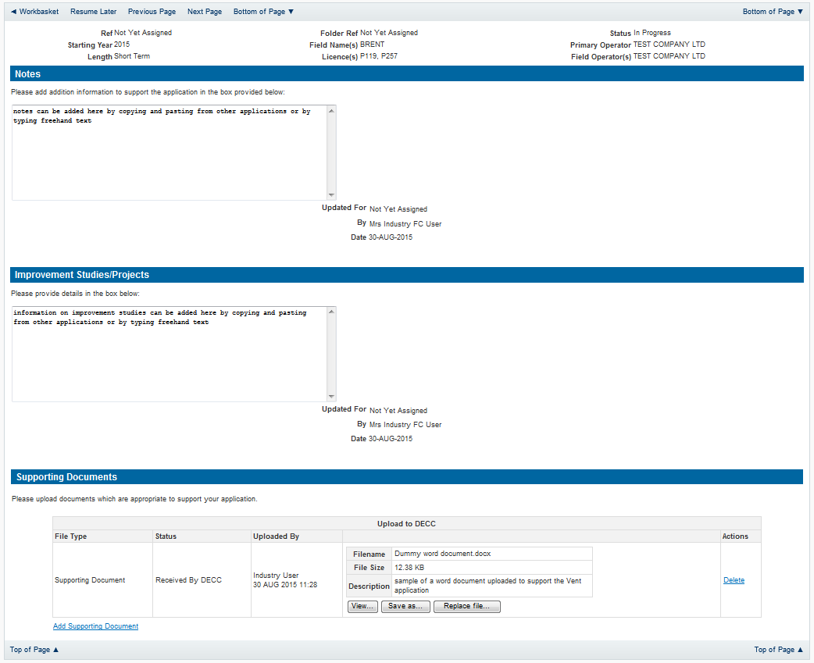

Click on ‘Next Page’ on the navigation bar to move to the next screen.

The Print Selection Screen allows the Operator to generate and print .pdf versions of the Flare Consent application. Check the boxes for the areas of the application you wish to create or click the ‘Select all’ link to choose all parts of the application. Click on the
‘Generate pdf’ button to produce the .pdf version of the Consent application. A copy will open in .pdf format in a new tab in the browser.
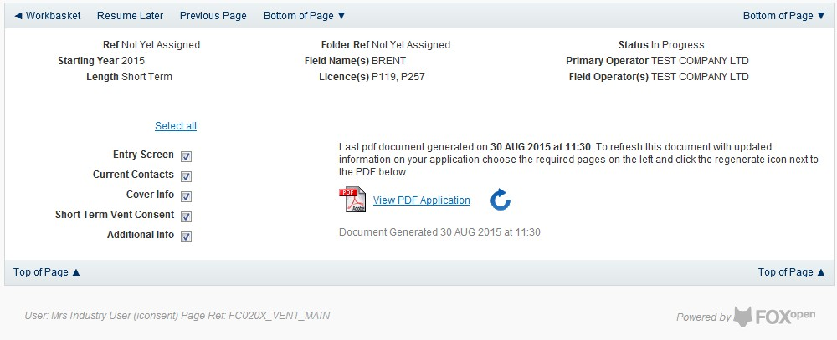

If the Consent application is ready to submit click on the submit button on the left hand menu to proceed to the next stage.
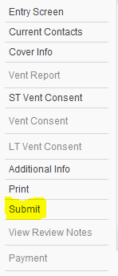

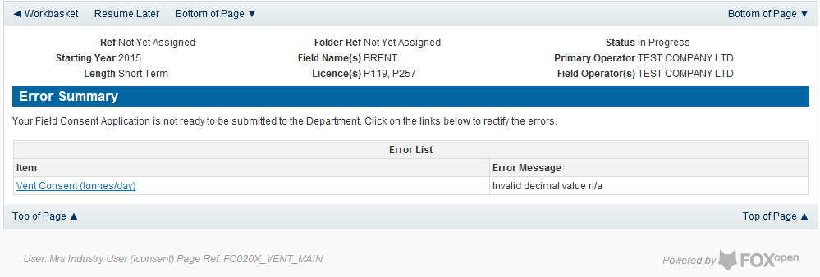
Once the ‘Submit’ button is pressed the Field Consents System will check all the entries made on the consent application. If any on the entries are invalid or missing they will be displayed in an error summary. Any error must be rectified before the application can be submitted.

Click on the item on the errors list and you will be taken to the screen containing the error. The error will be indicated by a red cross.

Hovering over the cross will give an indication of what has caused the entry to be invalid. Correct the error and click on the ‘Error Summary’ link on the left hand menu.

If there are still errors on the application they will still appear in the errors list. Repeat the process to view and correct all errors until all corrections have been made. The error summary will be empty.
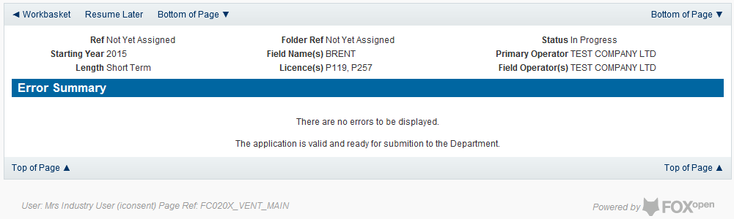

Click on the Submit link on the left hand menu to go to the submission screen.
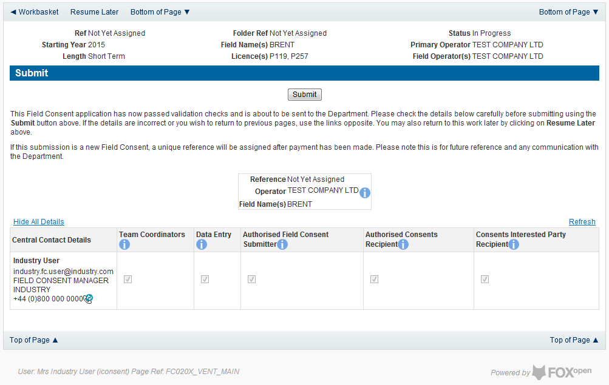

YOU MUST CLICK ON THE ‘SUBMIT’ BUTTON ON THIS PAGE TO PAY FOR THIS APPLICATION AND FINALISE THE SUBMISSION PROCESS
Clicking the ‘Submit button will send the application to the OGA Consents team and take the Operator to the payment screen. Details on how to make payments are contained in the in “Processing Payments” section later in this guide document.

New Annual Vent Consent
Follow the process for creating a blank Venting Consent application described above and proceed to the Cover Info screen
The Cover Info page is where the Operator is able to define the Field(s) and duration for the consent being applied for.
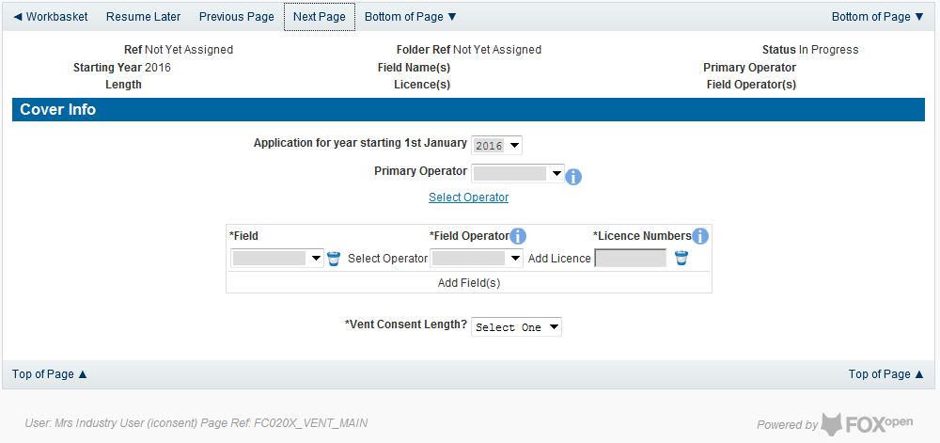

The Operator is chosen by searching for the operators name from the approved list of Operators registered with the UK Energy Portal. To use the search facility click on the select Operator link on the screen:

This will open the Organisation Directory Search Screen

Enter the name (or the beginning letters) of the name of the Operator Responsible for the Field for which the consent is being prepared. E.G. Entering ‘tes’ as the organisation and clicking on ‘Search’ will return search results of TESSENDERLO UK LIMITED and TEST COMPANY LTD. Click on the ‘Select’ link to inset the Organisation into the application.
Add the field for which the venting consent is being prepared. To add the field click on the ‘Add Field’ link on the screen.
This will open the DEVUK Field Search Screen

Enter the name (or the beginning letters) of the name of the Field name for which the consent is being prepared. E.G. Entering ‘bren’ as the Field Name and clicking on ‘Search’ will return search results of BRENDA and BRENT. Click on the ‘Select’ link to the right of the correct Field Name to inset the Field into the application
The Licence Number(s) associated with the Field are automatically entered into the application.

To add further Fields into the application click the ‘Select Field link and repeat the process. Any additional fields added to the application will also add any further associated Licences to the application.

Select the field at which the venting is going to take place by clicking the drop down menu next to the question “Which field are the venting facilities located?” and selecting the correct Field name.
Set the Vent Consent Length to ‘Annual’ by selecting this option from the drop down menu. Adding the consent length will open further areas for which information is required.
Set the Field Location by selecting the area from the drop down box.

Select the field at which the venting will be taking place from the drop down list.

Finally, enter the figure which was granted for the previous Consent Period.
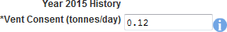

The Figure for the requested Vent quantity for this new application and Vent rate for the previous (or current) period are not enterable. These figures are automatically generated from the Vent Report and the Vent Request data supplied later in the process.
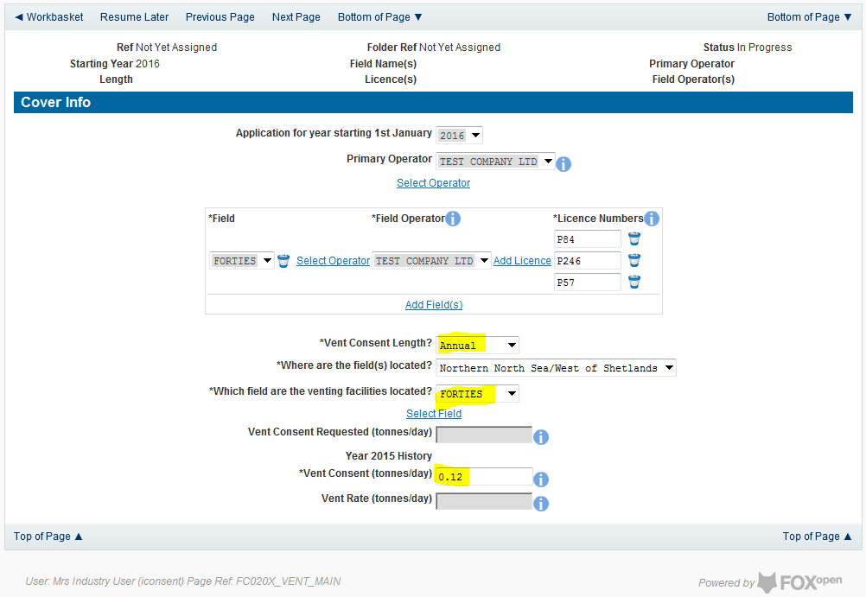

The screen should now be completely populated. Click on ‘Next Page’ on the navigation bar to move to the vent report screen and continue the application process.
The next stage in the process to supply details of the amount of venting reported for the past 12 months from the date of application (October to September) for categories A, B and C along with details of the measuring method used for reported figures.

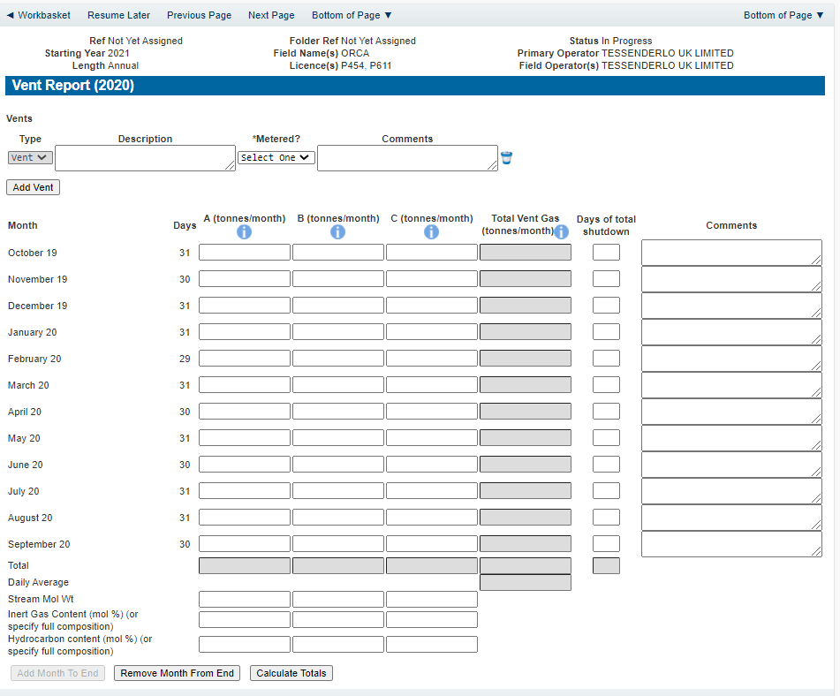

Enter the details of the recorded vent figures.
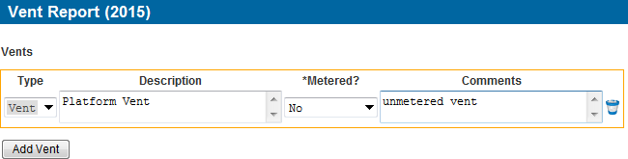

Extra entries may be added if needed by clicking on the ‘Add Vent’ button

Each item in the list of vents should contain an optional description and a mandatory indication of if this vent was metered or not. An optional comments box is available to allow freehand text comments.
Details of the monthly venting activity is recorded in the next section along with details of days a Field may have been shut in and a comments box to add notes relating to the entry.

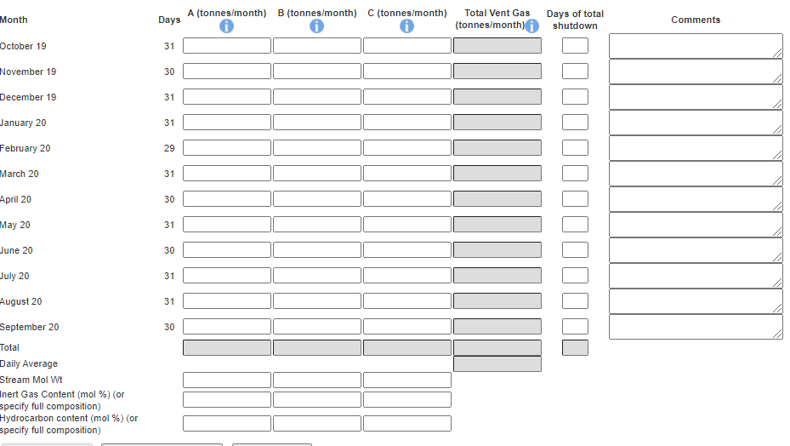

By default the screen request details for October to September. Figures for the entire October to September period should be filled in. If, for any reason (such as operational/new field), figures are not available for the whole period months can be removed from this list by clicking the ‘Remove Month From End’ button. Operators should provide reasons for incomplete figures due to unavailable months in the comment box of the last month reported for the vent report.

The reported figures should be populated in the appropriate sections on the screen

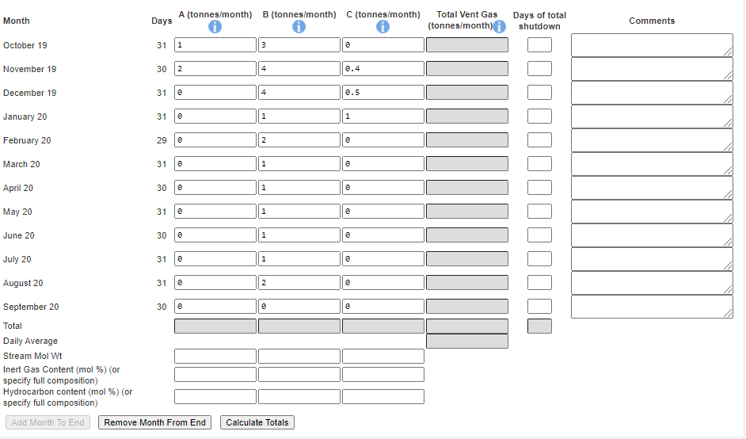

Click on ‘Calculate Totals’ to populate the totals on this screen.

The system will also populate the Vent Rate item contained on the Cover Info page which was previously greyed out and could not be entered manually.

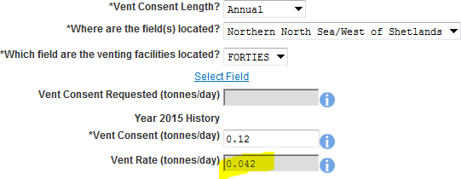

Click on ‘Next Page’ on the navigation bar to continue the application process and move to the Vent Request screen.
The Operator must supply reasonable estimates of the amount of hydrocarbon the will required for venting purposes during the consent period.

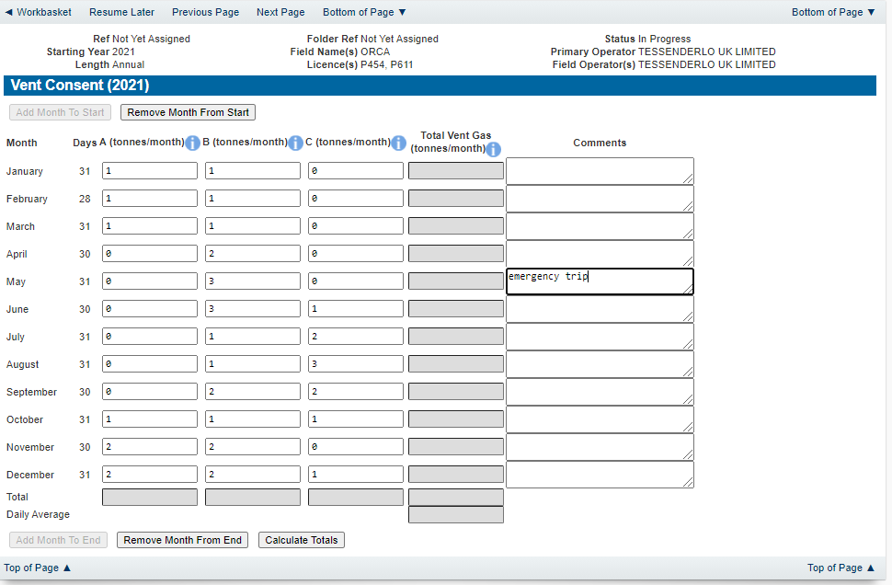

Click on the ‘Calculate Totals’ button to populate the total and Daily Average on this screen.

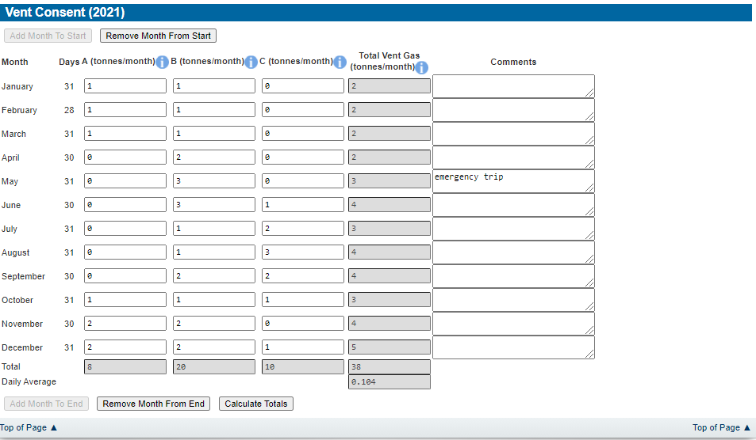

Clicking the ‘Calculate Totals’ button will also populate the Requested Vent Consent figure on the Cover Info page which were greyed out and could not be entered manually.

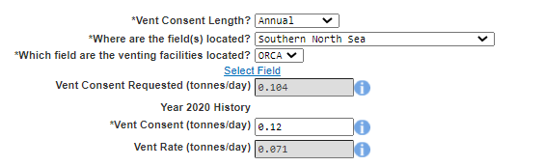
Click on ‘Next Page’ on the navigation bar to continue the application process and move to the Additional info screen.
Additional notes can be added in the notes box using free text or copied and pasted from other applications. These notes are automatically saved when the Operator navigates away from the page.

Details can also be recorded relating to improvement studies and projects on this page. These details can be types as free text or pasted from other applications. Any added details are automatically save when the Operator navigates away from the page.
Supporting documentation can also be uploaded by clicking on the ‘Add Supporting Document’ Link on this page.

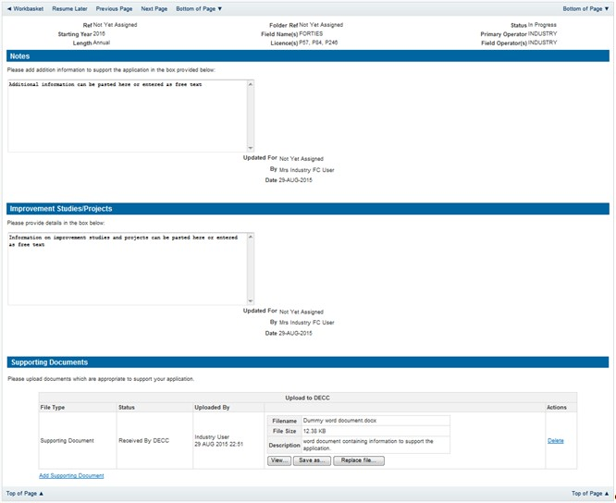

Click on ‘Next Page’ on the navigation bar to move to the next screen.

The Print Selection Screen allows the Operator to generate and print .pdf versions of the Flare Consent application. Check the boxes for the areas of the application you wish to create or click the ‘Select all’ link to choose all parts of the application. Click on the
‘Generate PDF’ button to produce the .pdf version of the Consent application. A copy will open in .pdf format in a new tab in the browser.

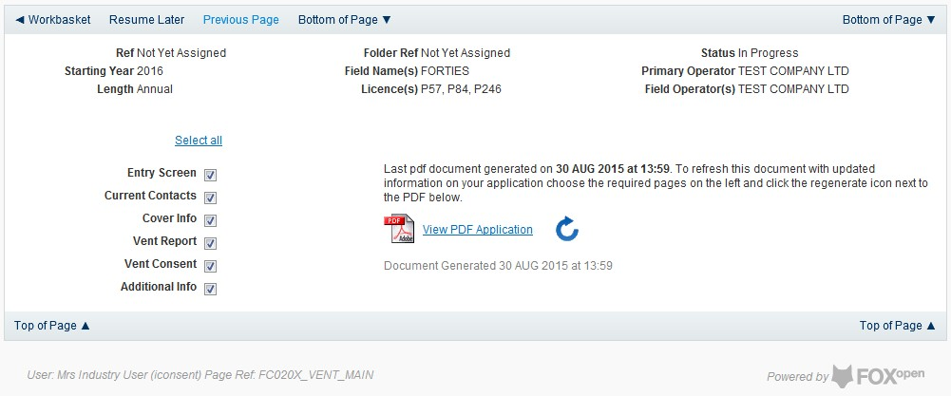

If the Consent application is ready to submit click on the submit button on the left hand menu to proceed to the next stage.
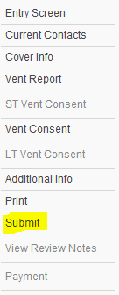

Once the ‘Submit’ button is pressed the Field Consents System will check all the entries made on the consent application. If any on the entries are invalid or missing they will be displayed in an error summary. Any error must be rectified before the application can be submitted.
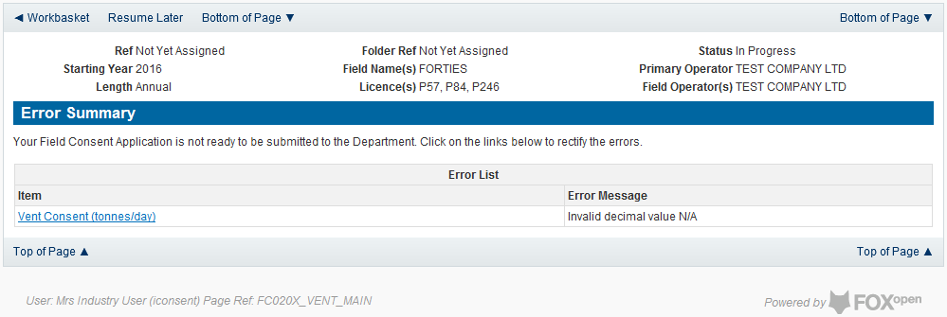

Click on the item on the errors list and you will be taken to the screen where the error is contained.

The error will be indicated by a red cross.

Hovering over the cross will give an indication of what has caused the entry to be invalid. Correct the error and click on the ‘Error Summary’ link on the left hand menu.

If there are still errors on the application they will still appear in the errors list. Repeat the process to view and correct all errors until all corrections have been made. The error summary will be empty.
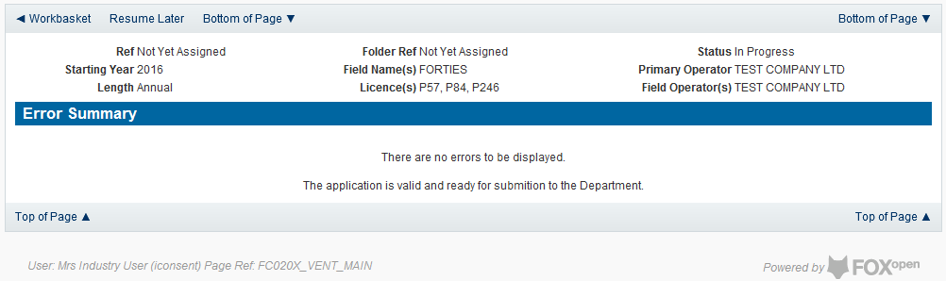

Click on the Submit link on the left hand menu to go to the submission screen.

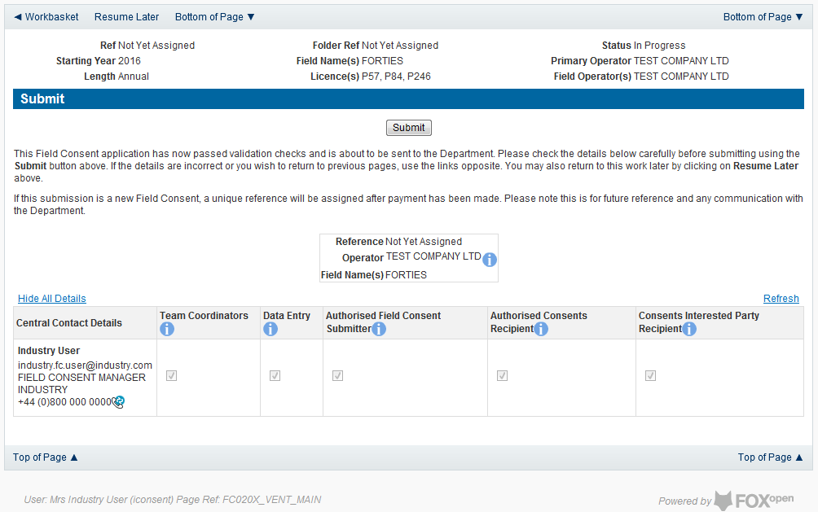

YOU MUST CLICK ON THE ‘SUBMIT’ BUTTON ON THIS PAGE TO PAY FOR THIS APPLICATION AND FINALISE THE SUBMISSION PROCESS
Clicking the ‘Submit’ button will send the application to the OGA Consents team and take the Operator to the payment screen. Details on how to make payments are contained in the in “Processing Payments” section later in this guide document.

New Long Term Vent Consent
Long term vent consents are currently only granted for onshore Fields

Follow the process for creating a blank Venting Consent application described above and proceed to the Cover Info screen
The Cover Info page is where the Operator is able to define the Field(s) and duration for the consent being applied for.
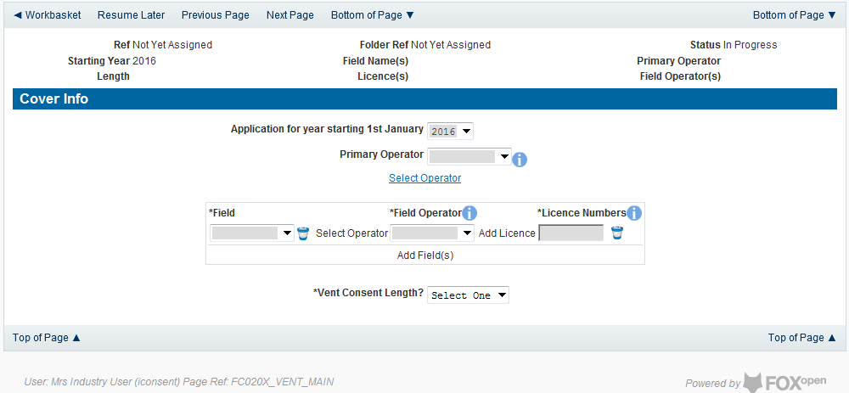

The Operator is chosen by searching for the operators name from the approved list of Operators registered with the UK Energy Portal. To use the search facility click on the select Operator link on the screen:

This will open the Organisation Directory Search Screen

Enter the name (or the beginning letters) of the name of the Operator Responsible for the Field for which the consent is being prepared. E.G. Entering ‘tes’ as the organisation and clicking on ‘Search’ will return search results of TESSENDERLO UK LIMITED and TEST COMPANY LTD. Click on the ‘Select’ link to inset the Organisation into the application.
Add the field for which the production consent is being prepared. To add the field click on the ‘Add Field’ link on the screen.

This will open the DEVUK Field Search Screen
Enter the name (or the beginning letters) of the name of the Field name for which the consent is being prepared. E.G. Entering ‘bren’ as the Field Name and clicking on ‘Search’ will return search results of BRENDA and BRENT. Click on the ‘Select’ link to the right of the correct Field Name to inset the Field into the application
The Licence Number(s) associated with the Field are automatically entered into the application.

To add further Fields into the application click the ‘Select Field link and repeat the process. Any additional fields added to the application will also add any further associated Licences to the application.
Set the vent Consent Length to ‘Long Term’ by selecting this option from the drop down menu.
When the duration had been set to ‘Long Term’ further items which need to be completed will be displayed on the screen.
Select the field at which the venting is going to take place by clicking the drop down menu next to the question “Which field are the venting facilities located?” and selecting the correct Field name.

Enter the Consent figure for Venting which was granted during the current (or previous) consent period.

Enter the actual vent rate reported by the Operator for the current (or previous)consent period.

The screen should now be completely populated. Click on ‘Next Page’ on the navigation bar to continue to the Long Term Vent Request Page and continue the application process.

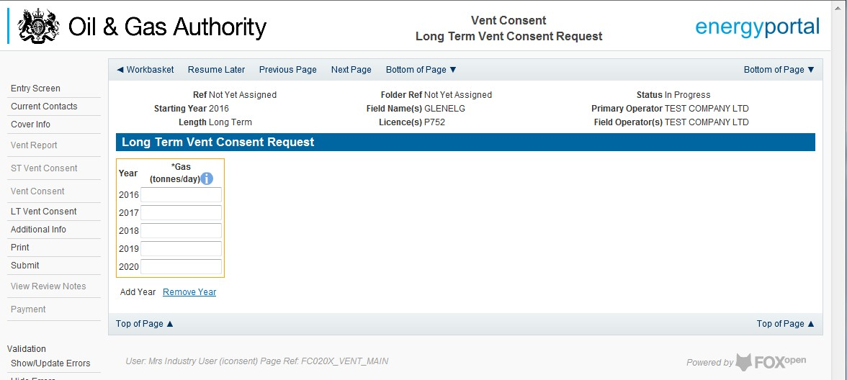

By default the Long Term Vent request screen allocates a maximum of a five year period for which the Operator may submit a long term Vent Consent. This period may be reduced to a minimum of two tears by clicking on the ‘Remove Year’ link on this page.
The operator must provide an average figure that they reasonably expect to need to Vent per day for each year for the consent period.
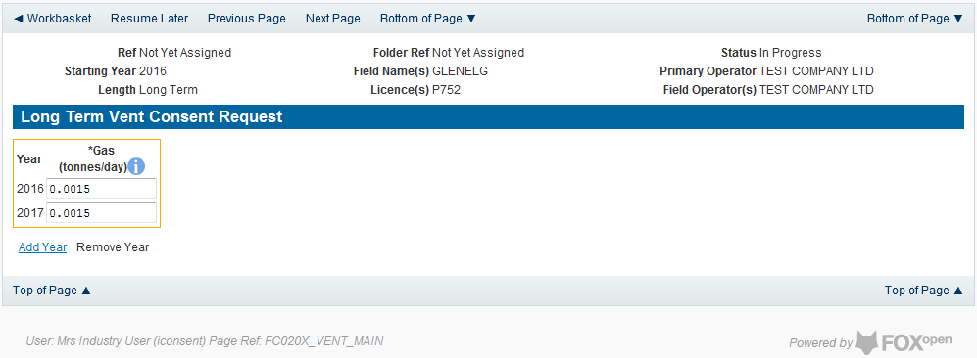

Click on ‘Next Page’ on the navigation bar to continue to the additional Information screen and proceed with the application.

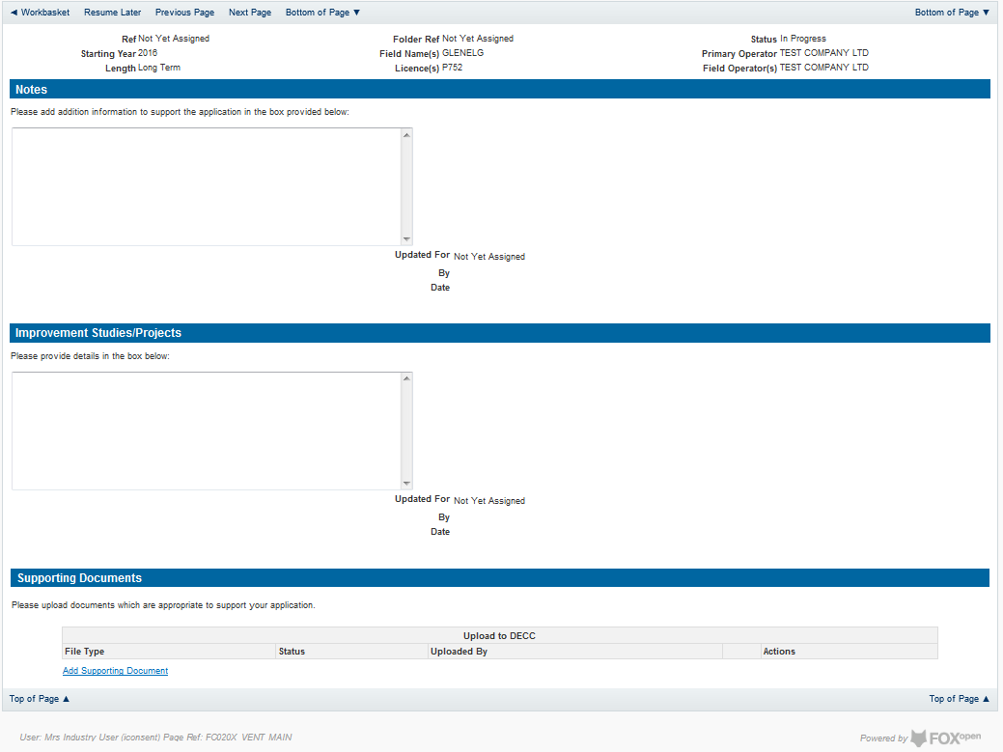

Additional notes can be added in the notes box using free text or copied and pasted from other applications. These notes are automatically saved when the Operator navigates away from the page.
Details can also be recorded relating to improvement studies and projects on this page. These details can be types as free text or pasted from other applications. Any added details are automatically save when the Operator navigates away from the page.
Supporting documentation can also be uploaded by clicking on the ‘Add Supporting Document’ Link on this page.

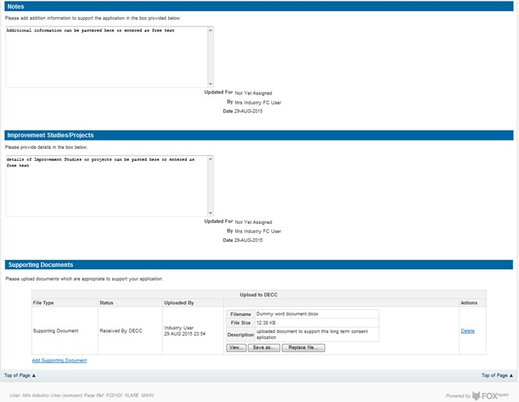

Click on ‘Next Page’ on the navigation bar to move to the next screen.

The Print Selection Screen allows the Operator to generate and print .pdf versions of the Flare Consent application. Check the boxes for the areas of the application you wish to create or click the ‘Select all’ link to choose all parts of the application. Click on the
‘Generate PDF’ button to produce the .pdf version of the Consent application. A copy will open in .pdf format in a new tab in the browser.
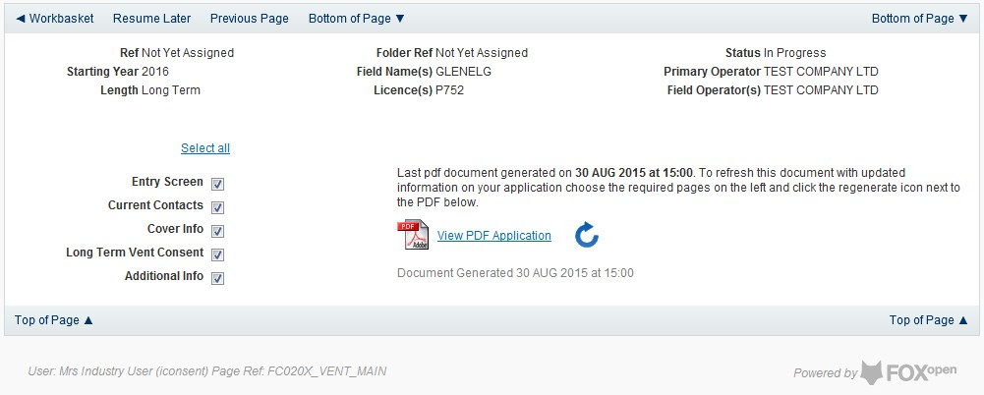

If the Consent application is ready to submit click on the submit button on the left hand menu to proceed to the next stage.

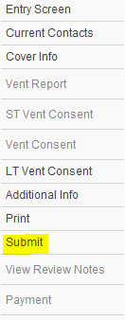

Once the ‘Submit’ button is pressed the Field Consents System will check all the entries made on the consent application. If any on the entries are invalid or missing they will be displayed in an error summary. Any errors must be rectified before the application can be submitted.
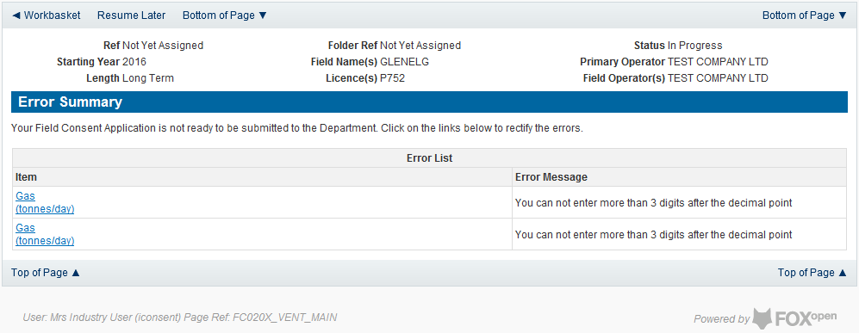

Click on the item on the errors list and you will be taken to the screen where the error is contained.

The error will be indicated by a red cross.

Hovering over the cross will give an indication of what has caused the entry to be invalid. Correct the error and click on the ‘Error Summary’ link on the left hand menu.

If there are still errors on the application they will still appear in the errors list. Repeat the process to view and correct all errors until all corrections have been made. The error summary will be empty.
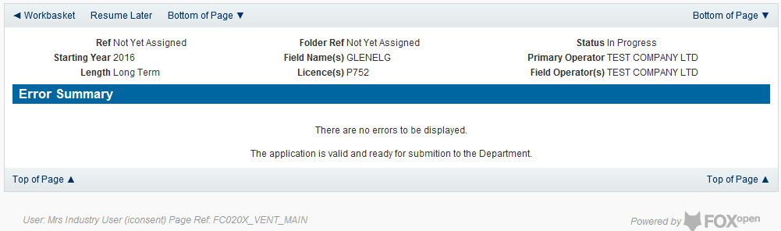

Click on the ‘Submit’ link on the left hand menu to go to the submission screen.
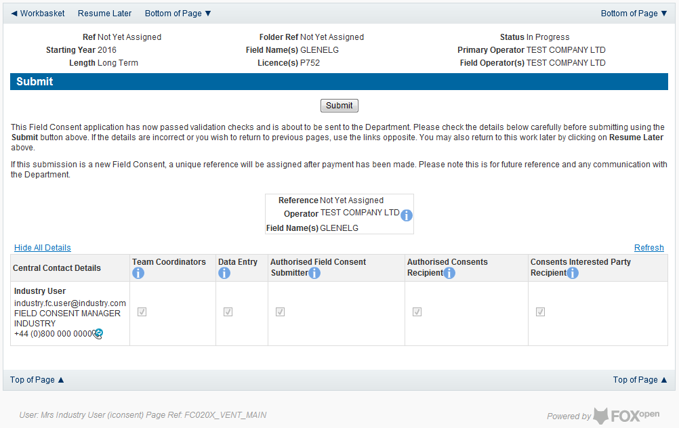

YOU MUST CLICK ON THE ‘SUBMIT’ BUTTON ON THIS PAGE TO MAKE THE PAYMENT AND FINALISE THE SUBMISSION PROCESS
Clicking the ‘Submit’ button will send the application to the OGA Consents team and take the Operator to the payment screen. Details on how to make payments are contained in the Processing Payments section contained later in this guide document.

Acknowledging receipt of Consents and viewing notifications

Acknowledging receipt of a consent
When the review process has been completed The OGA will issue all the parties involved with a field for which the consents has been approved a digitally signed copy of the Consent Document.
When the Consent is issued by The OGA, the interested parties will receive an email informing them that the consent has been issued and requesting that they acknowledge the receipt of the Consent.
It is the Operators responsibility to acknowledge the receipt of the consent document.

On receipt of the email the Operator should log into the UK Energy Portal.

In their Portal Workbasket they will see an entry for the completed and issued Consent.

If no entry is in the workbasket for the Consent listed in the notification email the Consent may have been acknowledged by another member of the Consent team. To check if a consent has been acknowledges by another team member please follow the viewing notifications guide below.
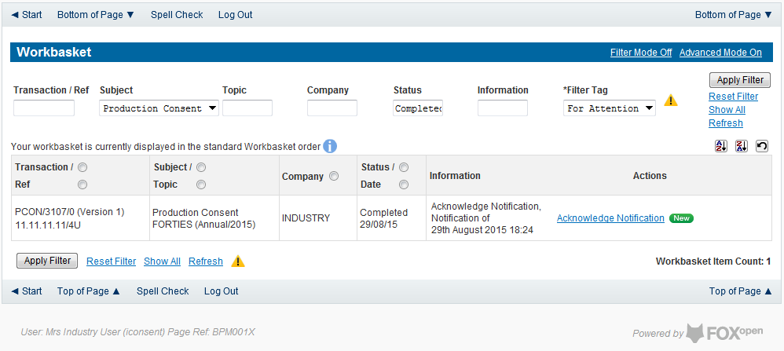
Click on the Acknowledge Notification link on the right hand side of the workbasket entry.

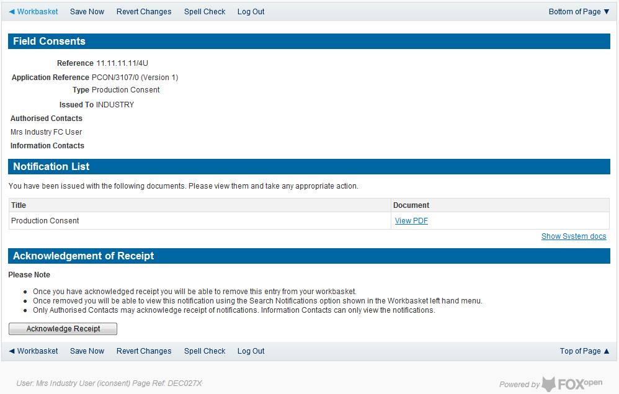
Clicking on the View PDF link will open an electronic copy of the signed Consent Document in .pdf format in a new tab within the browser.
Once the document has been checked the Operator must click the ‘Acknowledge Receilt’ button at the bottom of the page.
Any discrepancies with the information contained in the document should be raised with the OGA Consents team before the Acknowledge Receipt button is pressed. The contact details for the Consents team are contained in the Consent Application.
Once the button is pressed the acknowledgement is recorded against the Consent.

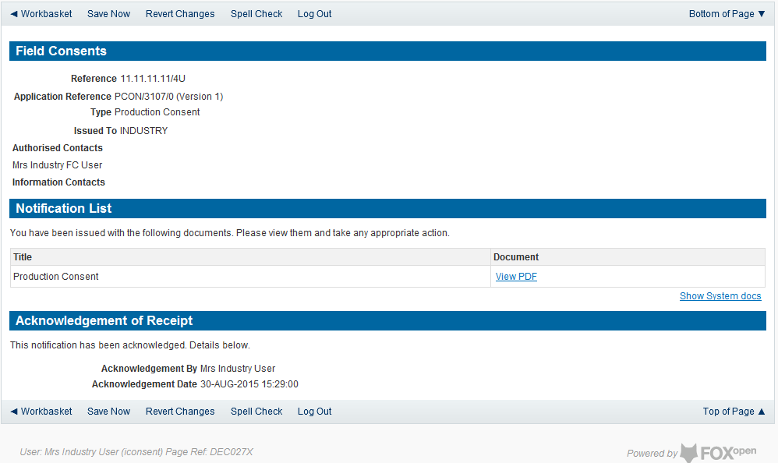

Click on Save now or Workbasket link in the navigation bar to return to the workbasket. The entry in the workbasket will now have a view notification link on the right hand side on the workbasket entry.
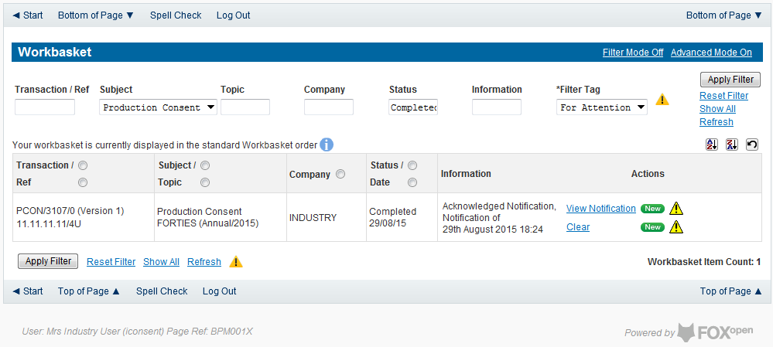

If the operator has no further actions to take on this Consent they should remove it from their workbasket by clicking the ‘Clear’ link on the right hand side of the workbasket entry.

Viewing Field Consent notifications
To view previous notification log in to the UK Energy Portal. On the left hand menu click on ‘Search Notifications’

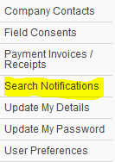

This will open the Notification search screen.
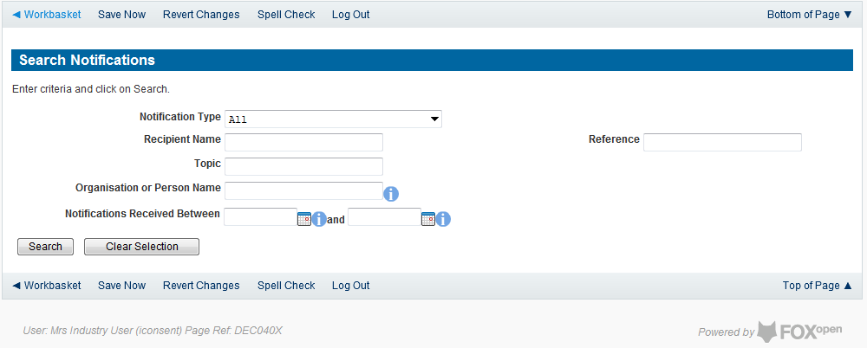

Select the notification type of ‘FC’ from the drop down menu. Enter any other search criteria in the appropriate section and click on ‘Search’.

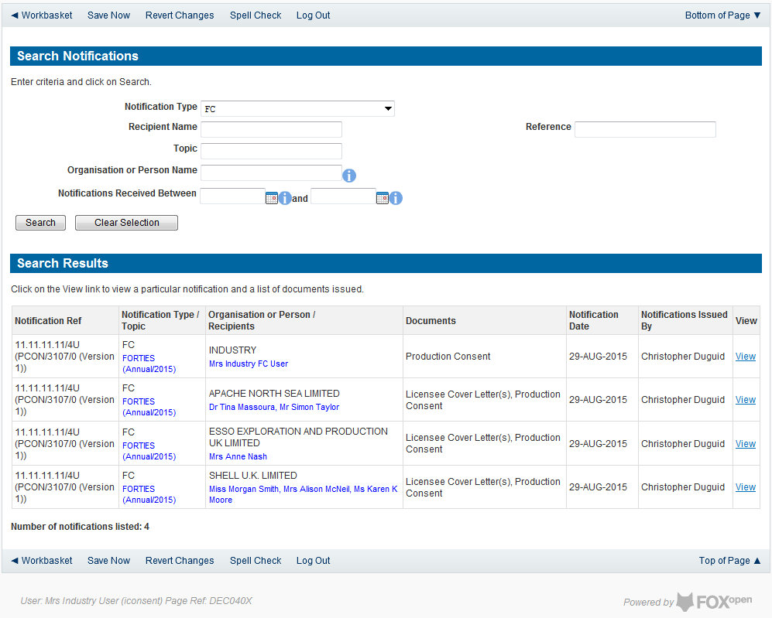

Click on ‘view’ to the right of entry in the search results list to go to the Field Consent Notification screen where the document can be viewed and details of who has acknowledged this notification.

Revising an existing Field Consent

The Operators have the ability to revise a Field Consent and re-submit it to The OGA for approval.
Only Field Consents which have been issued (Completed) and are current are able to be revised. The person who wishes to revise a consent must be a member of the team who manage the consent. Please see Controlling access using Field Consent Teams and Contacts in this document.
From the workbasket, Click on Field Consents on the Left Hand menu.

Select the Application Status of ‘Completed’ from the drop down list. Enter any further search criteria as required. Click on Search.
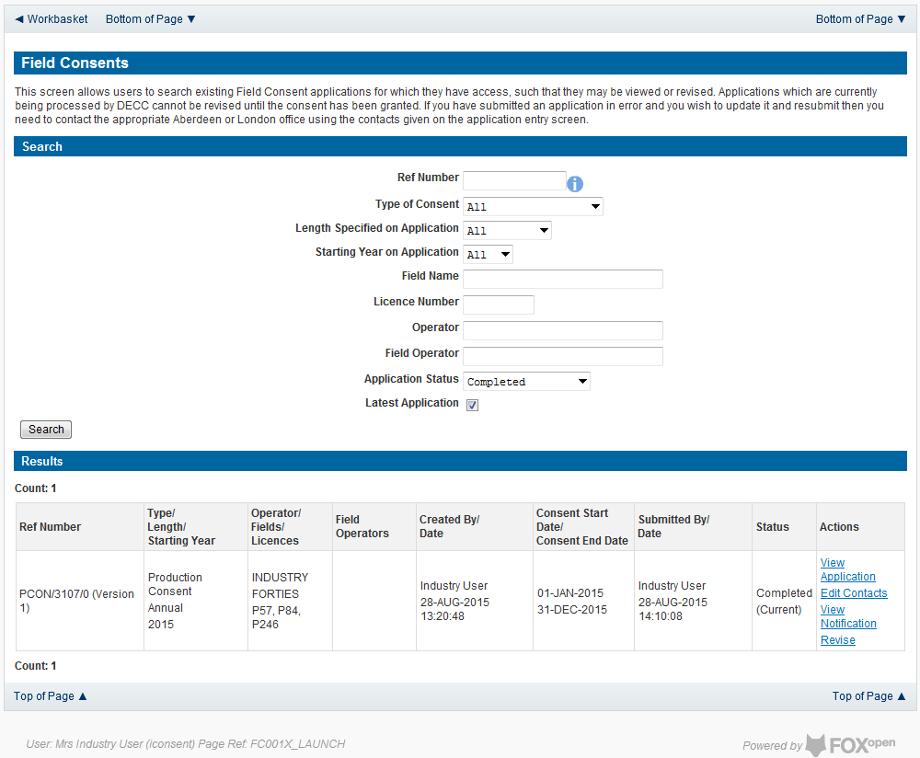

Click on the ‘Revise’ link to the right of the entry in the results list to begin a revision. The operator will be given a message box as a warning that the Consent is about to be revised and an option to cancel the revision.

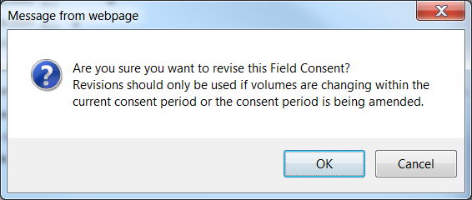

Click on OK to create the new revision.

At this point the original consent is still active. A revision has been created with a new reference number. The original version of the consent will have a reference number of PCON (or FCON or VCON for flaring and venting consents) a consent number, a revision number and a version number. An example is PCON/3107/0 (Version 1). The new revision will increase the revision number by 1. I.E PCON/3107/1 (Version 1)
The new revision may be edited and submitted to The OGA using the same process as a new Consent application.
Until the revised application is approved and issued the original Consent remains in force.

Applications returned for amendment or withdrawal

The OGA may request that changes are made to application submitted by Operators before they can approve them and issue consents.
In this case the Operator had the option to amend the application or to withdraw it. If the application is amended it may be re-submitted using the usual submission process. If the application is withdrawn a new consent application will need to be submitted for the Field(s) affected.
When an application is returned by The OGA the operator will receive an email informing them of OGA’s request for an amendment. The email will ask the operator to take action on returned application(s) from their UK Energy Portal workbasket.
Applications returned for amendment will appear in the Operators workbasket
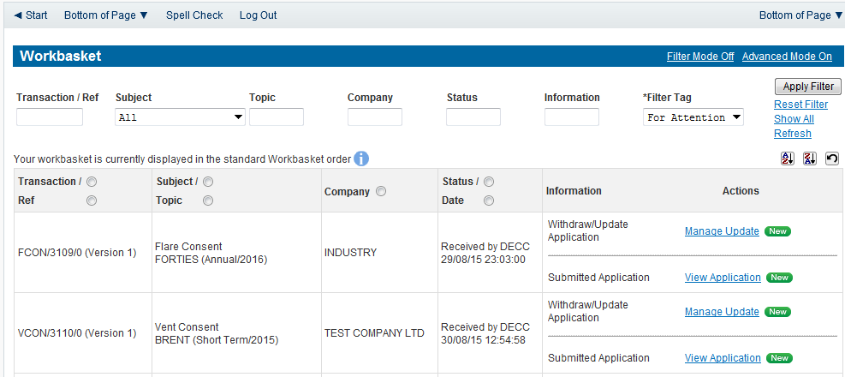
Clicking on the View application link will allow the Operator to view the application in the format that it was originally submitted to The OGA.
Clicking on the ‘Manage Update’ link will display any messages sent from the OGA Field Consents administration team to the Operator

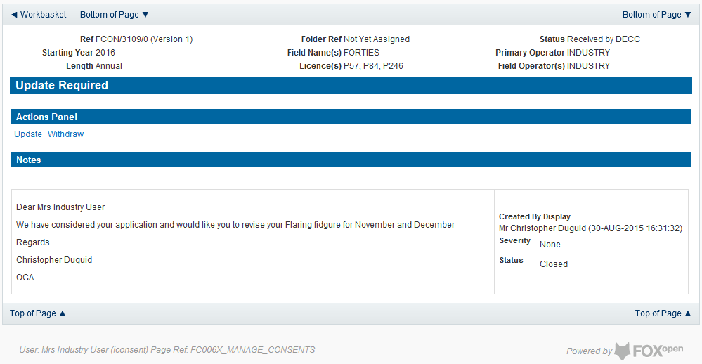

The Operator has the option to either update the application and resubmit or withdraw this application and submit a fresh application.

Withdrawing applications
To withdraw the application click on the ‘Withdraw’ link on the actions panel
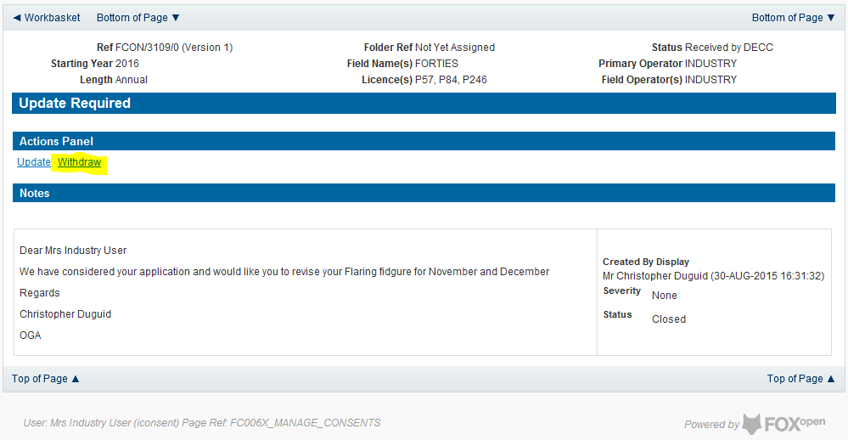

The operator will receive a warning message asking for confirmation of this action.

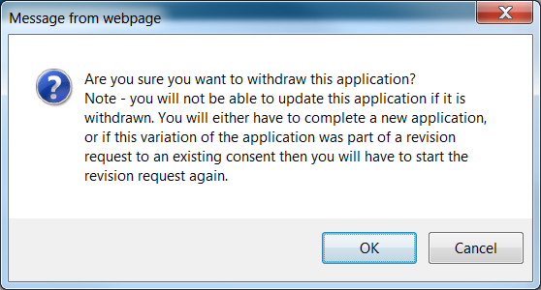

If the application is withdrawn the entry will be withdraw from the workbasket and archived.

Amending applications
To amend the application the operator should click on ‘Update’ from the View/Manage Case screen.
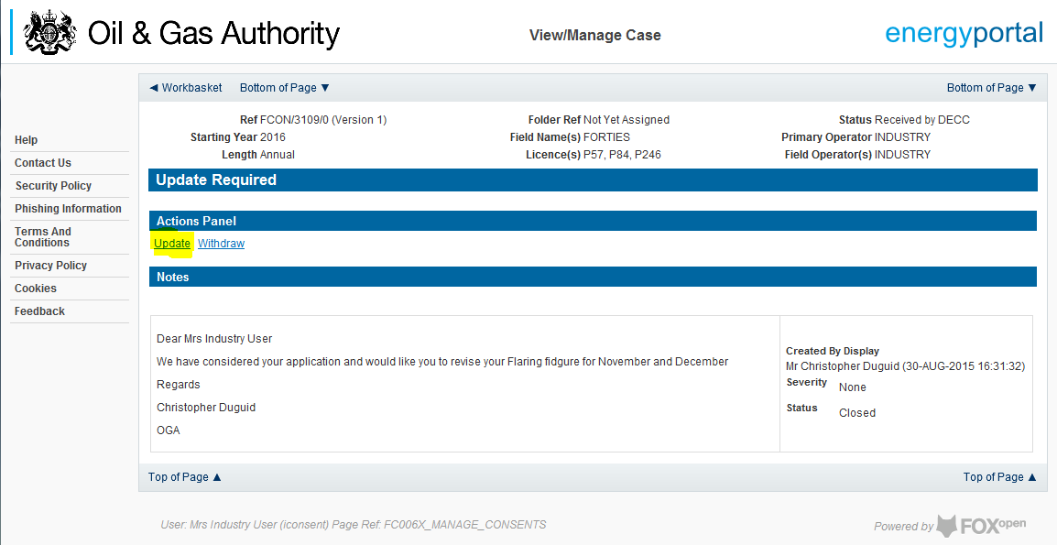
The Operator will be given a warning message asking for confirmation of the amendment of this application.

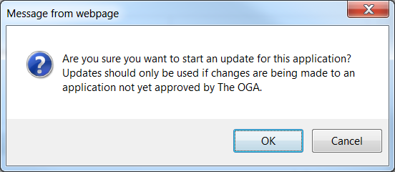

Once the amendment is confirmed a new version of this application will be created. The Version number will be increased by 1. E.G FCON/3109/0 (Version 1) will become FCON/3109/0 (Version 2)
The application process should then be followed as if this were a new application. It should be noted that neither the original or the new version will be in force until they have been processed by The OGA and a Consent Document issued.

Processing Payments
Once you submit your application to The OGA you will be taken to the Payment screen
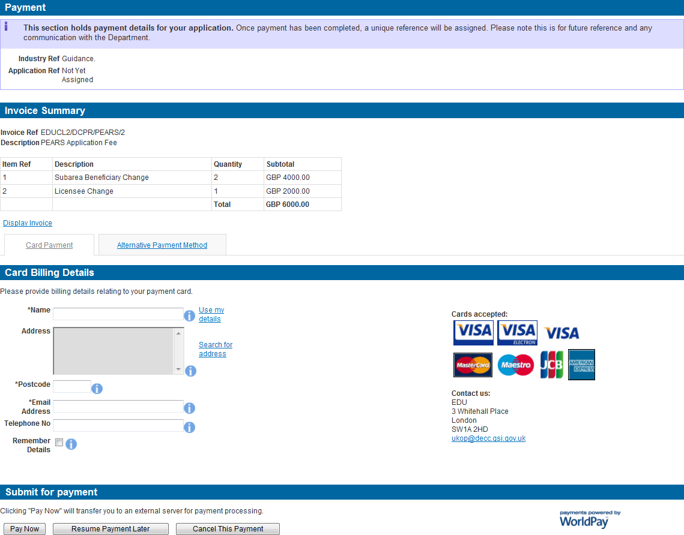

If you need to view/print the Payment Request (Invoice), you can click on the ‘Display Invoice’ link.
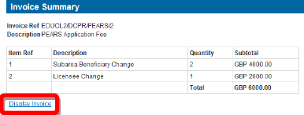

This will display the Payment Request in a PDF format.

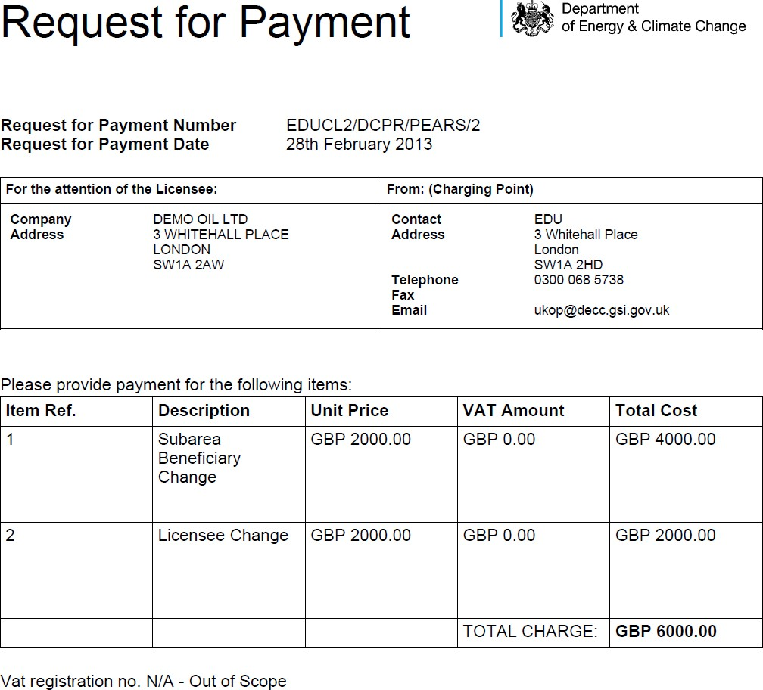

When you are ready to pay for your application you will need to select a Payment Method

You can choose either ‘Card Payment’ which allows you to pay using a credit card through our ‘WorldPay’ system or you can select ‘Alternative Payment Method’ which allows you to arranging a ‘BACS or CHAPS’ payment

WorldPay Payments
If you are using WorldPay as your payment method you will need to enter your card billing details. If you click on ‘Use my details’ it will import the details that are held against your
Portal Account. When searching for your company address click on the ‘Search for address’ link

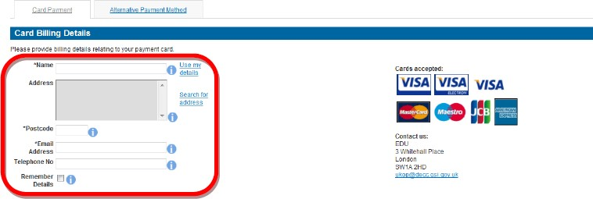

Once you have entered your post code click on the ‘Search’ button
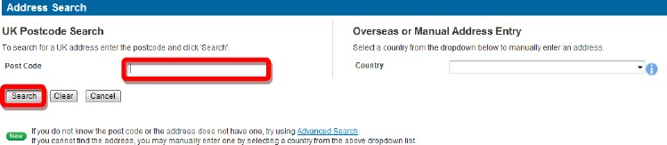

Once your search results have returned, you need to click on the relevant address link
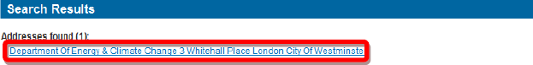

Once all your details have been entered you need to click on the ‘Pay Now’ button

You will now be directed to the WorldPay system

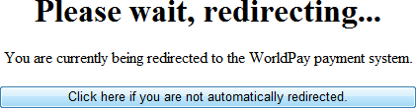

You will now need to select your Card Type by clicking on the relevant card icon

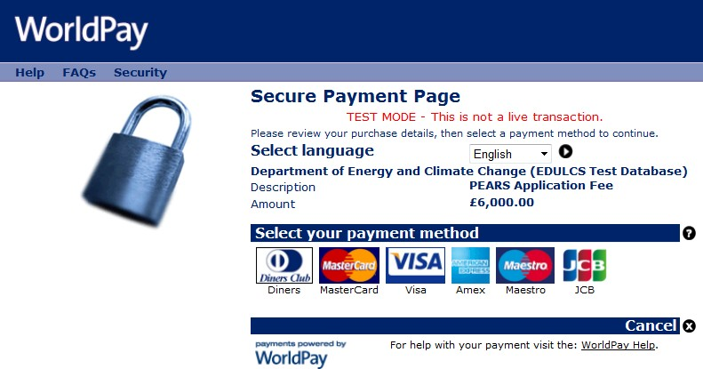

You are new required to enter your card details and then click on the ‘Make Payment’ tick icon
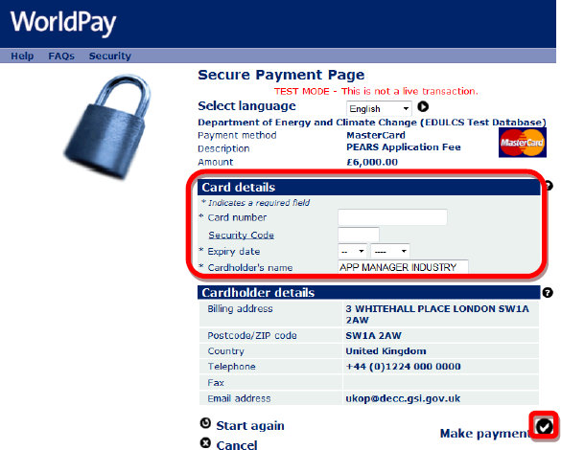

You will now receive a message stating that your payment has been submitted for processing

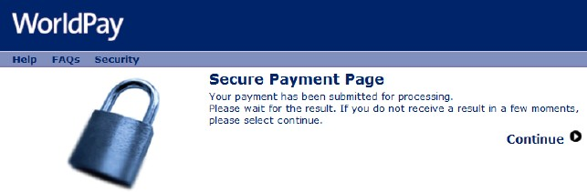

You will now receive a payment status informing you if your payment has been successful or not. You now need to click on the ‘Return to the portal’ button
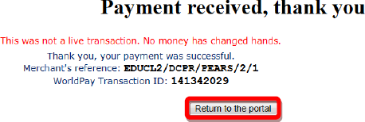

You can now see the payment details as well as being able to view both the ‘Payment Request (Invoice)’ and ‘Receipt’ by clicking on the relevant button
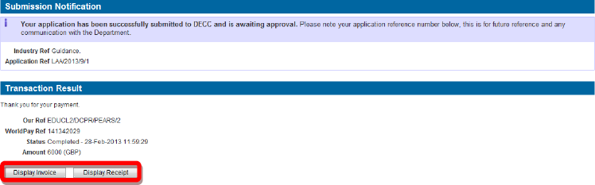

An example of a receipt is show below

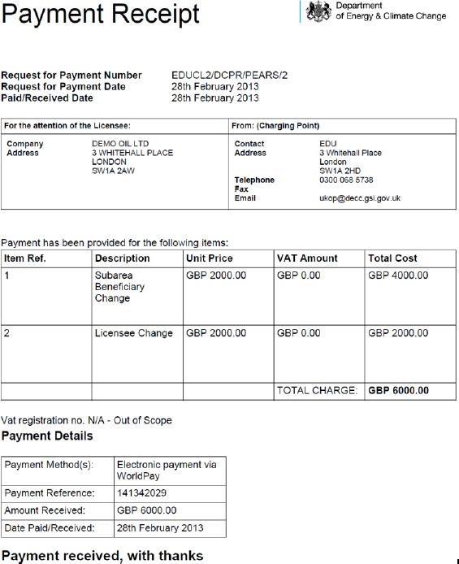

BACS/CHAPS Payments
If you are using an alternative payment method, you will need to enter ‘Payment’ and ‘Bank’ details. You will also be required to enter a ‘Security Code’ from the ‘Security Image’ provided.
Once you have entered this information you need to click on the ‘Submit Alternative Payment’ button

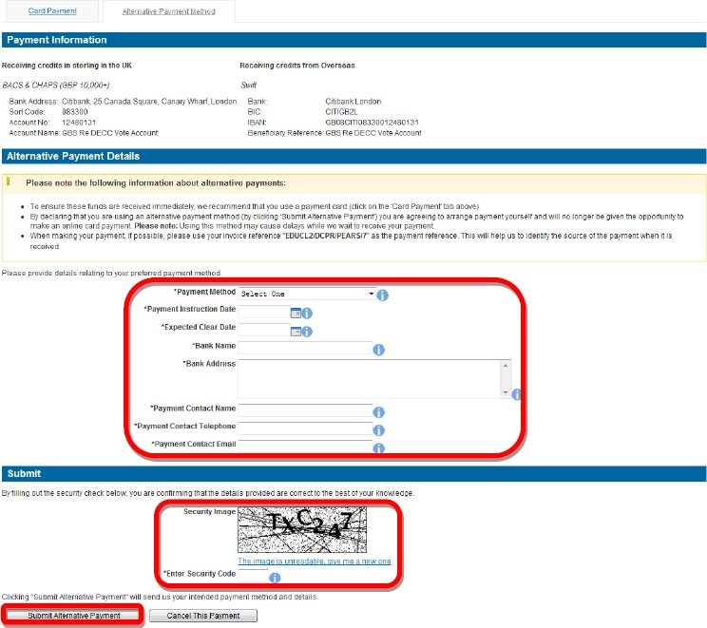

Opting to pay using this method will prevent the Operator from paying by Credit / Debit card in for this application.
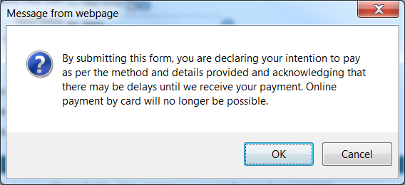
You will now see your payment details

