Options Variation & Deposit Consent

Application Template

Name of Field/Project: XXXX
PWA: X/W/XX
PA ref: to be supplied by NSTA
Operator Document No: XXXX – to be supplied by Operator

Contact: Name (Holder)
Role: Job Title
Email: work email address
Tel: work telephone number

Earliest proposed start of work: DD MMM YY (Any works associated with the application to include deposits)
Mobilisation Date: DD MMM YY

Conditions of Use:
- The Options application is not to be used as a substitute for surveying and investigating a problem. Where there are problems with pipelines, the Operator should have thoroughly surveyed and investigated the fault or situation. Where the problem may not be clearly identified and there may be various points of possible failure, NSTA may consider an Options case.
- To apply under the above circumstances, the Holder should email consents@nstauthority.co.uk (marked FAO The Consents Team Lead / Consents Senior Case Manager) requesting the works are treated as an Options, detailing why they would like NSTA to consider the case being handled as an Options (not setting a precedence as NSTA always reserves the right to make a decision on how each individual case is processed).
Completion Instructions:
- All questions must be answered in the order they are presented.
- The numbering of the questions is not to be altered.
- All Company Names and addresses are to be shown exactly as per Companies House.
- Additional information is to be provided in the relevant section following from the main paragraph.
- All coordinates must be provided in WGS84 format (XX^{O} XX’ XX.XX”N XX^{O} XX’ XX.XX”E).
- All coordinates must be provided in WGS84 format (XX^{O} XX’ XX.XX”N XX^{O} XX’ XX.XX”W).
- All Table As and DepCon Forms are to be provided in landscape.
- All attached drawings or schematics must be a high resolution with routes and co-ordinates shown in bold.
- Please send notification of the Option used along with the amended application (including the relevant Table A(s) and Drawing(s)) to NSTA Case Officer on completion of works within 5 working days.
- Following completion of all works and associated testing, “As-built” information must be submitted to the NSTA via the PWA portal As-Built process.
- If Branding must be used it should be restricted to the front page only.
- Please ensure the application is thoroughly checked before submitting to NSTA.
- Remove NSTA advice in red including completion instructions and change blue text to black. DO NOT remove or amend wording already in black.
- Please do not remove Version number/date from the footer on page 1 – Coversheet.
Final Consents are authorised and issued by the Oil and Gas Authority.
North Sea Transition Authority is a business name of the Oil and Gas Authority. Oil and Gas Authority is a limited company registered in England and Wales with
registered number 09666504 and VAT registered number 249433979. Our registered office is at Sanctuary Buildings, 20 Great Smith Street London, SW1P 3BT
Document Control - Optional - to be completed by the Operator

Insert completed Tables of Document revisions as per example below

Approvals - Optional - to be completed by the Operator

 | Name | Signature | Date
Prepared by |  |  | DD MMM YY
Reviewed by
Approved by

Revision Control – to be completed by the Operator

Revision No | Reference | Changes/Comments | Issue Date
0 | Issued for comments to NSTA |  | DD MMM YY
1 | Application revised following feedback provided on review on DD MMM YY.
 | …
5 | Final Issued Version

Distribution List – Optional - to be completed by the Operator

Name | Company | No of Copies
…………

Contents
1. Introduction 5
2 Administrative Details 5
2.1 Overview - Options of works 5
2.2 Options Timeline 6
2.3 HSE 500m Safety Zone 6
2.4 PWA 6
2.5 Approximate Field/Project location from shore 6
2.6 Method of pipeline installation 6
2.7 Block Crossing Agreements 6
2.8 Telecom cable crossings 7
2.9 Pipeline Crossing Agreements 7
2.10 Median Line Agreement 8
2.11 Applicant 8
2.12 Holder, User, Operator and Owner information 9
2.13 Relevant environmental permits 10
3 Variation Details 10
3.1 Trenching 10
3.2 Table A(s) and Schematic(s) 10
3.3 Permanent Deposits 17
3.4 Temporary Deposits 17

Annex X DepCon Table(s) and Drawing(s) 18
Annex X Block Crossing Agreements (to be provided for all Blocks being crossed) 21
Annex X Cable Crossing Agreements (to be provided for all cables being crossed) 22
Annex X Pipeline Crossing Agreements (to be provided for all Pipelines being crossed) 23
Annex X NSTA Agreement to treat case as an Options 24

Note: - Once all sections within the application have been completed: Please right click on the contents page above and select “Update Field” then “Update Page Numbers Only”. This will ensure the location of text in the application matches the contents page exactly.

Introduction
Please complete the following statements.

In accordance with the Petroleum Act 1998/ or relevant regulation and under the Guidance of the Oil and Gas Authority guidance notes (Company Name of PWA Holder) apply for authorisation to replace a 4” hydraulic jumper and deposit materials on the seabed in association with (Field/Project Name).

(Company Name of PWA Holder) hereby adheres to the conditions on “Options” and will notify the NSTA of the “Option” selected.

Where you report back to the NSTA that the works have been carried out as per a stated “Option”, you must then update the HUOO, pipeline details and schematics before passing this back for review to the Case Officer. This must be done no later than 5 working days after final date of completion, as stated in your application.

The NSTA agreed to treat the following works as an Options case via email on dd/mm/yy. Copy of the email is contained in Annex X.

Administrative Details

2.1 Overview - Options of works
Insert a brief description of the works for each option (see examples in blue). If available, it is useful to have a 3D project layout diagram (not necessarily to scale) showing pipeline(s) in the project (see below drawing).

The example given is for 2 options. If you have more than 2 options, you should create the additional option in the style and in order of probability with the most probable being Option 1.

(Company Name of PWA Holder) would like to carry out fault finding and repair to the pipeline where necessary, due to low line insulation resistance.

- Option 1
Disconnect the existing flexible pipeline, from (point 1) and reconnect it to (point 2). This connection will provide the production tie-in of the well back to (platform), via the existing pipeline.

- Option 2
Installation of a new flexible pipe to connect at (point 3) and back to (point 4). If the existing line is unsuitable, a new length of pipe shall be used. The existing line will be disconnected at both ends, flushed, blinded and wet stored.

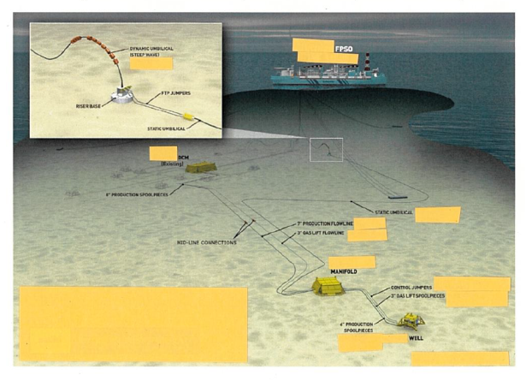

2.2 Options Timeline
Please include details of the timeline for the works proposed for each option.

Option | Activity | Month & Year
1 | Disconnection of flexible pipeline from (point 1) and reconnecting at (point 2). | Apr 2022 – Sep 2022
2 | Installation of new flexible pipeline connecting at (point 3) and (point 4) | Apr 2022 – Sep 2022

A maximum of a 6 month period may be requested. If a longer term is required, please provide justification for the longer period. If options works have not commenced within the agreed time period, the case will be closed, invoiced and the Holder will have to reapply.

2.3 HSE 500m Safety Zone
Select whether or not work will be carried out within a HSE recognised 500m safety zone.

Works will be carried out totally within a HSE recognised 500m safety zone (name of structure).

or

Works will be carried out totally outside a HSE recognised 500m safety zone.

or

Works will be carried out partially within a HSE recognised 500m safety zone (name of structure).

2.4 PWA

Provide reference as to which PWA/Carbon Storage Permit the Variation application is associated as per example in blue.

PWA: XX/W/XX

2.5 Approximate Field/Project location from shore
Provide the approximate location details as per example in blue.

The project/field location is approximately XXXkm due east of Aberdeen.

2.6 Method of pipeline installation
Insert the details of the method of pipeline installation, see example in blue.

Installation is scheduled to begin in (state date MMM YY) using a dynamically positioned pipe lay vessel. The pipeline will be installed using the S-lay method.

or

Not applicable as no pipelines are being installed.

2.7 Block/Carbon Storage Area/Gas Storage Licensed Area Crossing Agreements
Complete table to show details of all blocks crossed and reference the Block/Carbon Storage Area/Gas Storage Licensed Area Crossing Agreements letters which should be provided in an Annex, see example in blue.

No Blocks/Carbon Storage Areas/Gas Storage Licensed Areas are to be crossed therefore no Block/Carbon Storage Area/Gas Storage Licensed Area crossings are required.

or

All Blocks/Carbon Storage Areas/Gas Storage Licensed Areas to be crossed are 100% owned by (Company Name - applying for authorisation) therefore no Block/Carbon Storage Area/Gas Storage Licensed Area crossings are required.

or

The pipeline traverses Blocks/Carbon Storage Areas/Gas Storage Licensed Areas (2/1a, 2/1b & 3). Block/Carbon Storage Area/Gas Storage Licensed Area crossing agreements have been confirmed as shown below. Agreement letters are contained in Annex X.

Block/Carbon Storage Area Crossing Agreements

UK Block Number | Licence Number | Agreement Confirmation from
2/1a | 4 | (Company Name A)
2/1b | 5 | (Company Name B)
3 | 6 | (Company Name C)

2.8 Telecom cable crossings
Details to be provided that the proposed route(s) have been checked for the presence of telecom cables against the KIS-ORCA, and details of findings, see example in blue.

(Company Name) has checked for the presence of telecom & offshore renewable cables against Kingfisher Information Service Offshore Renewable Cable Awareness (KIS-ORCA) and has found no evidence of any existing lines in the vicinity of the planned works.

or

Cable crossing agreements are provided at Annex X.

Telecom Cable Crossing Agreements

Cable Name/Location | Owner of Cable
XXXX to XXXX Submarine Communications Cable | (Company Name P)
YYYY to YYYY Submarine Communications Cable | (Company Name Q)

2.9 Pipeline Crossing Agreements
Insert details of any pipeline crossing (see example in blue). Written confirmation from the owner of any pipeline whose pipe is being crossed that there are no objections is required, in an Annex and referenced as such.

No pipelines are crossed; therefore no pipeline crossing agreements are required.

or

The pipeline(s) crosses PL1, PLU2 and PL3 which are all owned by operator name (company applying for application, name to be exactly as per the licence) therefore no pipeline crossing agreement letter(s) are required.

or

The pipelines crosses pipeline PL10, PL11 & PL12. Pipeline crossing agreements have been confirmed as shown below. Agreement letters are contained in Annex X.

Pipeline Crossing Agreements

Pipeline Number | Owner of Pipeline
PL10 | (Company Name P)
PL11 | (Company Name Q)
PL12 | (Company Name R)

2.10 Median Line Agreement
Median line is not crossed; therefore no Median Line agreement is required.

We (Company Name of Holder) confirm that we are in discussions with the Norwegian Ministry regarding this project to ensure all regulatory requirements will be met. (Contact email address and name……… Norwegian Ministry)

or

We (Company Name of the Holder) confirm that we have held (are in) discussions with the Norwegian Ministry regarding this project and they are content all regulatory requirements have been met (letter of agreement in Annex X). (Contact email address and name……… Norwegian Ministry)

2.11 Applicant
Provide the following statement as appropriate referencing the company name exactly as presented on Companies House/Licence.

The PWA is solely being applied for by (Company name) and no partners are involved.

or

(Company Name) on behalf of itself and its partners as specified in 2.12 makes this Pipeline Works Authorisation variation application.

2.12 Holder, User, Operator and Owner information

Submitted by: [Company Name] (Holder of PWA)
on behalf of: [Holder & Partners Company Names]
Field/Project Name: XXXX (Same as consented in original PWA)
PWA ref & date of issue: [XX/W/XX, dd/mmm/yy] (or date PWA authorised if pre-PWA numbering)
List Pipelines within PWA & Associated Variations: [PLXXXX – PLXXXX, PLXXXX] (Only pipeline numbers are required)
PA Ref: [PA/XXXX]
1. Date of licence transfer: [dd/mmm/yy]
2. Commercial agreement: [dd/mmm/yy]

All details to be stated exactly as per Companies House (i.e. no abbreviations unless listed in Companies House).

Names, registered addresses and registered company numbers of Holder; Users; Operator and Owners

Complete company details & annotate () whether Holder, User, Operator or Owner | Holder | User(s) | Operator | Owner(s)
Company Name
UK registered Company address
Registered Company Number
Company Name W
UK registered Company address
Registered Company Number
Company Name X
UK registered Company address
Registered Company Number
Company Name Y
UK registered Company address
Registered Company Number
Company Name Z
UK registered Company address
Registered Company Number

When completing the Holder, User, Operator and Owner table please ensure every page has all the approved headers shown above.

2.13 Relevant environmental permits
A statement should be provided stating the action taken to satisfy any relevant environmental regulations (i.e. Environmental Statement (ES), Direction and Exemption) including date (month and year) they were/will be submitted. Please liaise with DESNZ EMT OPRED@Energysecurity.gov.uk. Timely submission is advised to avoid potential delays.

3 Variation Details

3.1 Trenching

State whether pipeline(s) is to be trenched and/or buried and/or backfilled and target depth of trench see examples below in blue.

Not applicable as no new pipelines to be laid.

or

The pipeline will not be trenched.

or

The pipeline will be trenched by jetting and cutting seabed condition dependant and simultaneously buried such that the top of the pipeline is a minimum of X.Xm below the natural seabed and target trench depth of X.Xm. The trench shall maintain a distance of XXm from any existing pipelines.

3.2 Table A(s) and Schematic(s)
Each option is to show the changes to existing Table A(s) and a new Table A for the replacement options. A simple line drawing is to be provided to clearly show all the options for the consultees.

A completed Table A must be provided for each Option and a Table A to show variation to existing line (as left on the seabed), showing only main component parts and providing coordinates (WGS84) for the ‘From’ and ‘To’ points of pipeline.
New main component parts such as ESDV, Manifolds, SSIV, Termination Units or component(s) that effect flow should have their own ident number and the same component description should feature in columns 3 to 5 (This only applies to the main production or umbilical pipeline).
If the pipeline dimensions/specifications are the same then they can be combined into one ident number rather than several separate idents (this includes spools).
All idents are to follow the direction of flow.
Column 6 should be completed to show total overall length of pipeline (total of all idented lengths).

PLEASE NOTE – FOR CCUS PWA’S, YOU MUST STATE THE PRODUCT & PHASE IN COLUMN 12 FOR EACH PIPELINE TABLE A. IN THE HEADER, STATE CLEARLY IF YOU ARE APPLYING FOR A CHANGE IN PHASE.

The following pages contain Table As for PLXXXX, PLUAAAA, PLYYYY and PLUBBBB.

Table A Contents

Option 1
New Electrical Well Jumper PLXXXX 11
Existing Services Umbilical Jumper PLUAAAA 12

Option 2
New Electrical Well Jumper PLYYYY 13
Existing Services Umbilical Jumper PLUBBBB 14

Electrical Jumper Replacement Schematic (Example Drawing Template 1) 15

When completing the table A please check every page has all the approved headers as seen in the example tables. If a pipeline has a number of idents and covers several pages, please ensure column 1 on each page has the pipeline number shown (e.g. PLXXXX cont.). Please include “Out of Use” in the pipeline name header if the pipeline is being taken out of use. Also include this annotation in Column 12.

Where there are numerous possibilities (more than 3) in an Options case, these could be represented in the same Table A following the below format and footnote:

Col 1 | Col 2 | Col 3 | Col 4 | Col 5 | Col 6 | Col 7 | Col 8 | Col 9 | Col 10 | Col 11 | Col 12* (IF CCUS YOU MUST STATE PRODUCT & PHASE IN EACH IDENT)
Pipeline No. | Ident No. | From | To | Description of Component Parts of the Pipeline | Length (m) | External Diameter (mm) | Internal Diameter (mm) | Wall Thickness (mm) | Type of Insulation /Coating | MAOP (Barg) | Products to be conveyed  *
 |  | YYY Manifold  XXº XX’ XX.XX” N  XXº XX’ XX.XX” E | XXX Well  XXº XX’ XX.XX” N  XXº XX’ XX.XX” E | Electrical Jumper |  |  |  |  |  |  | Electrical Power and Signal
PLXXXX | 1 | YYY Manifold | XXX Well | Electrical Jumper | Xx | Xx | Xx | Xx | - | Xx | Electrical Power and Signal

OR

Col 1 | Col 2 | Col 3 | Col 4 | Col 5 | Col 6 | Col 7 | Col 8 | Col 9 | Col 10 | Col 11 | Col 12* (IF CCUS YOU MUST STATE PRODUCT & PHASE IN EACH IDENT)
Pipeline No. | Ident No. | From | To | Description of Component Parts of the Pipeline | Length (m) | External Diameter (mm) | Internal Diameter (mm) | Wall Thickness (mm) | Type of Insulation /Coating | MAOP (Barg) | Products to be conveyed  *
PLYYYY | 1 | YYY Manifold | XXX Well | Electrical Jumper | Xx | Xx | Xx | Xx | - | Xx | Electrical Power and Signal

OR
Col 1 | Col 2 | Col 3 | Col 4 | Col 5 | Col 6 | Col 7 | Col 8 | Col 9 | Col 10 | Col 11 | Col 12* (IF CCUS YOU MUST STATE PRODUCT & PHASE IN EACH IDENT)
PLZZZZ | 1 | YYY Manifold | XXX Well | Electrical Jumper | Xx | Xx | Xx | Xx | - | Xx | Electrical Power and Signal

Footnote – Either of the above jumpers is intended to replace the electrical core within PLUAAAA which may be found to be faulty.

If more than 3 options are required, please contact consents@nstauthority.co.uk in the first instance.

TABLE A (Option 1)
PIPELINE NAME (Field/Project Name) Electrical Well Jumper PLXXXX
APPLICANT (Company Name)
PROJECT NAME (Field/Project Name) Development

PWA (PWA Number in format XX/W/XX)
REFERENCE DRAWING XXXXX

Col 1 | Col 2 | Col 3 | Col 4 | Col 5 | Col 6 | Col 7 | Col 8 | Col 9 | Col 10 | Col 11 | Col 12* (IF CCUS YOU MUST STATE PRODUCT & PHASE IN EACH IDENT)
Pipeline No. | Ident No. | From | To | Description of Component Parts of the Pipeline | Length (m) | External Diameter (mm) | Internal Diameter (mm) | Wall Thickness (mm) | Type  of Insulation/Coating | MAOP (Barg) | Products to be conveyed
PLXXXX |  | YYY Manifold  XXº XX’ XX.XX” N  XXº XX’ XX.XX” E | XXX Well  XXº XX’ XX.XX” N  XXº XX’ XX.XX” E | Electrical Jumper | XX |  |  |  |  |  | Electrical Power and Signal
PLXXXX | 1 | YYY Manifold | XXX Well | Electrical Jumper | XX | XX | XX | XX | - | XX | Electrical Power and Signal

This Jumper is intended to replace the electrical core within PLUAAAA which may be found to be faulty. (Note for example only)

If it is an Electrical Jumper it should start at the FPSO/Platform or Manifold and go to the Well as the power will be coming from the FPSO/Platform to the reservoir.

If Carbon Dioxide is being conveyed, Column 12 is to include the Phase the Carbon Dioxide is in.

Idents should be shown as 1, 2, 3 etc.

Please insert N/A into the table if the information required does not apply to the pipeline.

TABLE A (Option 1)
PIPELINE NAME (Field/Project Name) Services Umbilical Jumper PLUAAAA
APPLICANT (Company Name)
PROJECT NAME (Field/Project Name) Development

PWA (PWA Number in format XX/W/XX)
REFERENCE DRAWING XXXXX

Col 1 | Col 2 | Col 3 | Col 4 | Col 5 | Col 6 | Col 7 | Col 8 | Col 9 | Col 10 | Col 11 | Col 12* (IF CCUS YOU MUST STATE PRODUCT & PHASE IN EACH IDENT)
Pipeline No. | Ident No. | From | To | Description of Component Parts of the Pipeline | Length (m) | External Diameter (mm) | Internal Diameter (mm) | Wall Thickness (mm) | Type  of Insulation/Coating | MAOP (Barg) | Products to be conveyed
PLUAAAA |  | YYY Manifold  XXº XX’ XX.XX” N  XXº XX’ XX.XX” E | XXX Well  XXº XX’ XX.XX” N  XXº XX’ XX.XX” E | Services Umbilical Jumper | XX |  |  |  |  |  | Hydraulic, Electrical,  Scale Inhibitor
PLUAAAA | 1 | YYY Manifold | XXX Well | Services Umbilical Jumper | XX | XX | XX  XX  XX | XX  XX  XX | - | XX  XX  XX | 1 x Hydraulic  1 x Electrical (disconnected)  1 x Scale Inhibitor

PLUAAAA is a Services Umbilical Jumper. The Electrical core is to be disconnected and left in situ, remaining attached to the hydraulic and scale inhibitor cores which will remain in service. The Electrical core is to be replaced by PLXXXX if found to be faulty. (Note for example only)

If it is a Services Umbilical it should start at the FPSO/Platform or Manifold and go to the Well as the service will be coming from the FPSO/Platform to the reservoir.

Idents should be shown as 1, 2, 3 etc.

Please insert N/A into the table if the information required does not apply to the pipeline.
TABLE A (Option 2)
PIPELINE NAME (Field/Project Name) Electrical Well Jumper PLYYYY
APPLICANT (Company Name)
PROJECT NAME (Field/Project Name) Development

PWA (PWA Number in format XX/W/XX)
REFERENCE DRAWING XXXXX

Col 1 | Col 2 | Col 3 | Col 4 | Col 5 | Col 6 | Col 7 | Col 8 | Col 9 | Col 10 | Col 11 | Col 12* (IF CCUS YOU MUST STATE PRODUCT & PHASE IN EACH IDENT)
Pipeline No. | Ident No. | From | To | Description of Component Parts of the Pipeline | Length (m) | External Diameter (mm) | Internal Diameter (mm) | Wall Thickness (mm) | Type  of Insulation/Coating | MAOP (Barg) | Products to be conveyed
PLYYYY |  | YYY Manifold  XXº XX’ XX.XX” N  XXº XX’ XX.XX” E | XXX Well  XXº XX’ XX.XX” N  XXº XX’ XX.XX” E | Electrical Jumper | XX |  |  |  |  |  | Electrical Power and Signal
PLYYYY | 1 | YYY Manifold | XXX Well | Electrical Jumper | XX | XX | XX | XX | - | XX | Electrical Power and Signal

This Jumper is intended to replace the electrical core within PLUBBBB which may be found to be faulty. (Note for example only).

If it is an Electrical Jumper it should start at the FPSO/Platform or Manifold and go to the Well as the power will be coming from the FPSO/Platform to the reservoir.

Idents should be shown as 1, 2, 3 etc.

Please insert N/A into the table if the information required does not apply to the pipeline.
TABLE A (Option 2)
PIPELINE NAME (Field/Project Name) Services Umbilical Jumper PLUBBBB
APPLICANT (Company Name)
PROJECT NAME (Field/Project Name) Development

PWA (PWA Number in format XX/W/XX)
REFERENCE DRAWING XXXXX

Col 1 | Col 2 | Col 3 | Col 4 | Col 5 | Col 6 | Col 7 | Col 8 | Col 9 | Col 10 | Col 11 | Col 12* (IF CCUS YOU MUST STATE PRODUCT & PHASE IN EACH IDENT)
Pipeline No. | Ident No. | From | To | Description of Component Parts of the Pipeline | Length (m) | External Diameter (mm) | Internal Diameter (mm) | Wall Thickness (mm) | Type  of Insulation/Coating | MAOP (Barg) | Products to be conveyed
PLUBBBB |  | YYY Manifold  XXº XX’ XX.XX” N  XXº XX’ XX.XX” E | XXX Well  XXº XX’ XX.XX” N  XXº XX’ XX.XX” E | Services Umbilical Jumper | XX |  |  |  |  |  | Hydraulic, Electrical,  Scale Inhibitor
PLUBBBB | 1 | YYY Manifold | XXX Well | Services Umbilical Jumper | XX | XX | XX  XX  XX | XX  XX  XX | - | XX  XX  XX | 1 x Hydraulic  1 x Electrical (disconnected)  1 x Scale Inhibitor

PLUBBBB is a Services Umbilical Jumper. The Electrical core is to be disconnected and left in situ, remaining attached to the hydraulic and scale inhibitor cores which will remain in service. The Electrical core is to be replaced by PLYYYY if found to be faulty. (Note for example only)

If it is a Services Umbilical it should start at the FPSO/Platform or Manifold and go to the Well as the service will be coming from the FPSO/Platform to the reservoir.

Idents should be shown as 1, 2, 3 etc.

Please insert N/A into the table if the information required does not apply to the pipeline.
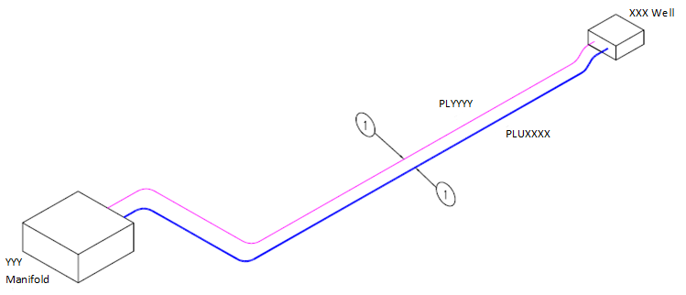

PLUAAAA
PLXXXX

PLUBBBB

PLYYYY

Title Example Drawing Template 1
Drawing Number  XXXXX | Sheet  1 of 1 | Rev | Rev | Revision | Date | App.

3.3 Permanent Deposits
NSTA advice – Please read before completing
A PWA must be in place before deposit consents can be authorised. A Deposit Consent is for the support and protection of a pipeline, if the deposit is not for this; contact DESNZ EMT to apply for a Marine Coastal Access Act (MCAA) licence. Materials which are to be laid prior to this date should also be applied for through a MCAA licence.
Column 2 should specify a period to allow for works to be completed, with a contingency to allow for any potential delays (Max. 6 months); longer periods must be discussed with the Consents Team Lead / Consents Senior Case Manager.
Column 4 the operator should consider whether exact amounts are known or whether a reasonable contingency is required. If the latter then this should be built into the number requested in column 4 and the table footnoted to say………”Includes contingency of X mattresses” or “include X% as a contingency”.
A rock berm profile should be included within the application to support any requests to deposit rock. The rock berm profile must include height and width dimensions and may be shown in the text or as part of the Deposit Consent drawing(s).

Select either

The Deposit Consent application can be found in Annex X and are requested for the support and protection of a pipeline/umbilical.

or

Deposits are not required for this scope of work.

Typical Rock Berm Profile (example only)

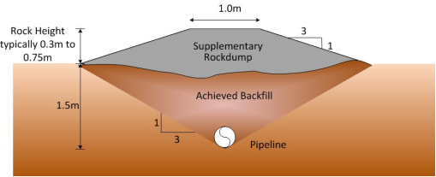

3.4 Temporary Deposits
Temporary deposits to be included but are for information only. Please apply to DESNZ Environmental Management Team for a permit OPRED@Energysecurity.gov.uk.

or

Temporary deposits are not required for this scope of work.

ANNEX X

DEPCON TABLE

APPLICANT [Holder of the PWA]

PROJECT/FIELD NAME [Field/Project Name] Development

PWA [PWA Number in format XX/W/XX]

Option 1
Col 1 | Col 2 | Col 3 | Col 4 | Col 5 | Col 6 | Col 7
Pipeline Number | Proposed date | Type & size of materials  (Display only the required criteria below) | Quantity (Number) | Location of deposit (including co-ordinates in WGS84 format)  FROM: | Location of deposit (including co-ordinates in WGS84 format)  TO: | Drawing number
PLXXXX | Apr 22 – Sep 22 | XXm x XXm x XXm concrete mattresses | 13 | YYY Manifold  XX^{O} XX’ XX.XX”N XX^{O} XX’ XX.XX”E | XXX Well  XX^{O} XX’ XX.XX”N  XX^{O} XX’ XX.XX”E | Field-DepCon-Date-1
PLXXXX | Apr 22 – Sep 22 | Rock  1-5” Grade | 2.8 te | YYY Manifold  XX^{O} XX’ XX.XX”N XX^{O} XX’ XX.XX”E | XXX Well  XX^{O} XX’ XX.XX”N  XX^{O} XX’ XX.XX”E | Field-DepCon-Date-1

Please note: 2 x mattresses and 40% rockdump have been included as contingency in this application.

OR

Option 2

Col 1 | Col 2 | Col 3 | Col 4 | Col 5 | Col 6 | Col 7
Pipeline Number | Proposed date | Type & size of materials  (Display only the required criteria below) | Quantity (Number) | Location of deposit (including co-ordinates in WGS84 format)  FROM: | Location of deposit (including co-ordinates in WGS84 format)  TO: | Drawing number
PLYYYY | Apr 22 – Sep 22 | XXm x XXm x XXm concrete mattresses | 7 | YYY Manifold  XX^{O} XX’ XX.XX”N XX^{O} XX’ XX.XX”E | XXX Well  XX^{O} XX’ XX.XX”N  XX^{O} XX’ XX.XX”E | Field-DepCon-Date-1
PLYYYY | Apr 22 – Sep 22 | Grout Bags  XXKg | 100 | YYY Manifold  XX^{O} XX’ XX.XX”N XX^{O} XX’ XX.XX”E | XXX Well  XX^{O} XX’ XX.XX”N  XX^{O} XX’ XX.XX”E | Field-DepCon-Date-1

Please note: 2 x mattresses and 10 x grout bags have been included as contingency in this application.

This Consent authorises only Deposits exactly as described, up to the maximum quantities specified in column 4 to be laid, in the positions listed and within the period stated within the Table - nothing else can be laid. If anything different to what has been authorised within this Consent is required you must have prior consent from NSTA before it can be laid.
When completing the DepCon table please ensure every page has all the approved headers shown above. The Quantity (number) in Column 4 should be the number of deposits as described in Column 3 of the table. The quantity shown above is for illustrative purposes only. A maximum of a 6 month period may be requested in Column 2 (except where the quantities of deposits are small and a maximum of a 3 month period will be consented).

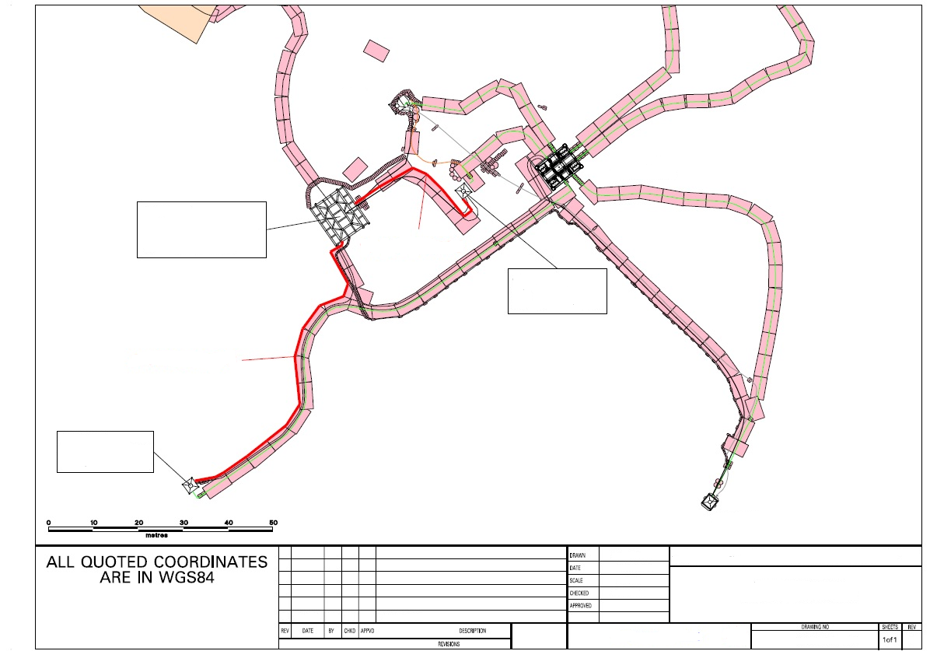
PLXXXX
2.8 te Rock
13 Mattresses
100 Grout Bags
7 Mattresses
PLYYYY

XXX Well
XX^{O} XX’ XX.XX”N
XX^{O} XX’ XX.XX”E

YYY Manifold
XX^{O} XX’ XX.XX”N
XX^{O} XX’ XX.XX”E

Annex X – Block Crossing/Carbon Storage Areas/Gas Storage Licensed Areas Agreements (to be provided for all Blocks/Carbon Storage Areas/Gas Storage Licensed Areas being crossed)

Licensee – Company Name A letterhead

Company Name
Registered Address

Date
Dear XXXX,

We, (Company Name A) Limited (“Licensee”), confirm that we (in our capacity as the Operator of Block/Carbon Storage Area/Carbon Permit/Gas Storage Licensed Area Reference (2/1a) have no objection in principle to the crossing of Block/Carbon Storage Area/Carbon Permit/Gas Storage Licensed Area Reference (2/1a) by the (Field/Project Name) pipelines and/or cable to be installed and or modified by (Company Name – Holder of PWA) as part of the (Field/Project Name) development located in Block/Carbon Storage Area/Carbon Permit/Gas Storage Licensed Area Reference (1) in the (Northern North) Sea.

Yours faithfully,

Director/secretary of Licensee
(Someone with appropriate authority to approve block crossing agreement)

Annex X – Cable Crossing Agreements (to be provided for all cables being crossed)

Cable Company Name letterhead

Company Name
Registered Address

Date
Dear XXXX,

We, (Cable Company Name A), confirm that we (in our capacity as the owner of cable (XXXX) have no objection in principle to the crossing of cable (XXXX) by the (Field/Project Name) pipelines and/or cable to be installed and/or modified by (Company Name – Holder of PWA) as part of the (Field/Project Name) development located in Block/Carbon Storage Area/Gas Storage Licensed Area (1) in the (Northern North) Sea.

Yours faithfully,

Director/secretary of Licensee
(Someone with appropriate authority to approve cable crossing agreement)

Annex X – Pipeline Crossing Agreements (to be provided for all Pipelines being crossed)

Pipeline Owners – Company Name F letterhead

Company Name

Registered Address

Date

Dear XXXX,

We refer to the Pipeline Crossing Agreement between (Company Name F) and (Company Name – Holder of PWA) in respect to the crossing of (PL10) by the (Field/Project Name) Gas Export Pipeline.

The Agreement was entered into by (Company Name F) as (PL10) Operator on behalf of (PL10) Owners and (Company Name – Holder of PWA) as the (Field/Project Name) Gas Export Pipeline Operator on behalf of the (Field/Project Name) Gas Export Pipeline Owners on DD MMM YY.

As such the (PL10) Owners have approved the crossing of (PL10) by the (Field/Project Name) Gas Export Pipeline.

Yours faithfully,

Managing Director/Business Manager
(Someone with appropriate authority to approve pipeline crossing agreement)

Annex X – NSTA Agreement to treat case as an Options
Copy of email from NSTA Consents Team Lead / Consents Senior Case Manager for application to be an Options case is to be included here.

